

Assembly Manual

Michael R. Dawson

April 9, 2018



Table of Contents

Bento Arm Assembly Manual 3

1.1 Introduction 3

1.2 Bill of materials 3

1.3 Desktop Stand 4

1.4 3D Printed Parts 10

1.5 Power Harness Cable 12

1.6 Dynamixel Servo Horn Assembly 13

1.7 Dynamixel Servo Programming 17

1.8 Part Modifications 22

1.8.1 Arm Modifications 23

1.8.2 Hand Modifications 29

1.9 Arm Assembly 31

1.10 Hand/Gripper Assembly 61

1.11 Arm Shell Assembly 74

1.12 Electronics Enclosure Assembly 77

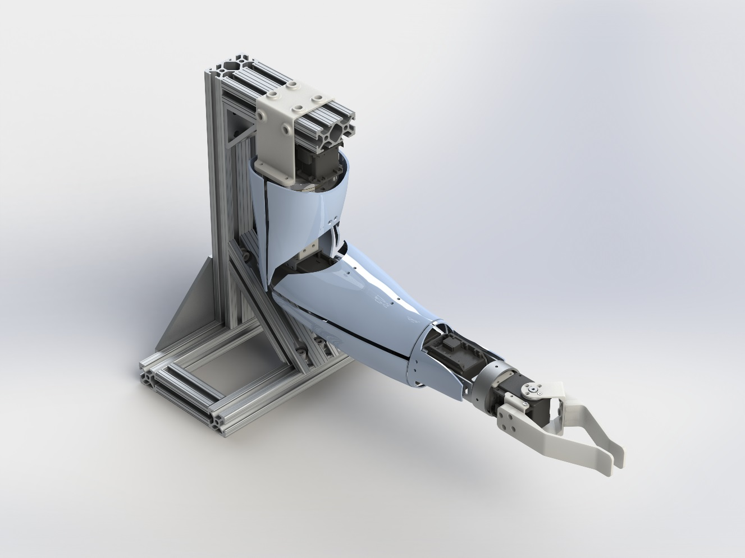

# Bento Arm Assembly Manual

## Introduction

This guide will help you from start to finish with creating a new Bento Arm including acquiring purchased parts, 3D printing custom parts, setting up the servos so that they can be controlled through some of the available software interfaces, and assembly of all parts.

## Bill of materials

Please see Bento Arm – Bill of Materials.xls for a full bill of materials for building a single Bento Arm. The bill of materials can be used to help find the parts and tools for each of the assembly steps.

The bill of material includes the following tools and equipment

* Hex keys
* Crimping tool
* Metric Bolt cutter

The following tools/materials are required, but not included in the bill of materials:

* Reprap 3D printer capable of printing PLA
* Soldering Iron
* Multibit screwdriver
* Needle nose pliers
* Counterbore
* Gel super glue
* Label maker

Note: We have listed the distributors that we have used in the past as a point of reference, but be aware that there are multiple distributor options for each part and that we do not endorse the listed distributors in any way.

## Desktop Stand

***Required Tools:*** 5/32” Hex key (ball head), 3/16” Hex key

***Required Materials:***

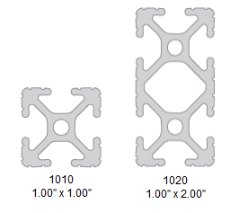 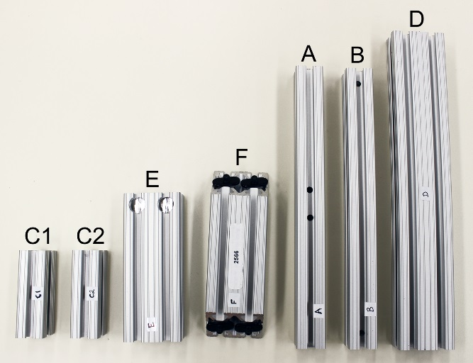

Figure 1 - 80/20 Aluminum profiles used in the Bento Arm stand

* Beam C1, 1010 extrusion, QTY:1, length 77.1 mm
* Beam C2, 1010 extrusion, QTY:1, length 77.1 mm
* Beam B, 1010 extrusion, QTY:1, length 254 mm (10in)
* Beam A, 1010 extrusion, QTY:1, length 254 mm (10in), has two access holes drilled at 4.5 and 5.5in from edge on same faces
* Beam D, 1020 extrusion, QTY:1, length 294.6 mm (11.6in)
* Beam E, 1020 extrusion, QTY:1, length 130 mm
* Beam F, 1020 extrusion (2566), QTY:1, length 127.14 (5in), edges cut at 45 degrees
* 7 hole 90 deg joining plates (4152), QTY: 2
* 8 hole inside gusset corner bracket (4138), QTY:1
* Standard end fasteners (3381), QTY:6
* Fasteners/nuts (3321), QTY:14
* 1/4-20x5/8 SHCS Washer and economy T-nuts, QTY:4
* ¼-20x ½” & Econony T-Nut (3393), QTY:8
* Anchor fasteners (3395), QTY:2

***Estimated time:*** 40 minutes

NOTE: Here are some detailed images of how to attach standard end fasteners that may be useful in the following steps. You can also refer to 8020’s [tutorial video](https://www.youtube.com/watch?v=gx-PCh7laB4).

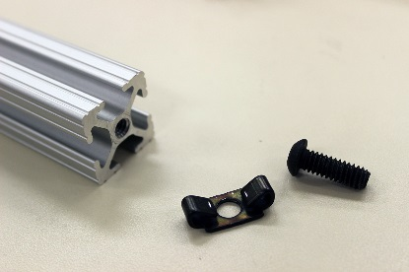 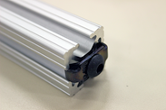 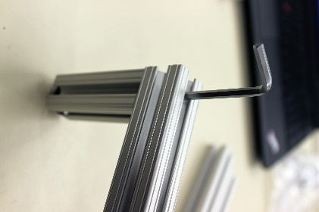

1. Attach beam C1 and C2 to beam B using standard end fasteners (3381). Fully tighten bolts using 5/32” hex key. Beam C1 and C2 are the smallest sized silver member. Beam B is a medium length member with no holes drilled in the middle only on the sides. Bolt the standard fasteners (3381) as shown in the photo below. Once beam C1 has been slid into beam B the bolt can be tightened by inserting the hex in through the small holes on the edges of beam B. NOTE: It is also important when building the base to ensure that it is level. We recommend building it on a flat surface and making sure it sits level without wobbling before tightening the fasteners

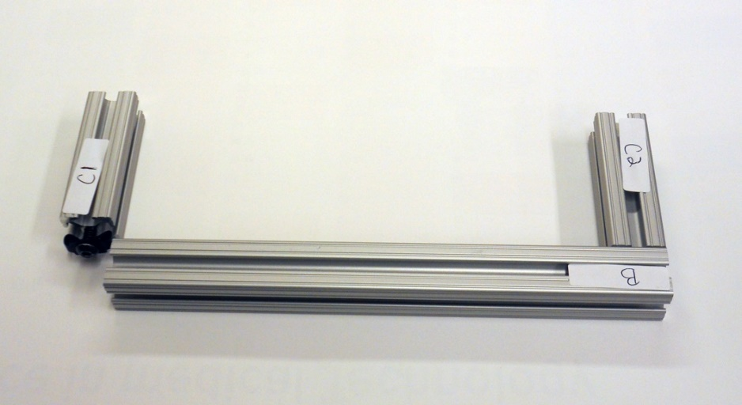

1. Attach standard end fasteners (3381) to other ends of C1 and C2, and slide in beam A, which is a medium sized member with 2 holes drilled in the middle. Make sure beam A lines up flush with the outside edges of C1 and C2. Fully tighten bolts using 5/32” hex key.

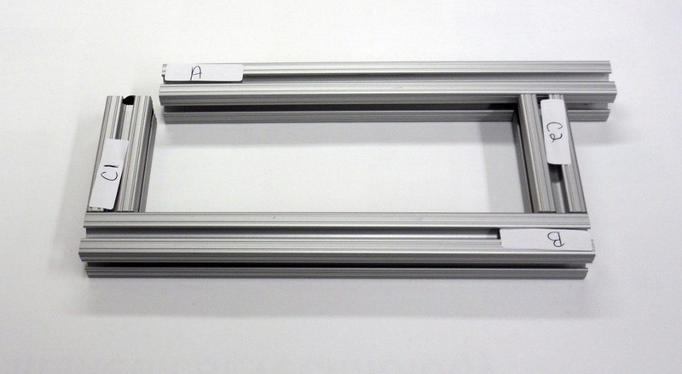

1. Attach the remaining 2 standard end fasteners (3381) to the bottom of joint D and leave untightened. Beam D a long double wide member.

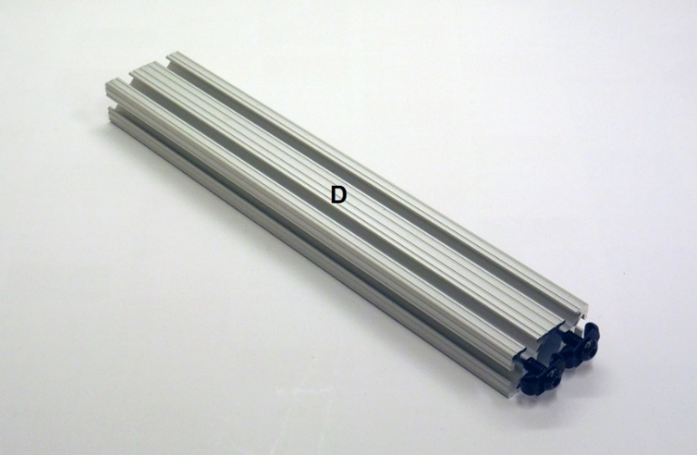

1. Attach the two 7 hole 90deg joining plates (4152) with fasteners/nuts (3321) to beam D on the same end as the standard end fasteners. Attach all the 3321 fasteners to the joining plates and keep them loose as you slide them into beams D. The pilot projection on the economy t-nuts should always face down towards the center of the extrusion. Keep the fasteners slightly loose in order to make the next steps easier.

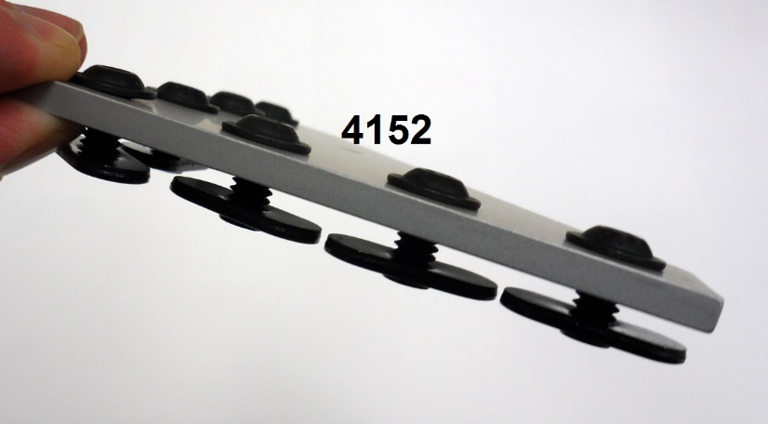

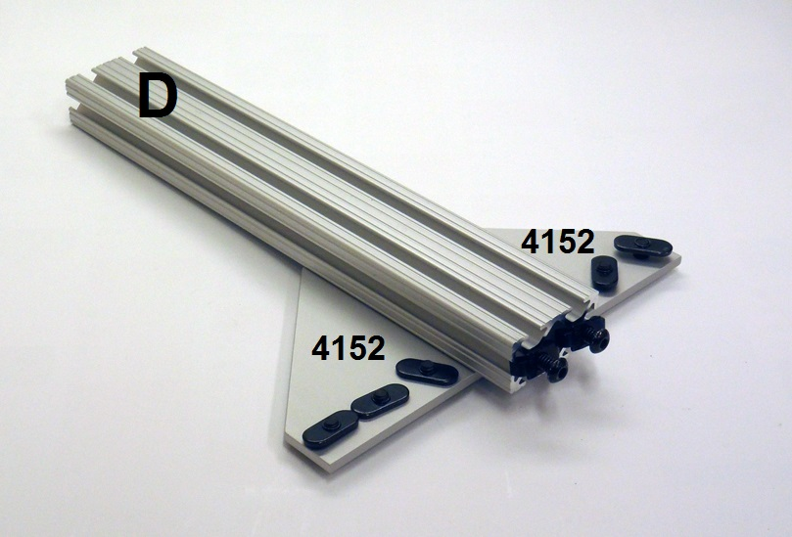

1. Attach fasteners (1/4-20x5/8 SHCS, Washer and economy T-nuts) to 45 degree support F (2566) and slide into beam D.

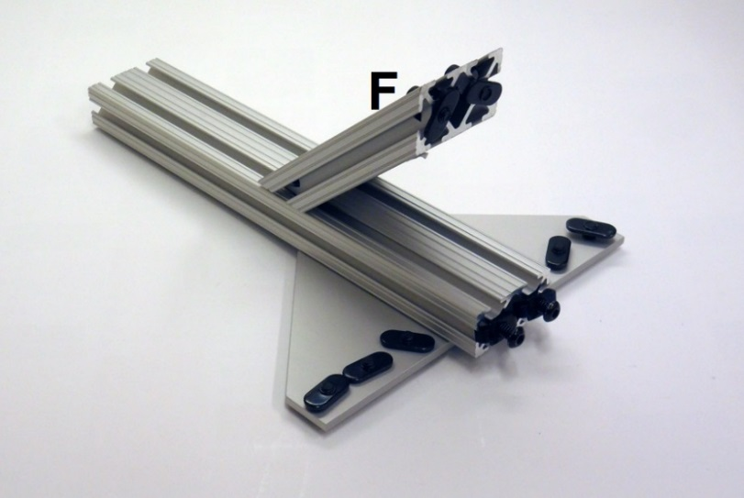

1. Slide beam D into beam A making sure to align the two through holes in A with the standard end fasteners in D. Fully tighten standard end fasteners with 5/32” Hex first and then fully tighten bolts on 7 hole 90 deg joining plates with 5/32” Hex and bolts on 45 degree support F with 3/16” Hex key.

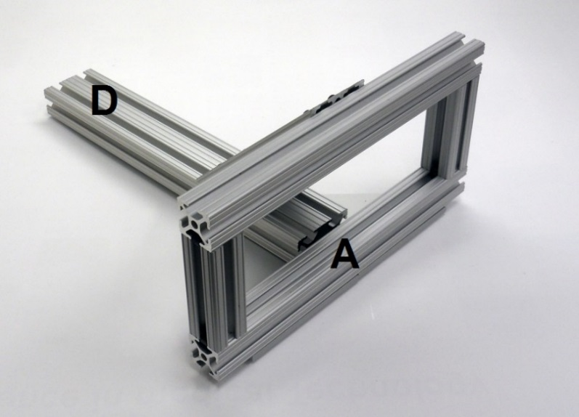

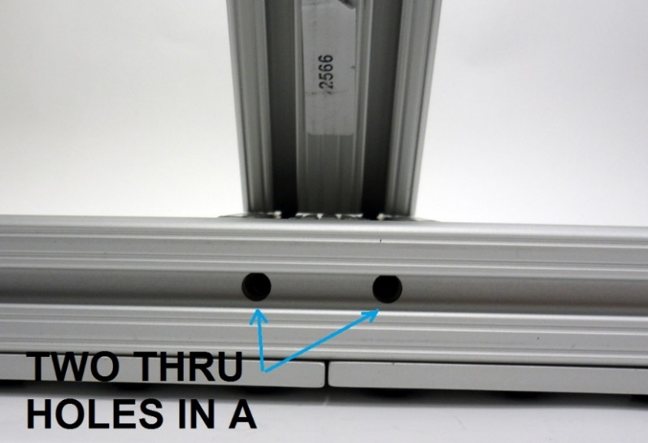

1. Attach 8 hole inside gusset corner bracket (4138) to beam E using ¼-20x ½” & Econony T-Nut (3393). Make sure edge of corner bracket is flush with edge of Beam E and then tighten the 4 mating fasteners with the 5/32” hex key Add the remaining 4 fasteners/t-nuts to the other side of the corner bracket and leave untightened.

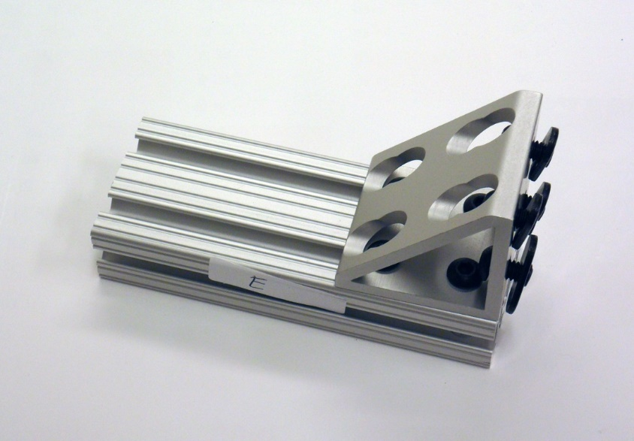

1. Loosen nuts on anchor fasteners (3395) and pop into beam E with the 80/20 inc logo facing outwards away from the central axes of the extrusion. For more information on how to install anchor fasteners please see 8020’s [tutorial video](https://www.youtube.com/watch?v=s72dKETW1cI).

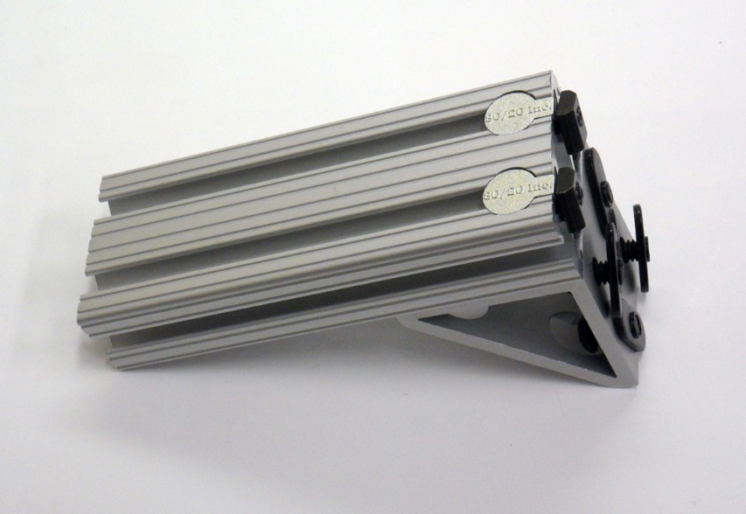

1. Slide anchor fasteners (3395) on beam E and (4138) into beam D. Make sure top of beam E aligns with edge of beam D. Tighten all fasteners with 5/32” hex key.

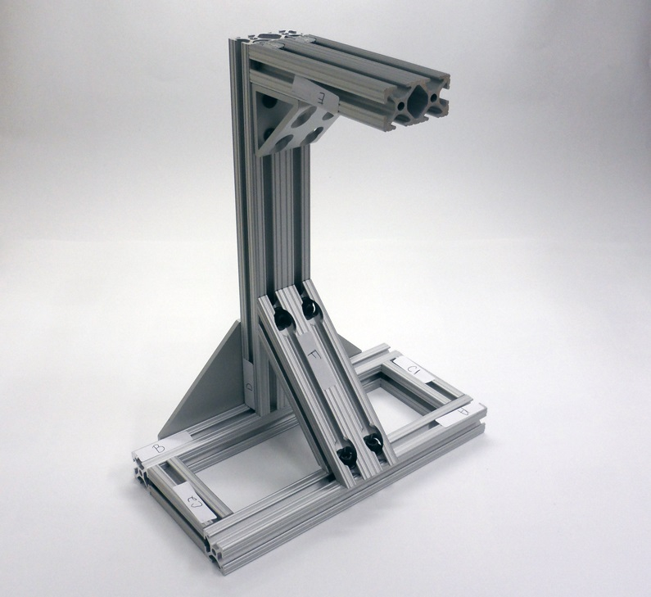

1. The assembly of the stand is now complete

## 3D Printed Parts

***Required Tools:*** Makerbot Replicator 2 3D printer or similar

***Required Materials:*** PLA filament

***Estimated print time:*** ~30 hours

1. Open Bento_Arm – 3D printing Guide.xls
2. If you have a Makerbot Replicator 2 you can print the .x3g files that we have presliced in the PLA material:
   1. 3D print all .x3g files listed under the ‘Arm – 3D Printed’ part type category in Table 1 – Multipart Print List
      1. Shoulder Bracket_rev3.x3g
      2. MX-64_back_8020_QTY3.x3g
      3. Standoff – 15_rev2_QTY4.x3g
      4. MX64_Bearing_adapter_rev2.x3g
      5. Bearing_MX106_Adapter_rev2.x3g
      6. 1in_square_tubing_brackets_QTY4_rev2.x3g
      7. 1in_square_tubing_upperarm_rev5.x3g
      8. 1in_square_tubing_forearm_rev5.x3g
      9. Wrist_Hand_Adapter_PLA.x3g
   2. 3D print all .x3g files listed under the ‘Gripper – 3D Printed’ part type category in Table 1 – Multipart Print List
      1. chopsticks_allparts_rev2b.x3g
   3. If you are using the electronics enclosure then 3D print all .x3g files under the ‘Enclosure – 3D Printed’ part type category in Table 1 – Multipart Print List
      1. enclosure_all_rev3.x3g
      2. cable_router_kit_QTY8.x3g
   4. If you are using the arm shells then 3D print all .x3g files under the ‘Arm Shells – 3D Printed’ part type category in Table 1 – Multipart Print List
      1. upper_ventral_rev2.x3g
      2. upper_dorsal_rev2.x3g
      3. forearm_dorsal_prox_rev2.x3g
      4. forearm_dorsal_dist_rev2.x3g
      5. forearm_ventral_prox_rev2.x3g
      6. forearm_ventral_dist_rev2.x3g
      7. wrist_medial_rev2.x3g
      8. wrist_lateral_rev2.x3g
      9. wrist_mounts_rev2.x3g
      10. magnet_armshell_mounts.x3g
3. If you are using a different reprap printer then you will need to grab the original STL files and reslice them in your respective slicer
   1. NOTE: The print orientation of the parts is very important since we have tried as much as possible to align the print grain in the optimal orientation for the loading of the part.
   2. The correct print orientation relative to the build plate for each print is demonstrated in the photo below
   3. Alternatively, you can also view the proper print orientations by downloading the makerbot desktop software (<http://www.makerbot.com/desktop>) and opening the .THING files.

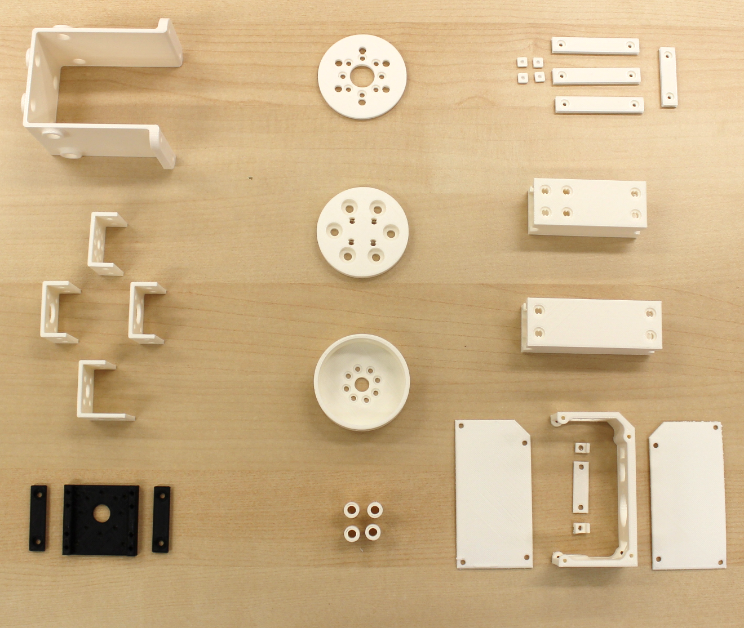

Standoff - 15mm_rev2_QTY4

Wrist_Hand_Adapter

Bearing_MX106_adapter_rev2

MX64_Bearing_adapter_rev2

enclosure_all_rev3

1in_tubing_forearm_rev5

1in_tubing_upperarm_rev5

cable_router_kit_QTY8

MX-64_back_QTY3

1in_brackets_QTY4_rev2

Shoulder Bracket_rev3

## Power Harness Cable

***Required Tools:*** Soldering iron

***Required Materials:*** MX series cable, 20 AWG Wire, DIN 8 power supply connector, solder, shrink tubing, electrical tape

***Estimated time:*** 0.5 hours

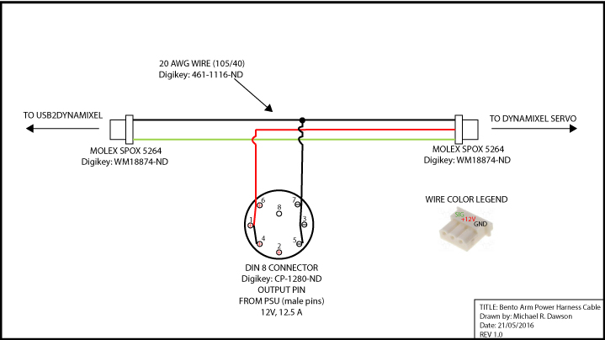

1. The easiest way to construct the power harness cable is to use one of the extra cables that come with the MX series motors
2. Cut the 12V+ power and GND cable in the middle of MX series cable
3. Cut one piece of 20 AWG wire to run to the GND pins on the DIN 8 Connector
4. Slide on heat shrink tubing
5. Solder the three GND wires together in the middle of the cable
6. Slide on heat shrink tubing to 12V+ power and GND wires going to DIN 8 connector
7. Snake the 12V+ power and GND wires into the DIN 8 connector to the appropriate pins as seen in the diagram above.
8. Solder the 20 AWG wire to each adjacent pin in the DIN 8 connector
9. Use a heat gun to set the heat shrink and ensure all exposed wires or connectors are covered. If there are still exposed connections then wrap them in electrical tape

## Dynamixel Servo Horn Assembly

***Required Tools:*** 1mm hex key, 2mm hex key, servo horns (found in servo boxes), label maker

***Required Materials:*** (see table below)

***Estimated time:*** 0.5 hours

1. Label servos ID1 through ID5 according to the following table with the label maker:

|  |  |  |
| --- | --- | --- |
| Arm Function | Servo Type | Servo ID |
| Shoulder Rotation | MX-64AT | 1 |
| Elbow Flexion | MX-106T | 2 |
| Wrist Rotation | MX-28AT | 3 |
| Wrist Flexion | MX-28AT | 4 |
| Chopsticks Gripper | MX-28AT | 5 |

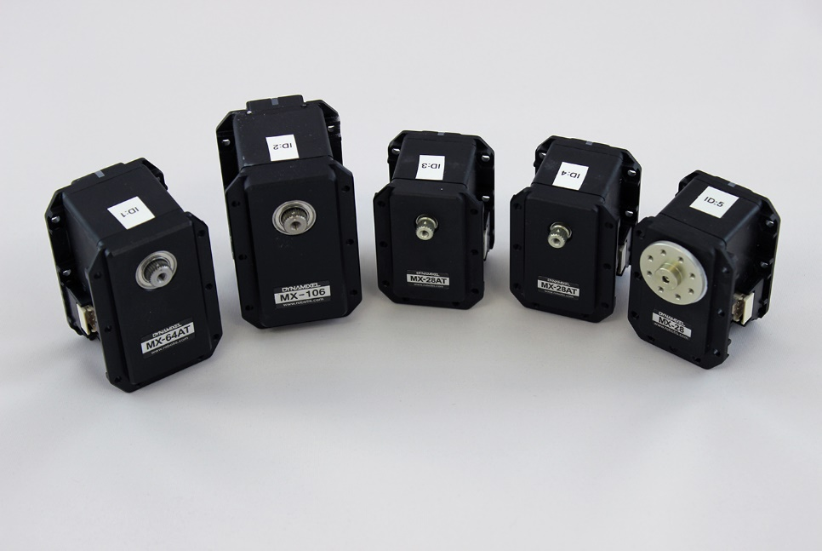

1. Attach servo horns to MX-64AT and MX-106 using hex screw provided

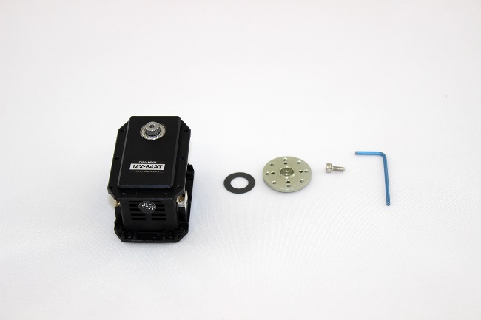

Washer

Screw

Horn

Hex

* 1. Ensure you put on the circular thrust washer **before** putting on the horn
  2. Instructions for how to install servo horn for this servo and all subsequent servos NOTE: THE TICK ON THE SPLINE NEEDS TO LINE UP WITH THE TICK ON THE HORN.

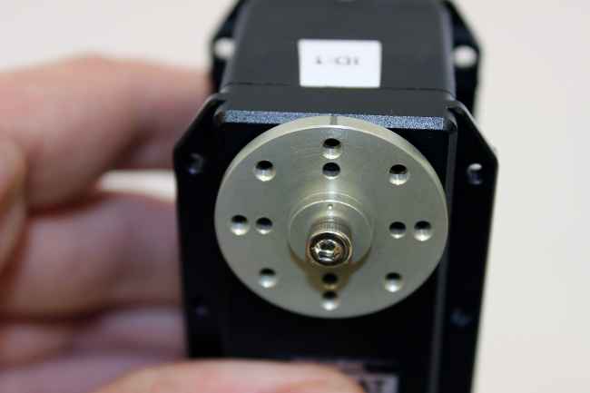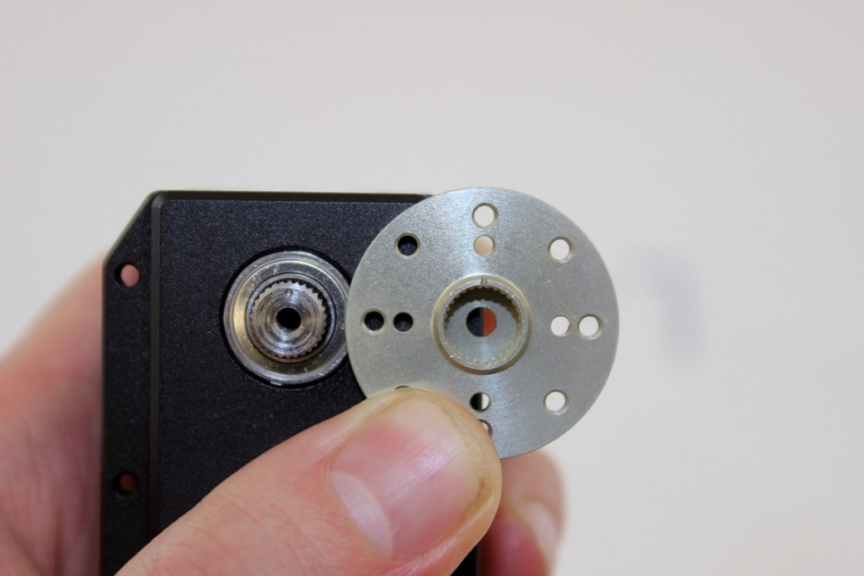

* 1. See following site for additional explanation: [https://forum.poppy-project.org/t/assembly-instructions-take-care-of-the-dynamixel-motorsconfiguration-and-assembly/98](https://forum.poppy-project.org/t/assembly-instructions-take-care-of-the-dynamixel-motors-configuration-and-assembly/98)
  2. Tighten the screw until it is snug or the horn is about 1mm away from the black servo housing
  3. Make a tick on the top of the servo horn with a pencil that lines up with the zero position

1. Attach HN07-N101 servo horn to mx-28 ID3 and ID4 with 1mm hex key. Line up center point on notch with center point on spline.

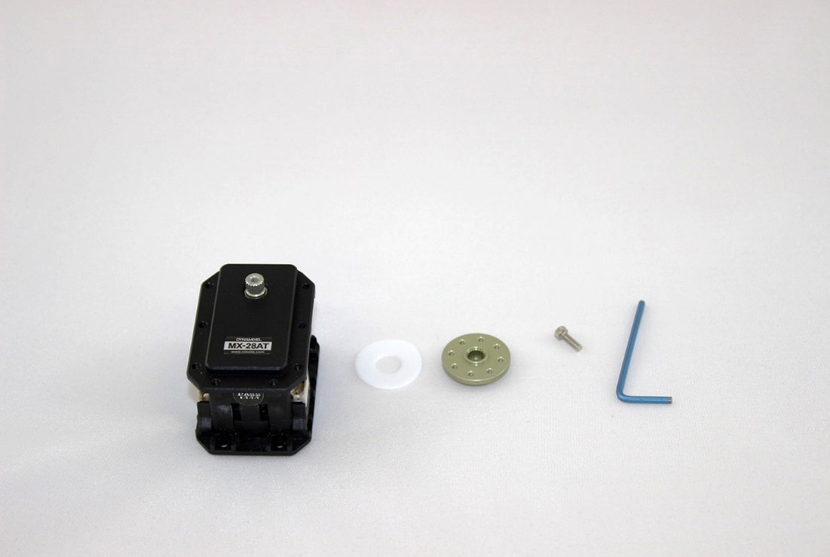

* 1. Ensure thrust washer is placed between horn and housing, with the convex side facing the plastic (away from the horn)
  2. Tighten until snug or horn is approximately 1mm away from housing
  3. Make a tick on the top of the servo horn with a pencil that lines up with the zero position

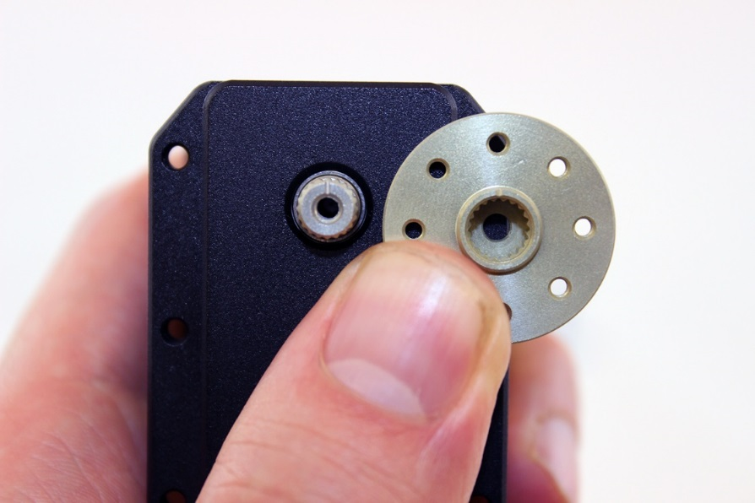

1. Attach HN07-N101 servo horn to MX-28AT for ID:5 using 1mm hex key.
   1. Ensure thrust washer is placed between horn and housing
   2. Tighten until snug or horn is approximately 1.5 mm away from housing
   3. Make a tick on the top of the servo horn with a pencil that lines up with the zero position

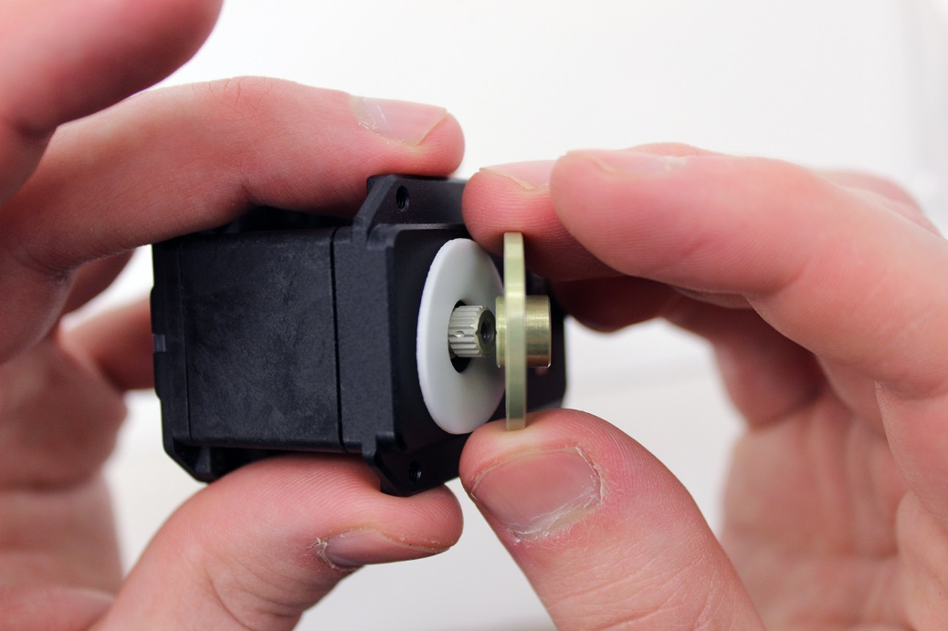

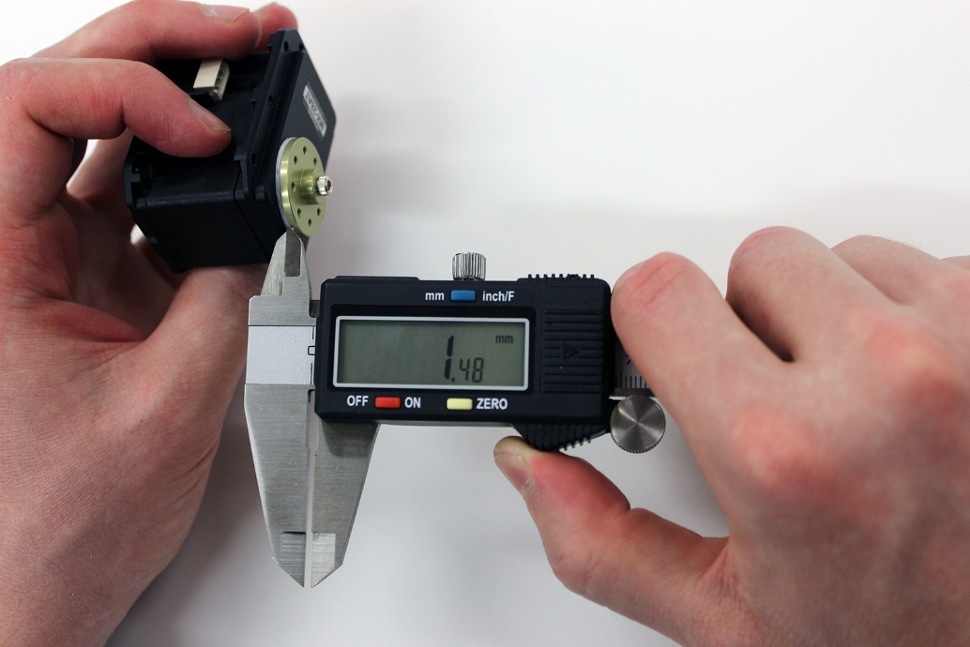

## Dynamixel Servo Programming

***Required Tools:*** Computer with Windows 7 or higher, USB2dynamixel, power harness cable, 12V/12.5A power supply

***Estimated time:*** 0.5 hours

|  |  |  |  |  |  |  |  |
| --- | --- | --- | --- | --- | --- | --- | --- |
| Arm Function | Servo Type | Servo ID | Baud Rate (BPS) | Return Delay Time (microsec) | CW Angle Limit | CCW Angle Limit | Max  Torque Limit |
| Shoulder Rotation | MX-64AT | 1 | 1000000 (1) | 20 (10) | 1028 | 3073 | 225 |
| Elbow Flexion | MX-106T | 2 | 1000000 (1) | 20 (10) | 1784 | 2570 | 300 |
| Wrist Rotation | MX-28AT | 3 | 1000000 (1) | 20 (10) | 1028 | 3073 | 250 |
| Wrist Flexion | MX-28AT | 4 | 1000000 (1) | 20 (10) | 790 | 3328 | 300 |
| Chopsticks Gripper | MX-28AT | 5 | 1000000 (1) | 20 (10) | 1928 | 2800 | 400 |

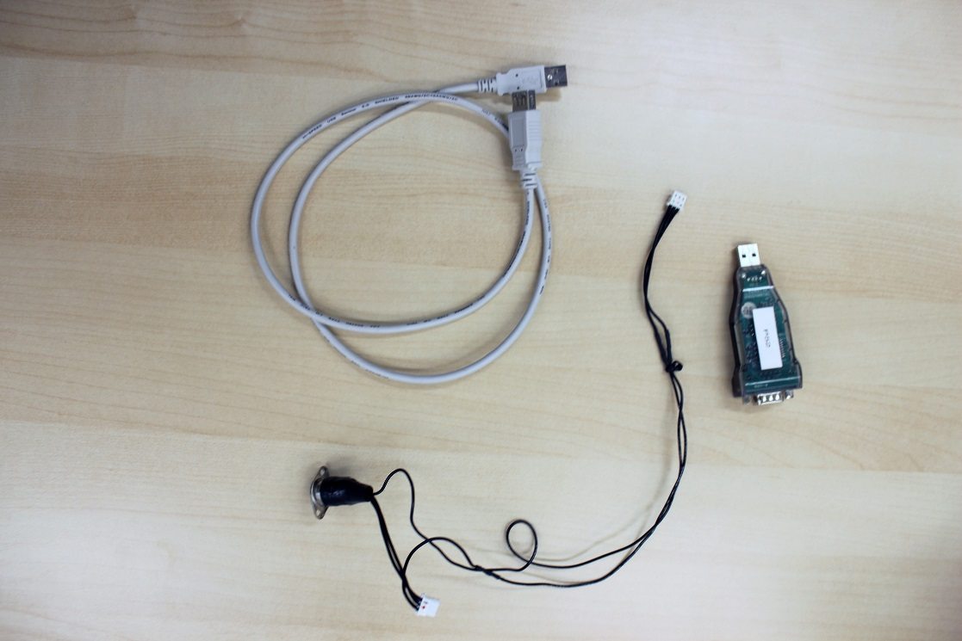

1. Ensure switch on USB2dynamixel is set to TTL

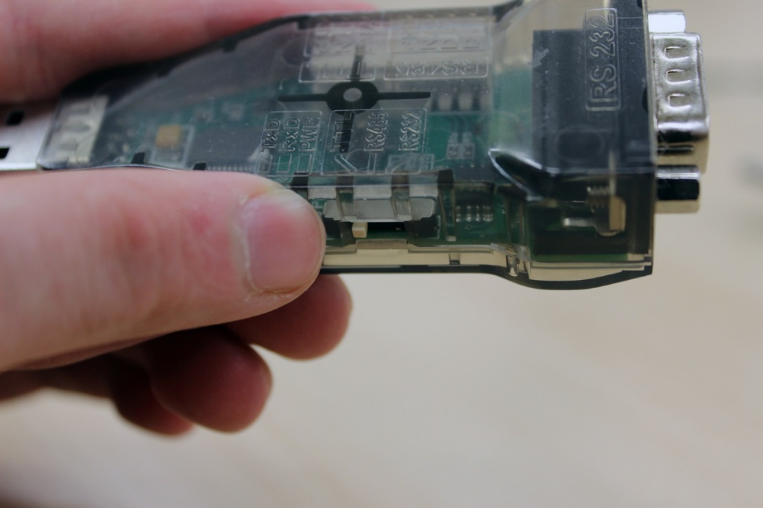

1. Connect USB2dynamixel to a USB port on a computer using a USB extender cable. It is important to plug this in first when setting up and unplug last when taking down.

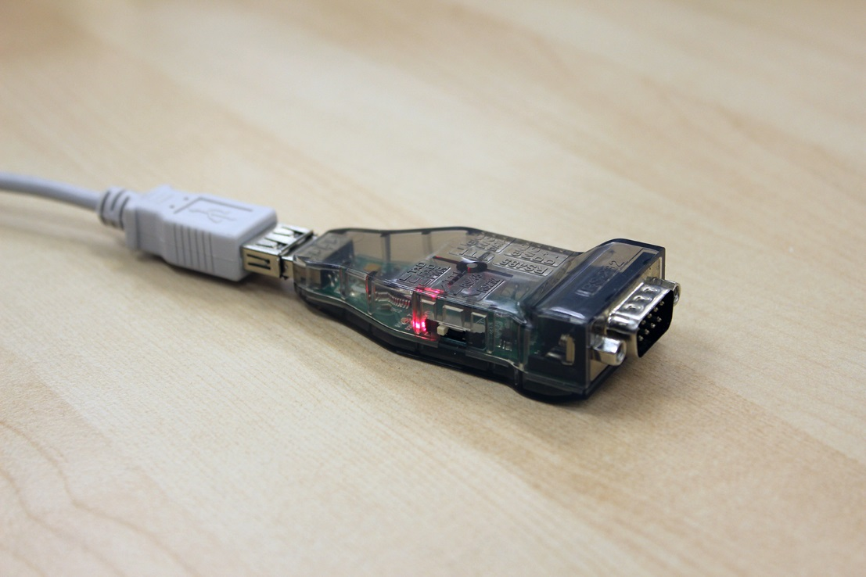

1. Plug the 12V power supply into the power connector of the Bento Arm power harness cable

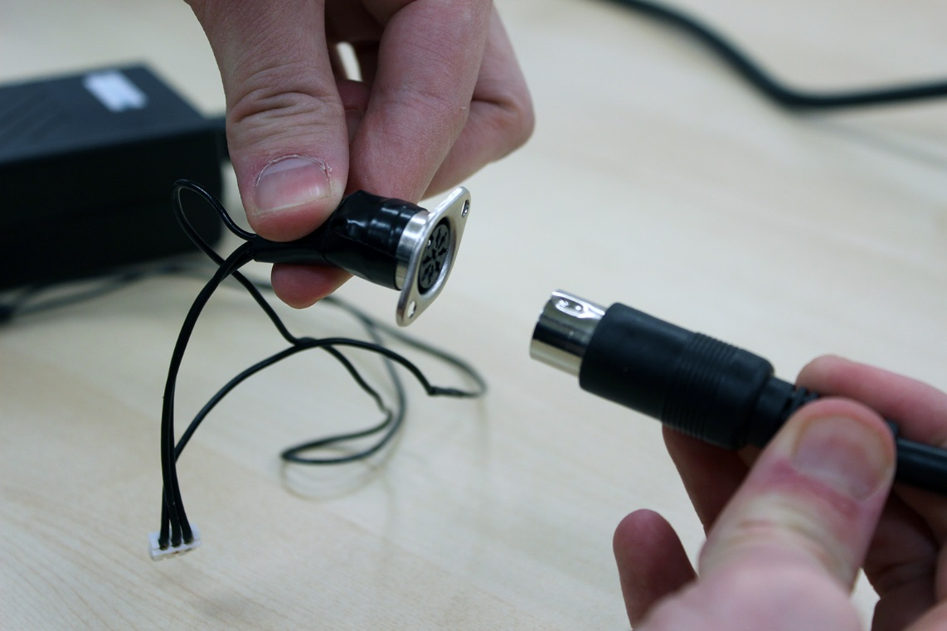

1. Plug the power molex connector (the side with the middle wire connected) of the Bento Arm power harness into the servo that you will be programming (either molex connector on the servo motor will work). The LED should flash briefly indicating that the servo has power.

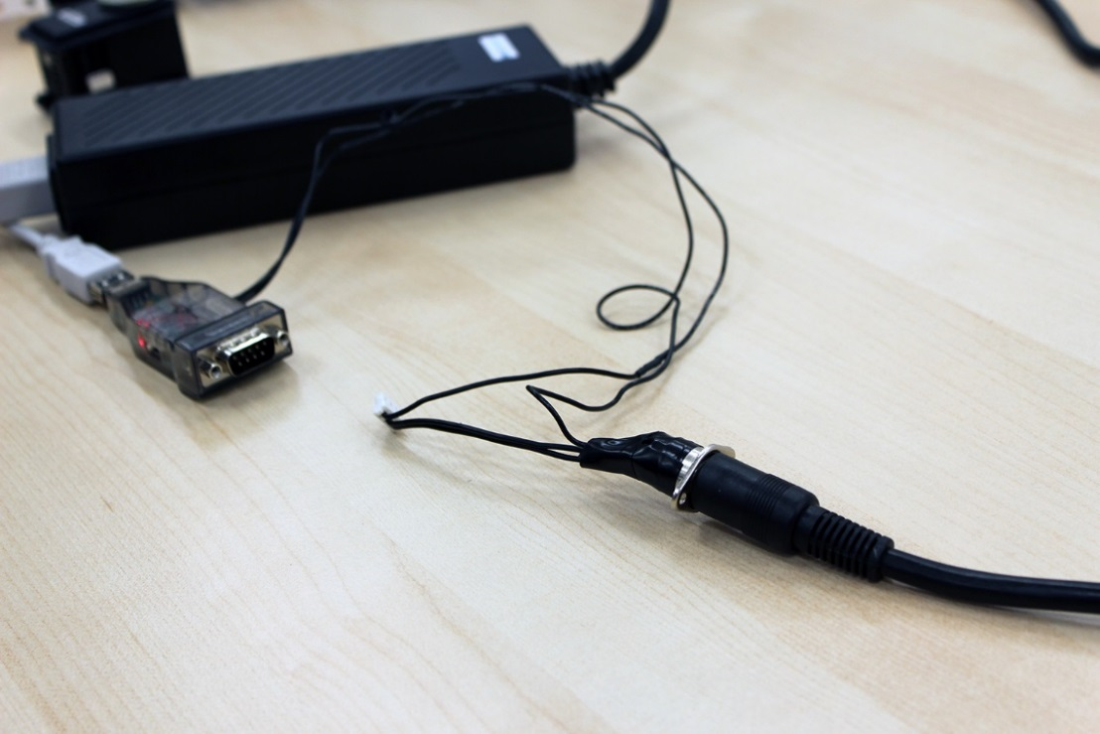

1. Plug the signal molex connector (the side without the middle wire connected) of the Bento Arm power harness cable into the USB2dynamixel. It is important to plug this in last when setting up and unplug it first when taking down.

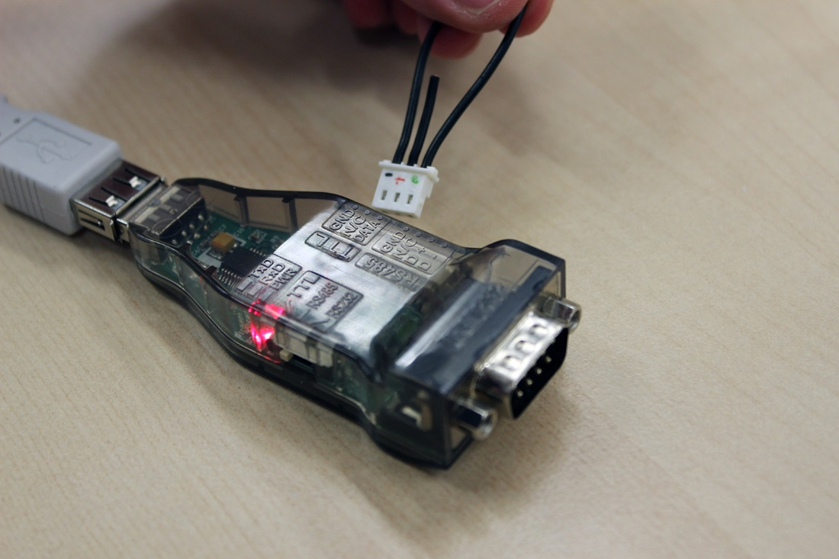

1. Download and install the latest version of the Robotis Roboplus software onto your computer
   1. <http://en.robotis.com/service/downloadpage.php?ca_id=10>
2. Once the software is installed go into Roboplus and open the dynamixel wizard, under the “expert” tab.

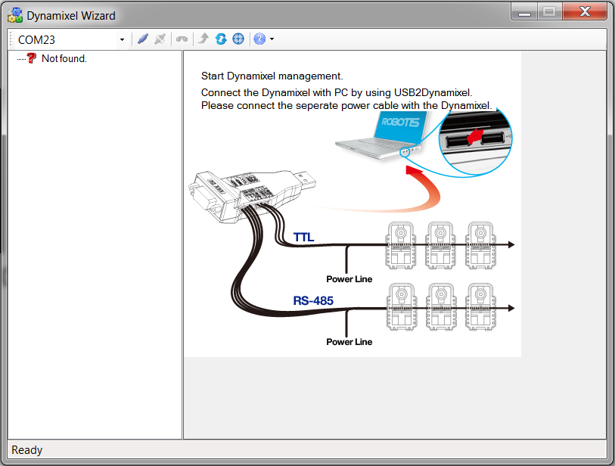

1. Select the com port for the USB2dynamixel and click “open port”

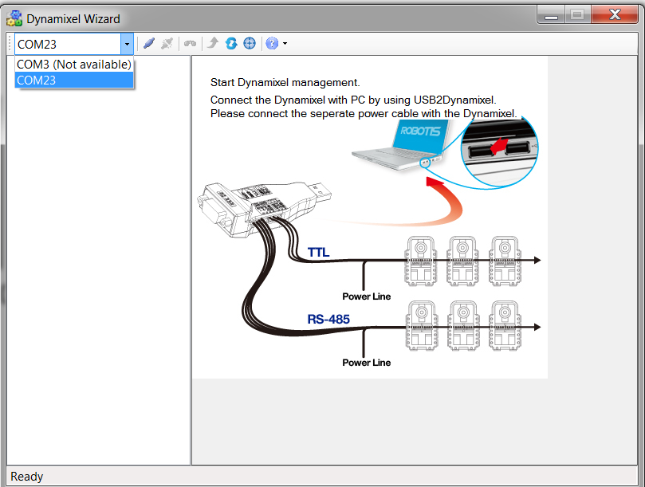

1. In the search settings select 1000000 and 57142 BPS and then click ‘start searching’. These are the most common baud rates that the servos are set to by default

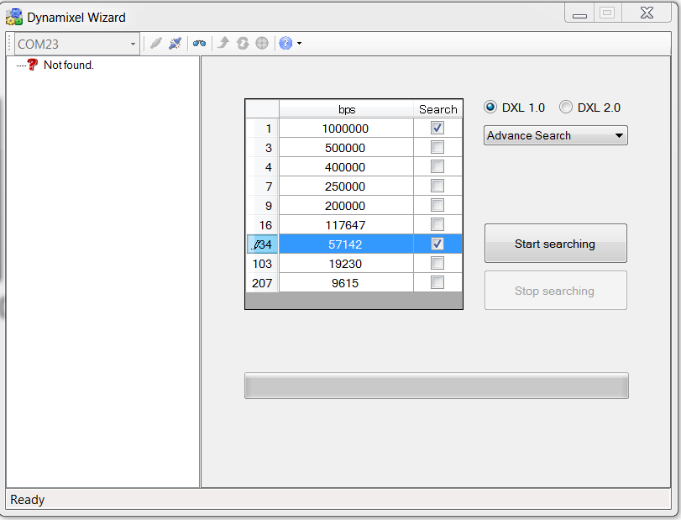

1. The servo that you connected will show up in the left pane. Typically the servos are initialized with ID = 1. Since all dynamixel servos on the bus need to have unique ID numbers you will need to do these steps individually when connecting to the servos for the first time. The parameters that we will change in the servos are defined in the table at the beginning of this section
2. We will setup the servo for the Chopsticks gripper as an example. Here are the default settings:

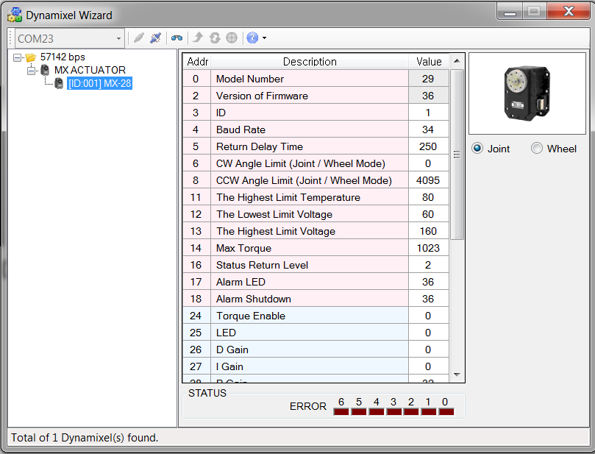

1. Change the ID to 5, baud rate to 1 (1000000 BPS), and return delay time to 10 (20 usec), CW Angle Limit to 1928, and CCW Angle Limit to 2800, and Max Torque to 400. You will need to select the register change the value and then click the ‘apply’ button to make these changes.
   1. **NOTE1**: It is very important to set the CW and CCW limits before you ever connect the servos to another software in order to prevent the servos or brackets from being damaged by moving beyond their range of motion. You can check the range of motion of a given joint or mechanism by manually moving the joint and reading out the max and min positions from the ‘present position’ register.
   2. **NOTE2**: The max torque limits are also an effective way of helping prevent the arm from damaging itself or overloading by pushing too hard into the table or other obstacles. If you want to carry heavier payloads you can increase the elbow and wrist flexion servos to as high as 400 without them overloading, but I think these lower values should work well. I was able to lift two cups and a ball no problem with these torque values. After you change the value in the register it will not be active until you cycle the power on the servo.
2. You can also move the servo in the dynamixel wizard by first setting the moving speed to a reasonably low testing speed such as 80 (9 RPM) and then changing the goal position using the rotational control that is built into the dynamixel wizard. NOTE: it is very important to set the moving speed first otherwise the servo defaults to moving as fast as possible which will increase the chances of causing damage of the settings are incorrect. NOTE: everything in red will save and everything in blue will clear.

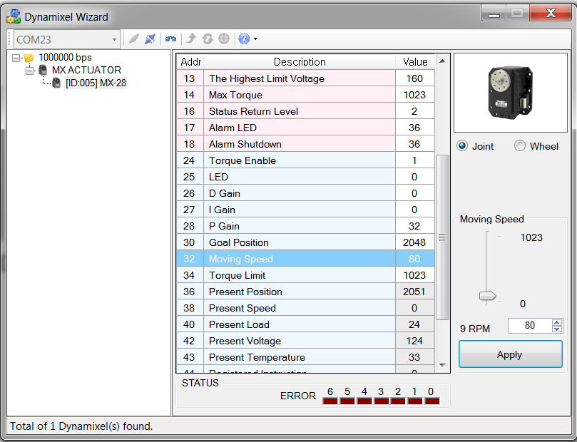

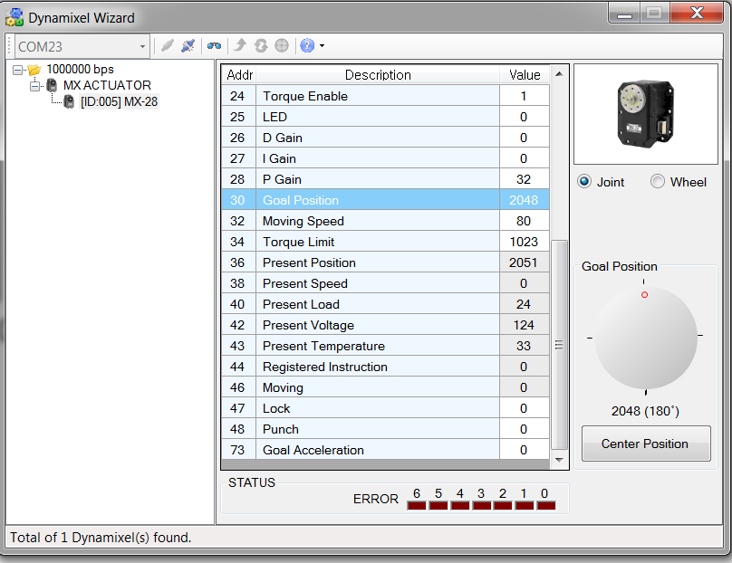

1. Click the “close port” button to be able to search for a new servo motor.

## Part Modifications

This section contains all the modifications required for the arm and gripper.

### Arm Modifications

***Required Tools:*** M4 Tap, M3 Tap, M2.5 Tap, needle file, screw driver

***Estimated time:*** 60 minutes

1. MX-64-back_FR05-B1_rev2
   1. Tap the outer QTY:12 holes with an M2.5 tap or M2.5 screw/screwdriver



1. Shoulder Bracket
   1. Tap M4 holes with M4 tap or M4 screw/screwdriver
   2. NOTE: the screw/screwdriver option works best for this step

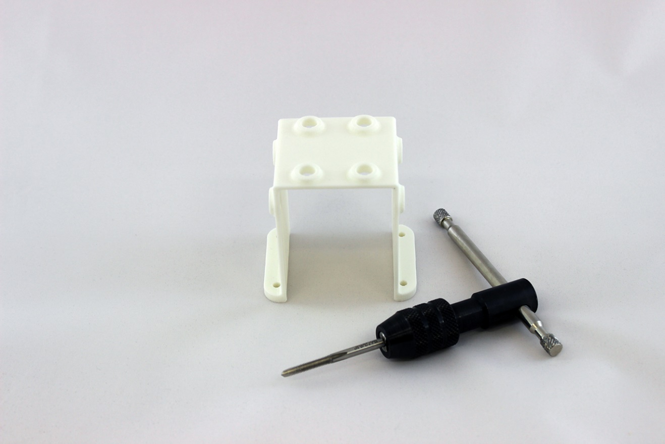

1. Cut down M4x30mm, QTY: 4, to 27mm thread length with metric bolt cutters (you might need someone strong to do this)
   1. Before cutting the screw, thread on a nut as seen below in the picture.
   2. After cutting remove the nut to help reform the threads

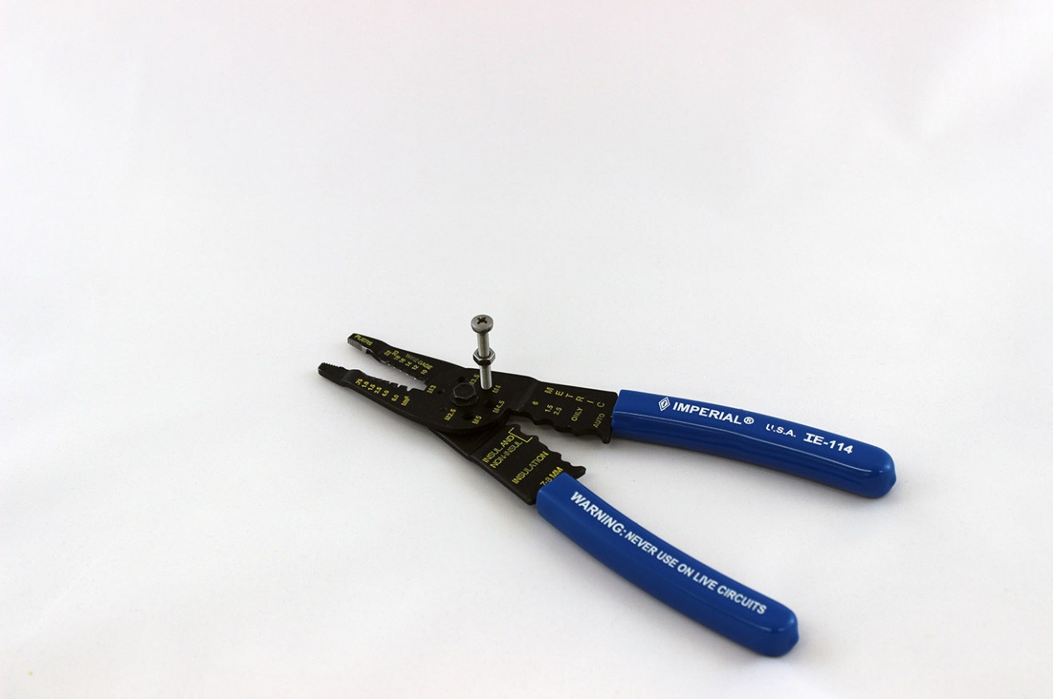

1. MX64 - Bearing Adapter (The thick circular part )
   1. Remove extra filament from inner 4 holes using a needle file
   2. Insert QTY:4 M3 threaded inserts with flange (McMaster 94510A240) into QTY:4 inner 4 holes using a drill press vice
      1. Ensure notches in 3D printed holes line up with the notches in the metal inserts and that the flange of the inserts goes into the side of the adapter with the counterbores on the inner holes
      2. Press insert in with your thumb as far as possible, making sure the inserts are going in straight and aren’t crooked. NOTE: this may not work easily, depending on tolerances. The main purpose is to align the inserts so that they are straight.

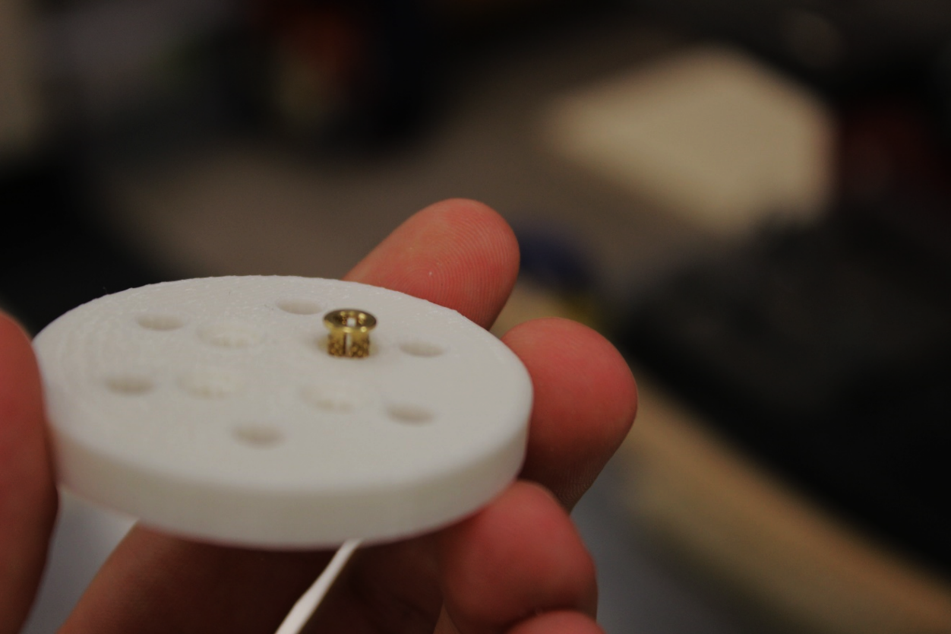

1. Whether you were able to get the insert started or not the next step is to screw in a flat head M3 Screw (such as McMaster 91420A118). It will be used to further press in the insert to make it flush. Do not put the screw in too far or you could crack the insert. 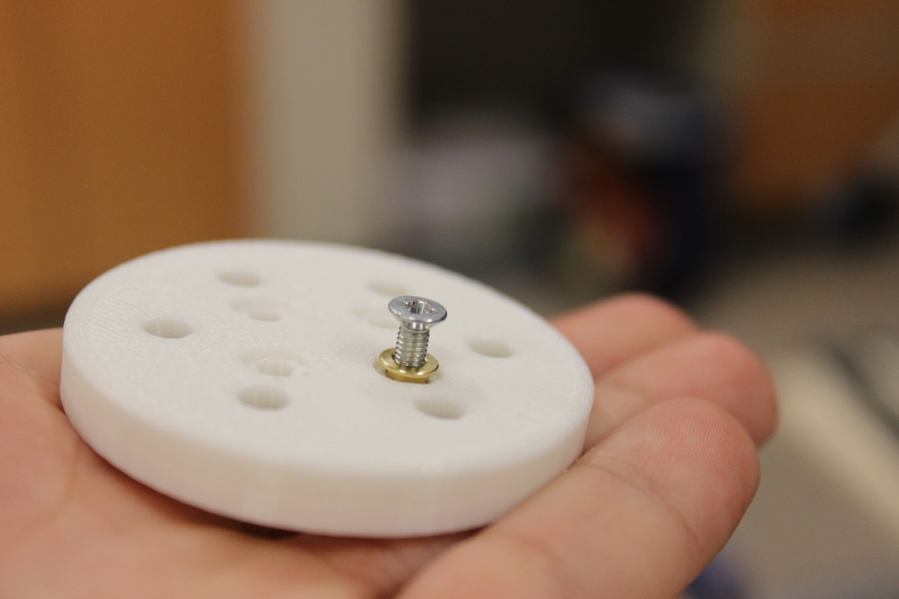
2. Then using a metal vice, place the adaptor with the insert into it. Use paper on either side to make sure the white 3D printed piece does not get dirty.

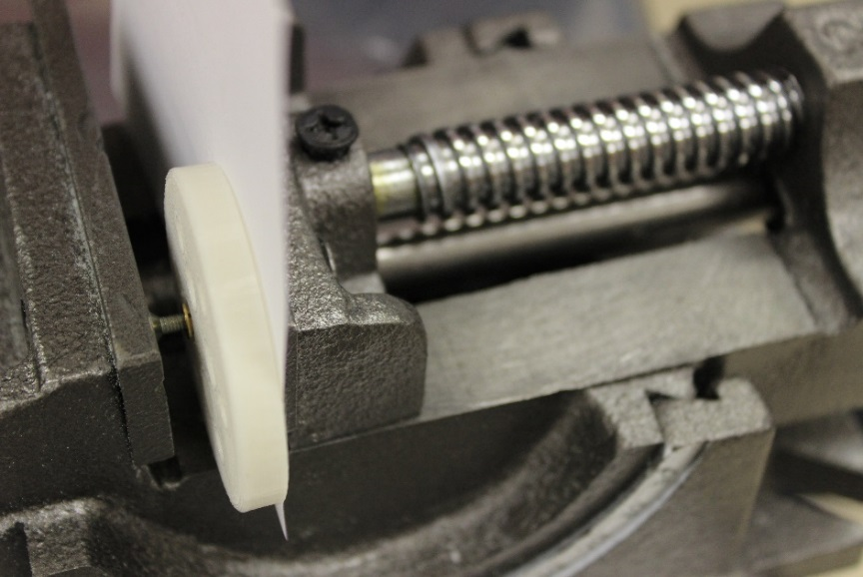

1. Press it in a little at a time checking several times to make sure it is not crooked. If it starts getting crooked apply more pressure on one side and make small adjustments. It often won’t self-adjust if you keep pressing it in flat. Only keeping pressing it in until the insert becomes flush with the 3D printed part. Do not go too far or you may break the insert’s flange.
2. Once it is flush you can remove the screw and it should look similar to the following images:

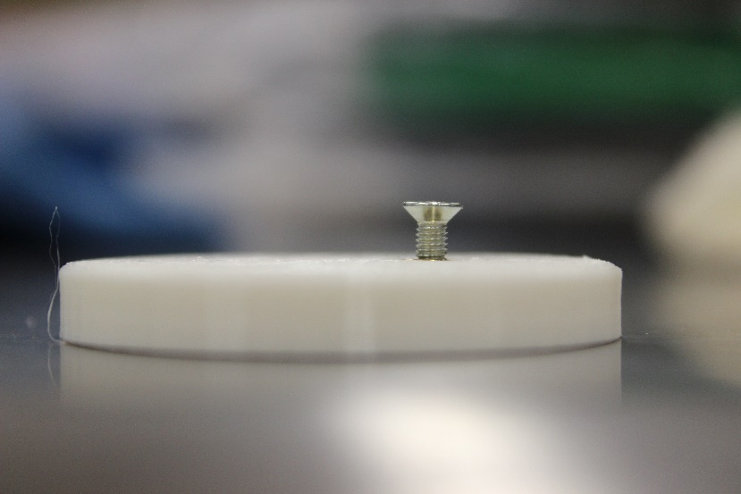

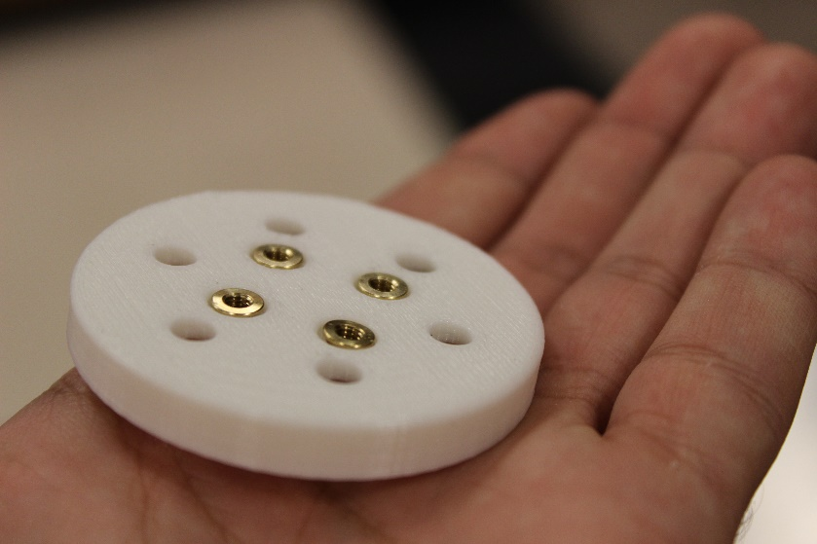

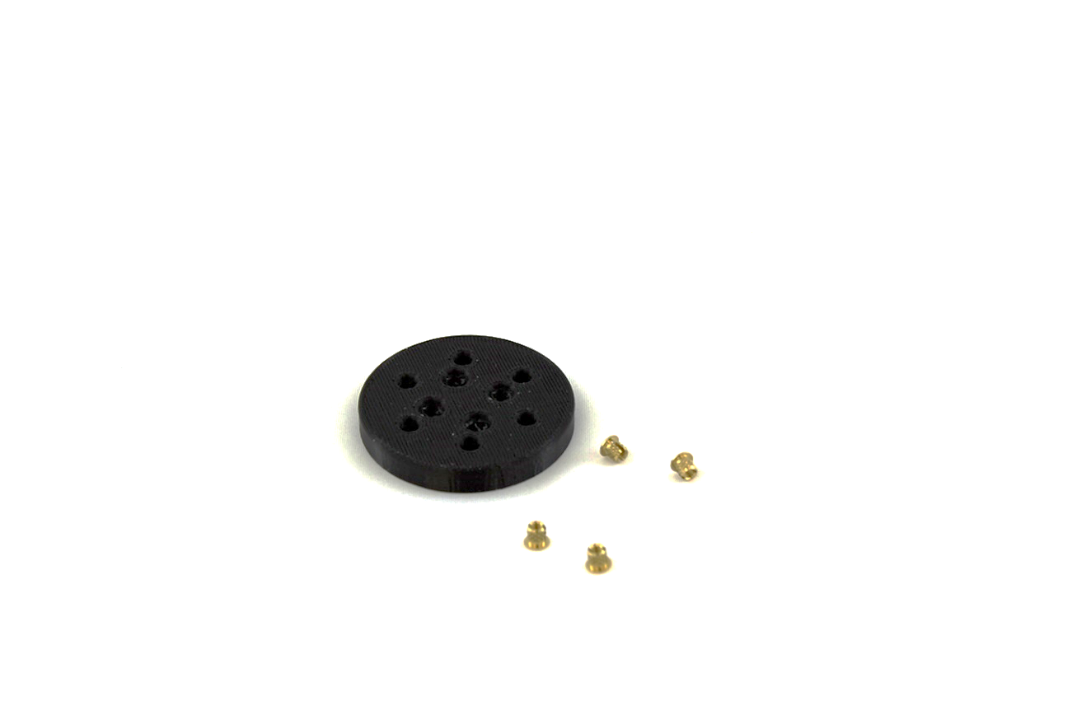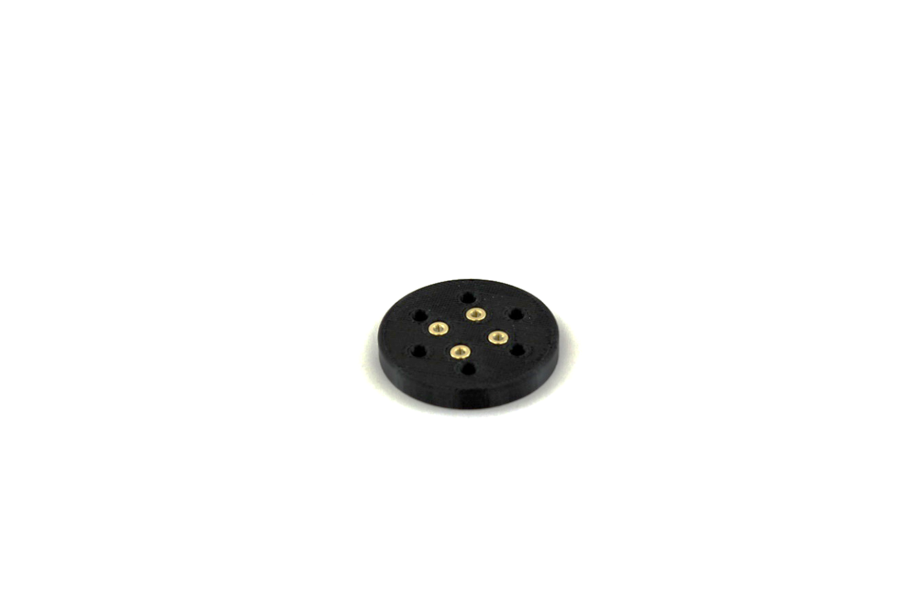

1. Square tubing upperarm
   1. Insert QTY:10 M3 threaded inserts with flange (McMaster 94510A240) into QTY:10 holes using a drill press vice as shown previously.

TIP: Try to run this like an assembly line. Get all the inserts in with the first vice and then once they are all almost in use the screw and second vice to push each in extra all at once.

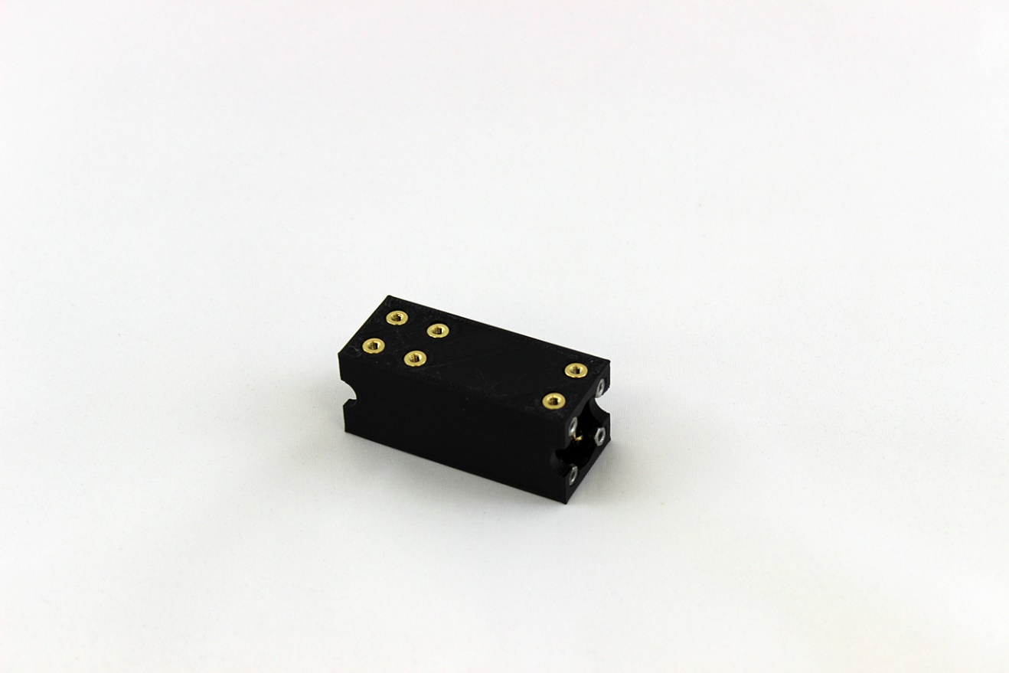

* 1. Apply gel super glue to the hexagon slots on the one end of the tube and insert QTY: 4 M2.5 nuts. Allow the glue to dry for at least an hour before starting assembly of the arm.

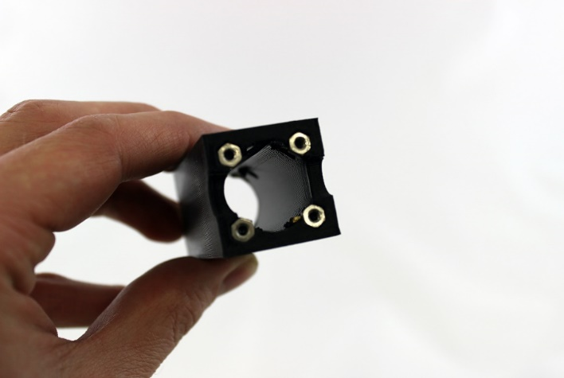

1. Square tubing forearm
   1. Insert QTY:8 M3 threaded inserts with flange (McMaster 94510A240) into QTY:8 holes using a drill press vice

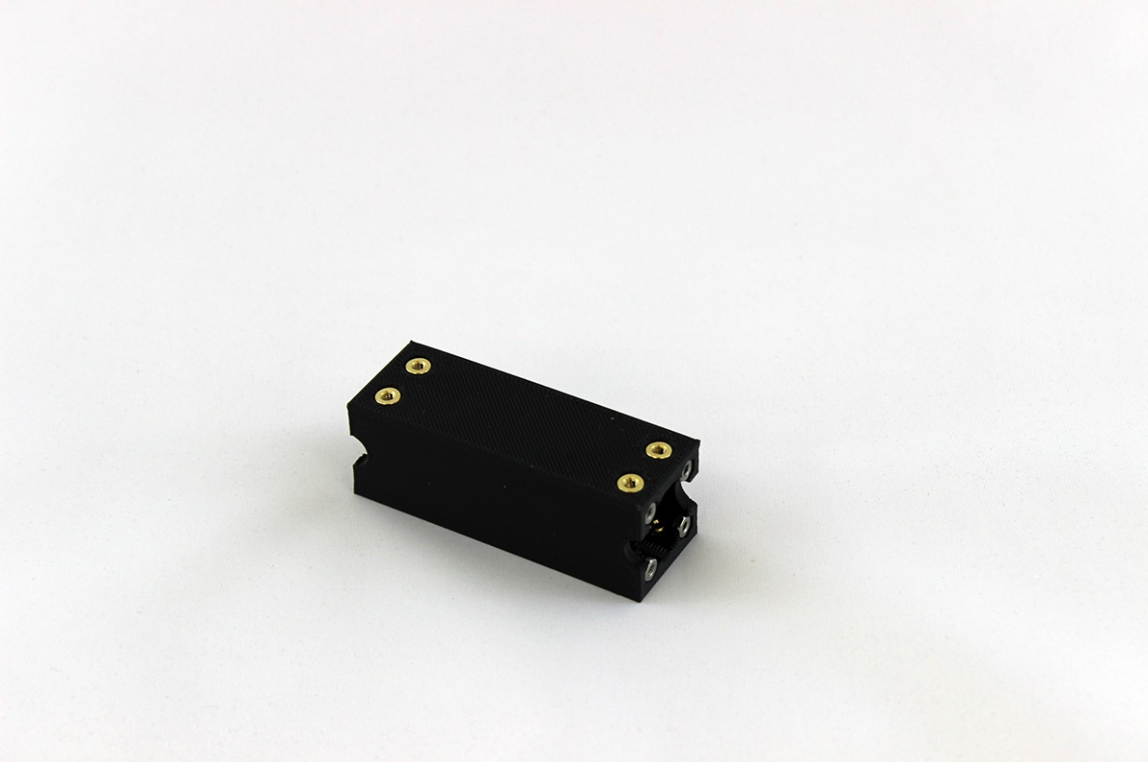

* 1. Apply gel super glue to the hexagon slots on the end of the tube that will face the elbow and insert QTY:4 M2.5 nuts. Allow the glue to dry for at least an hour before starting assembly of the arm.

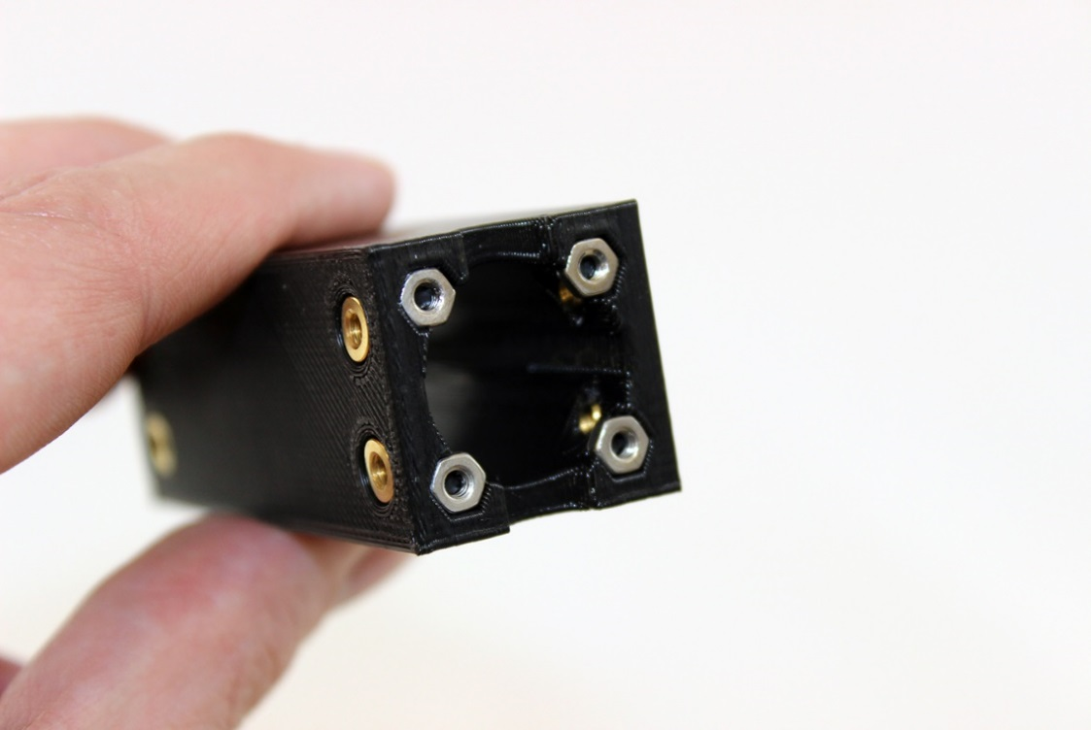

1. Wrist hand adapter
   1. Tap M3 holes using M3 tap or M3 screw/screwdriver
   2. Cut down M3’s to 3.4mm length QTY:4. They can be flat head screws or hex nut and they can be black or silver.

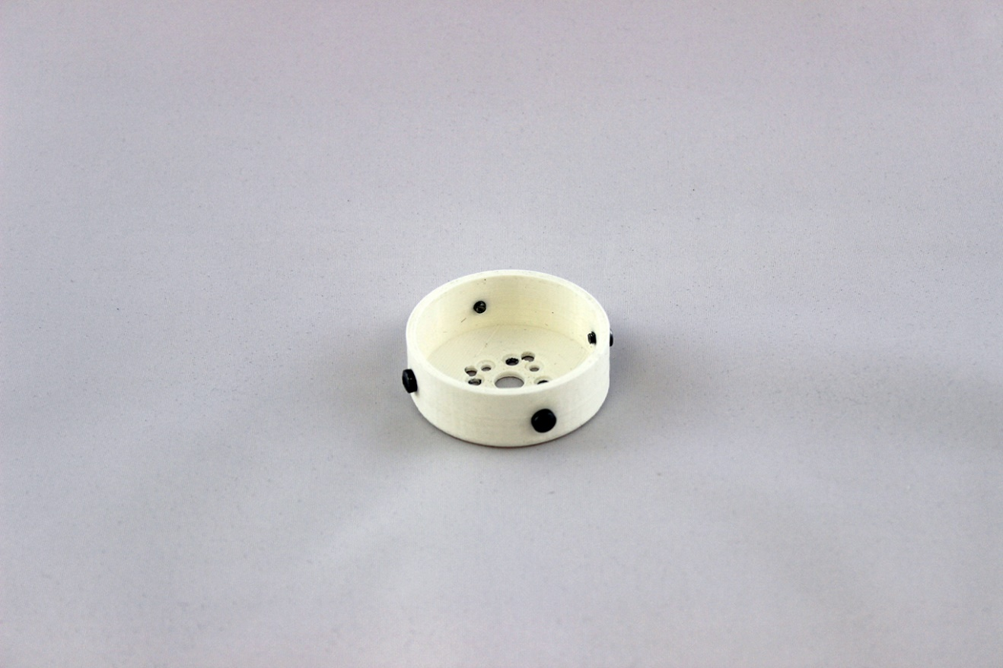

### Hand Modifications

***Required Tools:*** M3 screw (for tapping into plastic), needle pliers, screw driver, gel super glue

***Estimated time:*** 30 minutes

1. Chopsticks_hand_adapter
   1. Tap the outer QTY:4 holes with an M3 tap or M3 screw/screwdriver

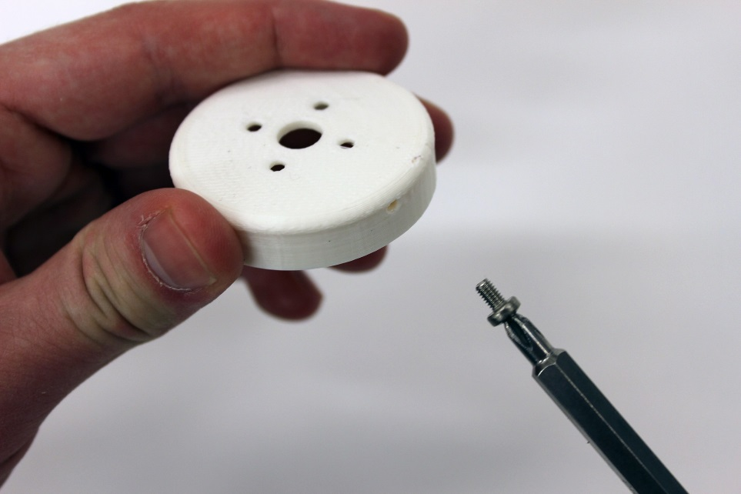

1. QTY:2 chopsticks_sidebottom_bracket
   1. Tap the bottom QTY:4 holes with an M2.5 tap or M2.5 screw/screwdriver

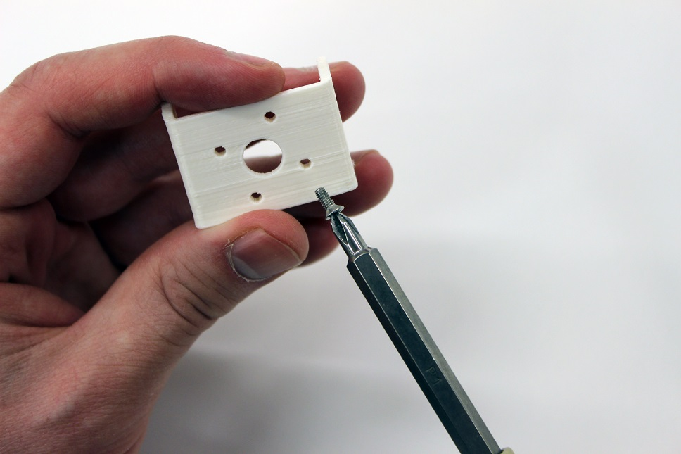

1. Chopsticks_flex_bracket
   1. Tap the bottom QTY:4 holes with an M2.5 tap or M2.5 screw/screwdriver

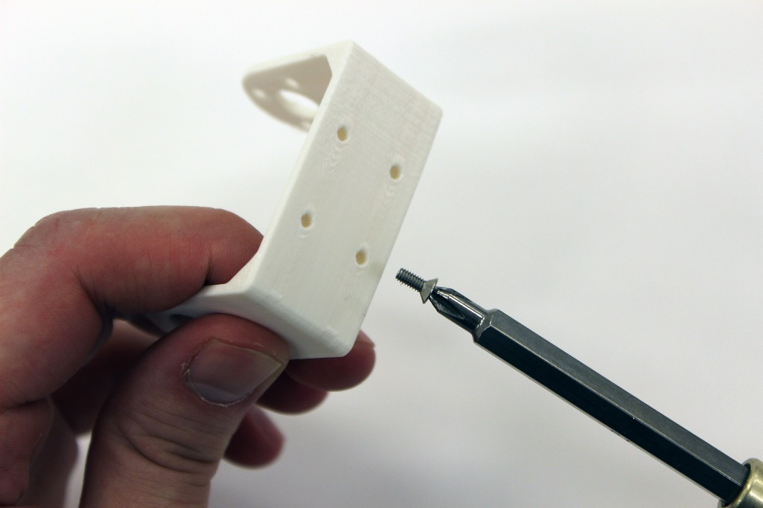

1. Use fixed_plate to trace outline on adhesive rubber. Use scissors to cut out QTY:2 rubber pieces that will be used on the fixed and moving plates.

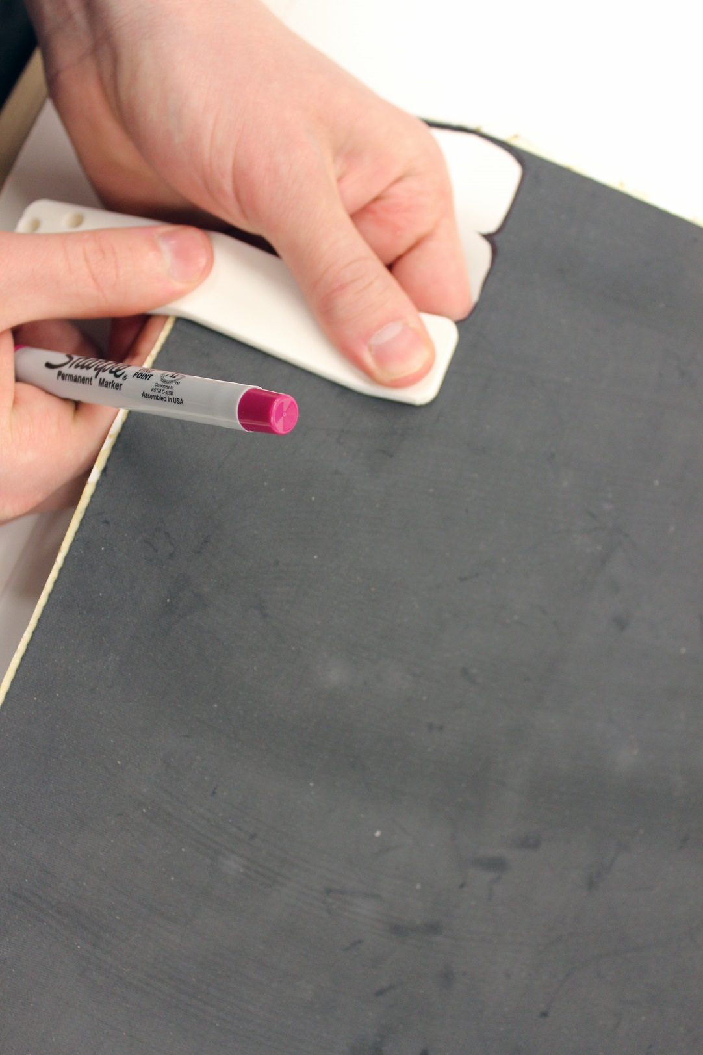

## Arm Assembly

***Required Tools:*** label maker, 2mm Hex key, #1 Drive Phillips Screwdriver, #2 Drive Phillips Screwdriver, needle nose pliers, crimping tool

***Required Materials:***

***Estimated time:*** 3 hours

***NOTE***: Steps where Loctite 220 thread locker can be optionally applied to help hold screws in place are marked with (LT). We recommend not adding the Loctite until you have assembled the arm all the way through at least once and are confident in the correct orientations of each part.

1. Attach QTY:2 MX-64_8020_adapter to FR05-B1 bracket with QTY:4 M2.5x6mm screws (flat head) from MX-64 screw pack.

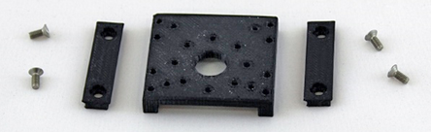

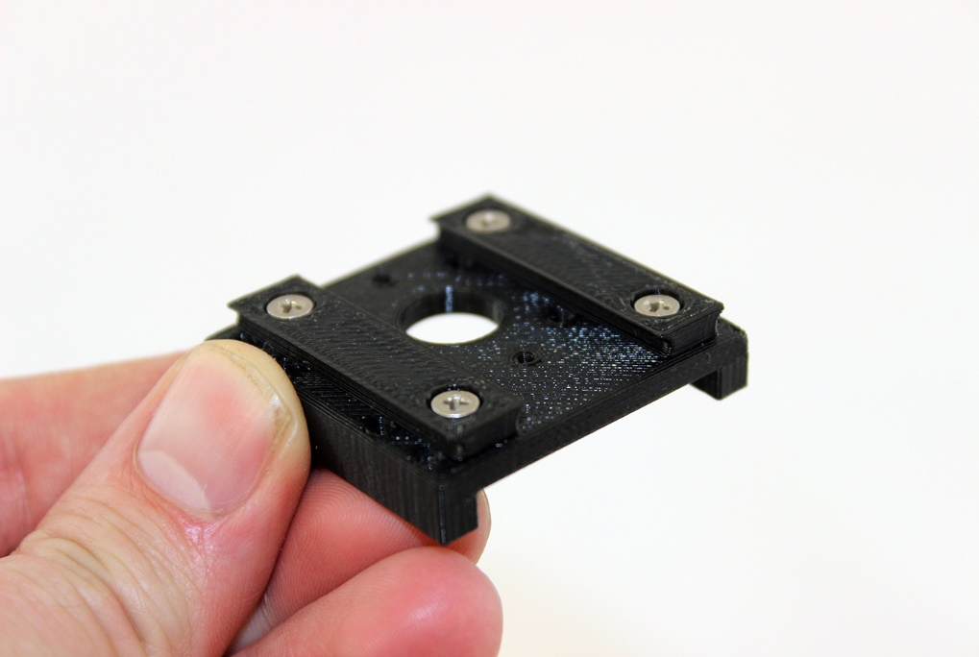

1. Attach FR05-B1 bracket to MX-64AT servo ID1 using QTY:4 M2.5 10mm length

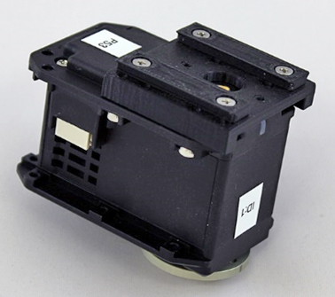

1. Attach MX64_bearing_adapter to servo horn using QTY:8 M2.5x6mm screws in star pattern (LT)
   1. Make a tick mark lining up with the neutral position on the MX64_bearing_adapter. This position is very critical or the arm will not work later on. You want the top open hole to line up with screw below it.

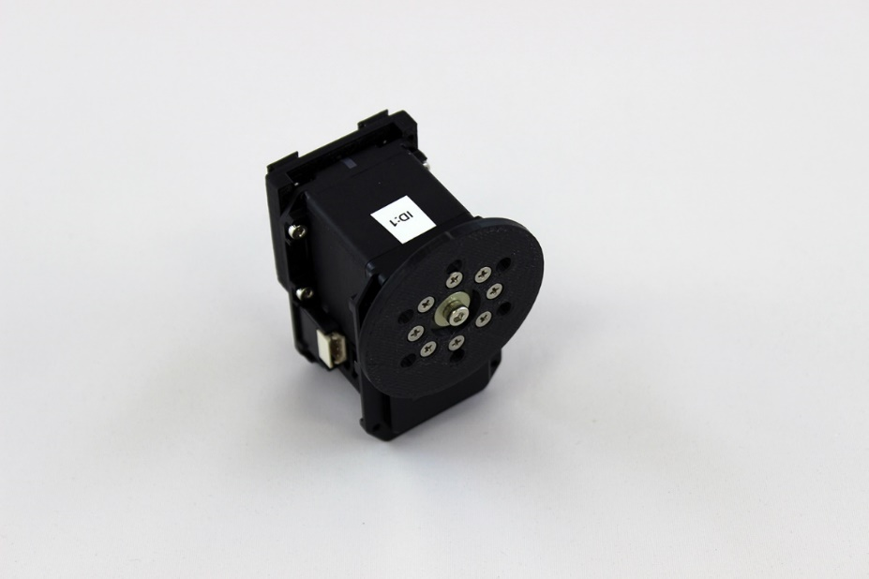

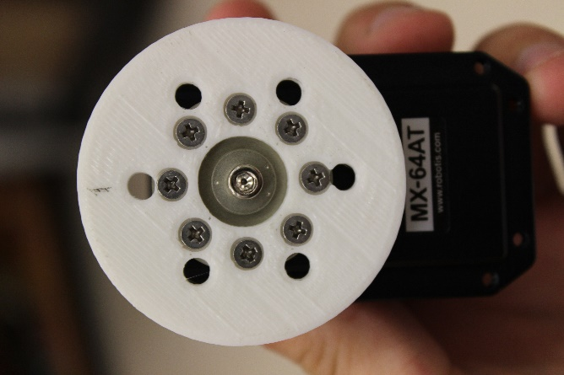

Tick mark

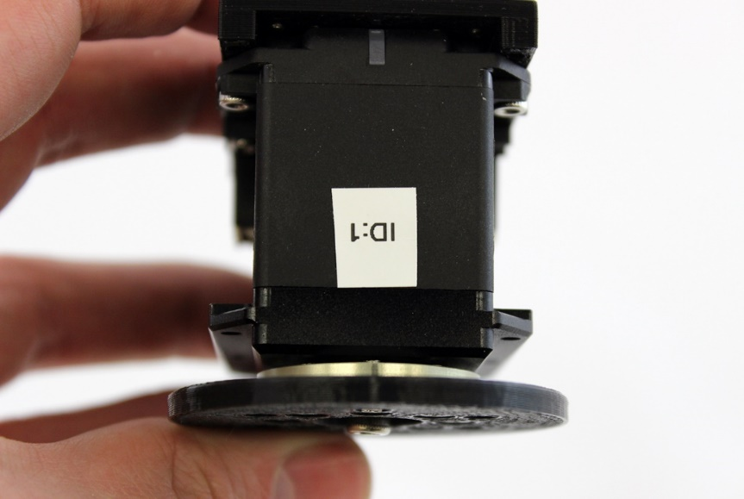

1. Attach bearing_MX106_adapter to bearing with QTY:3 M4x29mm screws (LT). NOTE: If you add the optional Loctite on this step be sure to only add it for about 2mm along the thread otherwise if you add too much it can be very difficult to disassemble.
   1. Make a mark with pencil on both sections of bearings indicating which direction will be the centered position for the MX-64AT servo

NOTE: In the second photo the brass insert holes should be perpendicular. If they are off axis then the adaptor has been put on slightly askew.

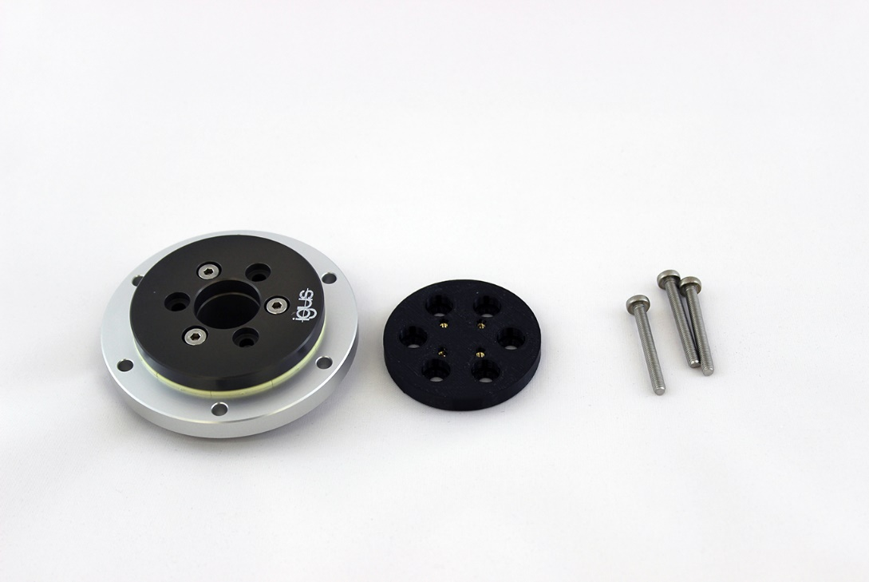

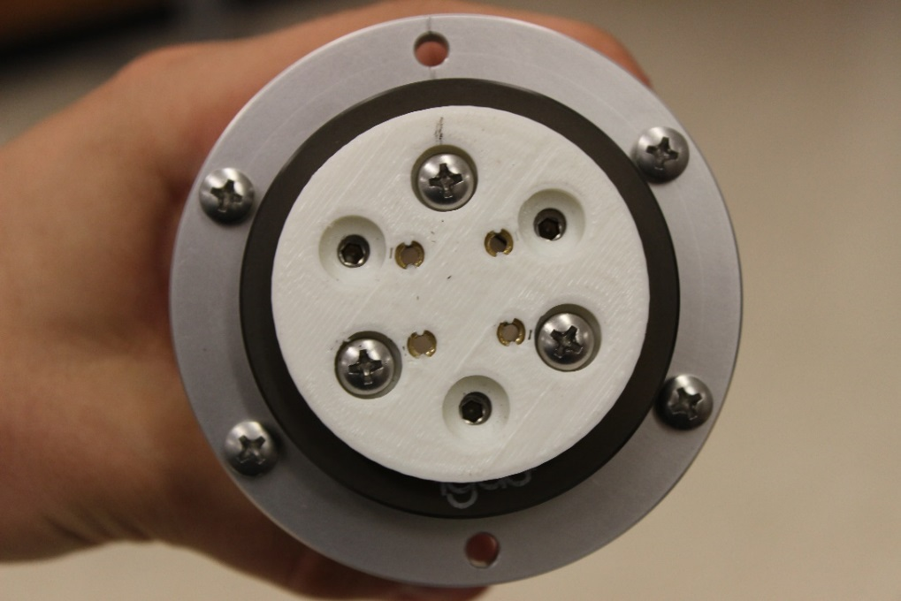

Tick marks

3 screws

1. Slide M4 screws coming through bearing into MX64_bearing_adapter. Ensure that the orientation of the center mark of the servo horn is aligned to the inner hole pattern on the bearing_MX106_adapter. The motor **does not** attach to the bearing and it should freely rotate. Be careful not to drop the motor for the rest of the procedure.

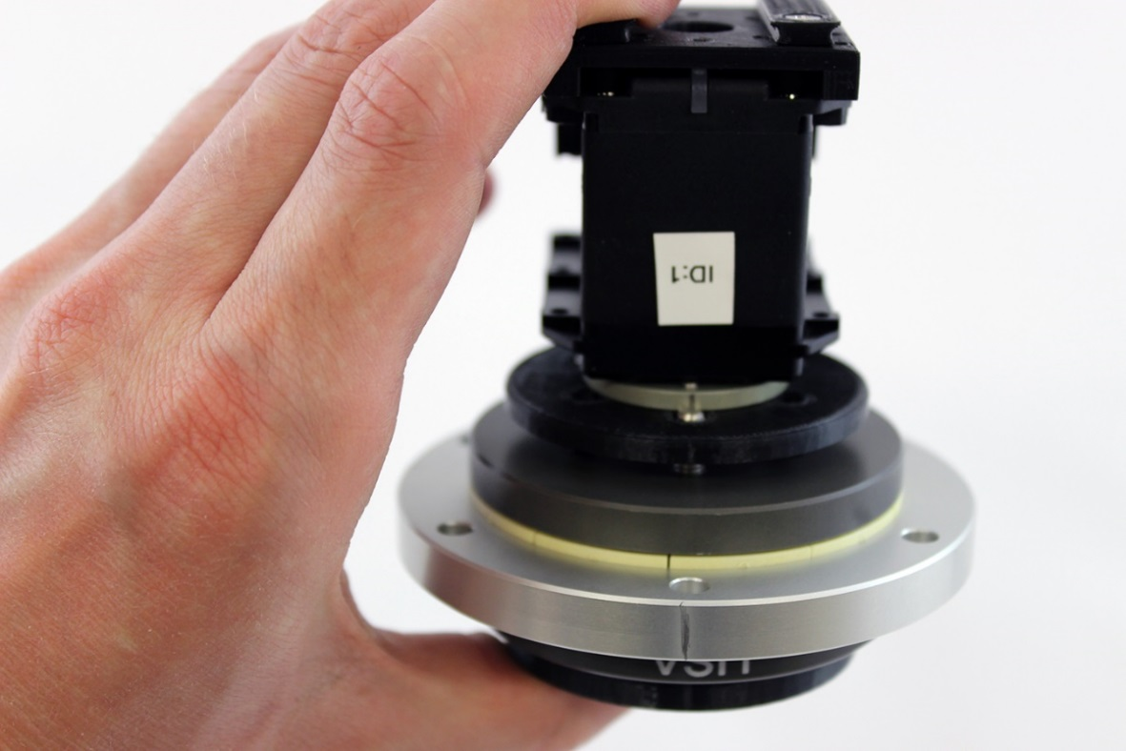

1. Attach Shoulder_Bracket to outer part of bearing using QTY:4 M4x27mm screws with 15mm standoffs between the bracket and the bearing.

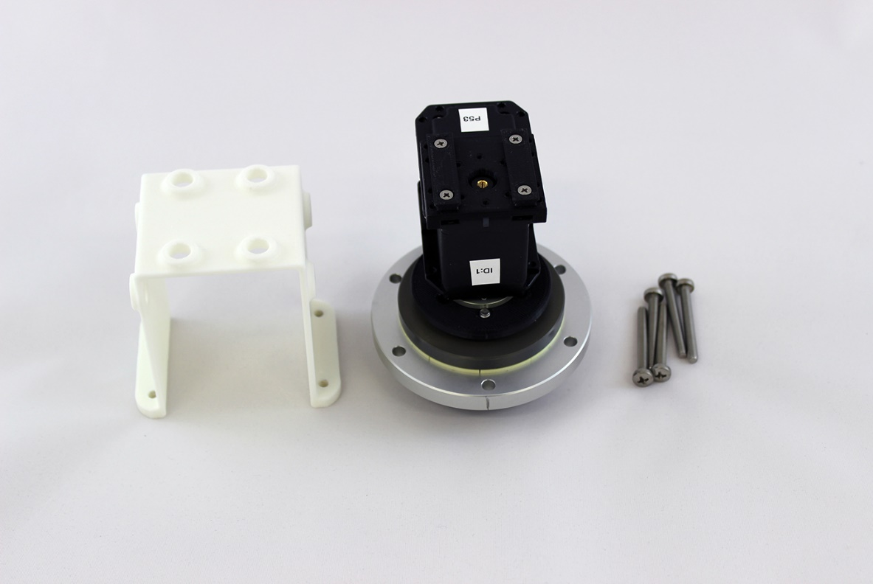

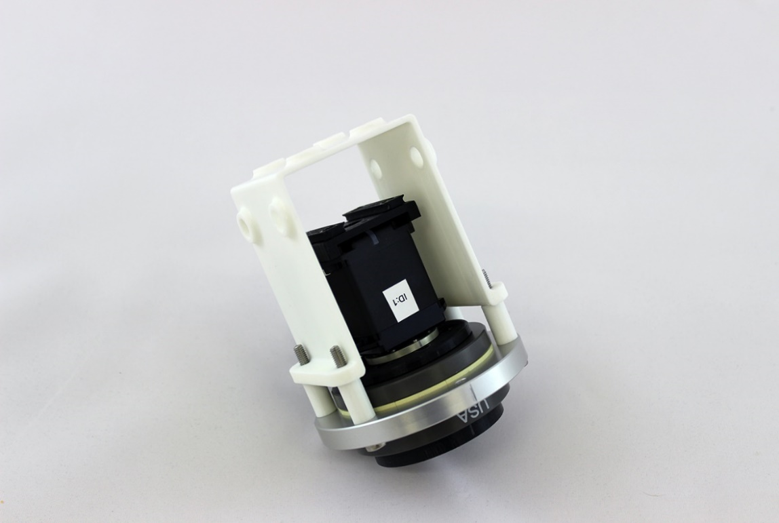

Stand Offs

1. Attach 1in_square_tubing_bracket_A to Bearing_MX106_Adapter using QTY:4 M3x8mm phillips screws and QTY:4 M3 washers to help distribute the load (LT).

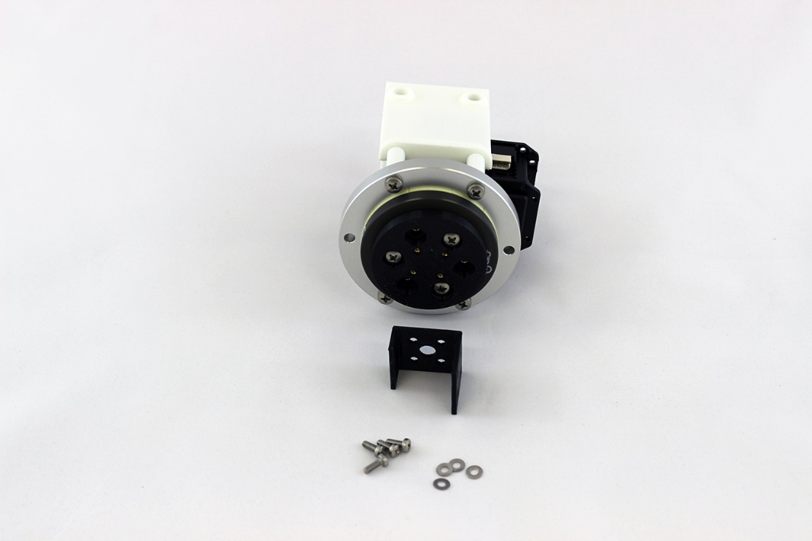

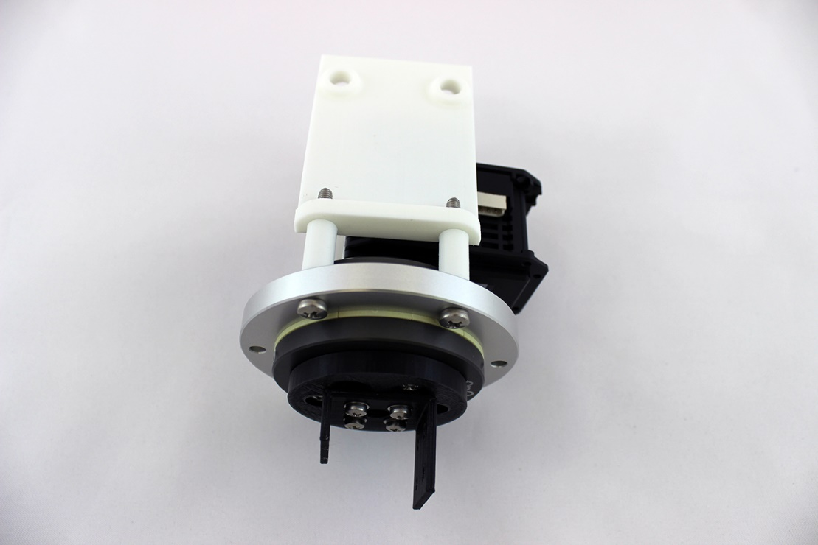

Tick mark on this side

1. Attach 1in_square_tubing_bracket_A to 1in_square tubing upperarm using QTY:6 M3x8mm flat head screws and washers. Tighten until screw is snug against the washer. Do not overtighten or the washer will bend and the magnet arm shells will not fit on properly.

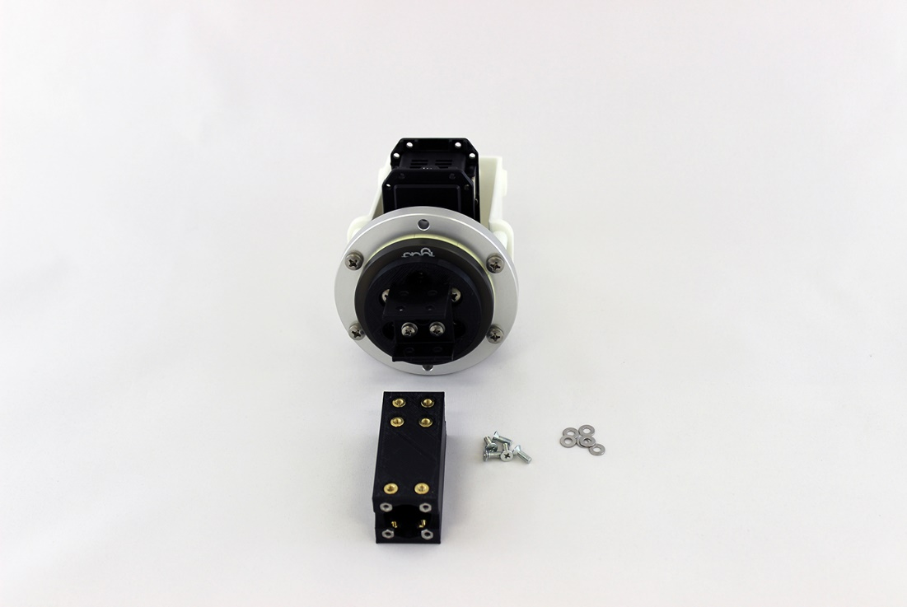

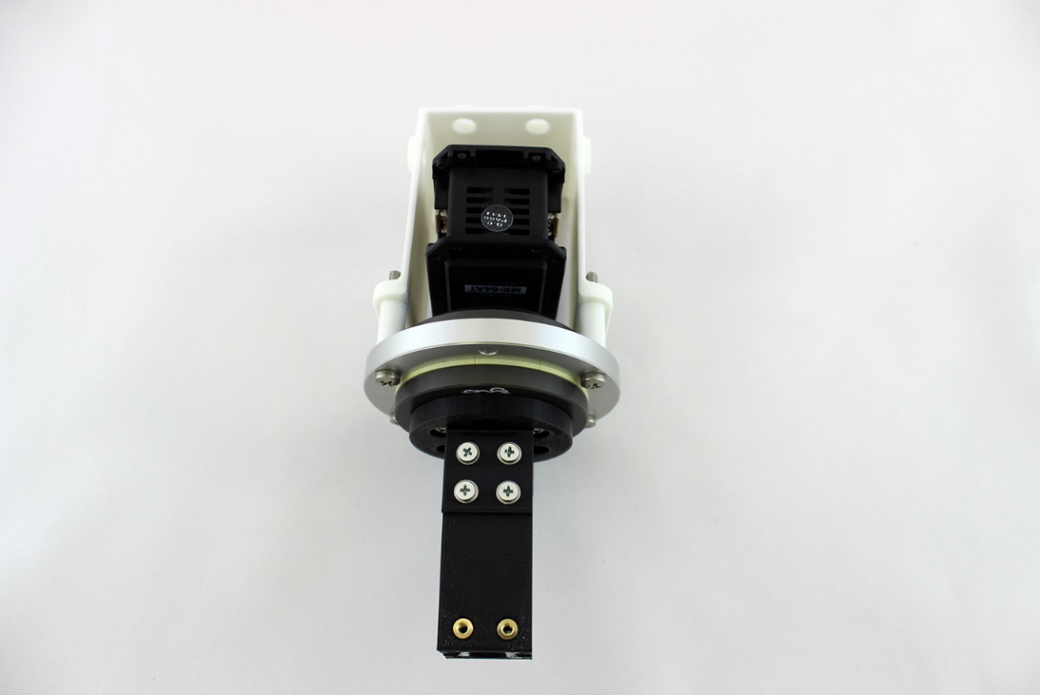

Tick marks are on the opposite side

1. Attach 1in_square_tubing_bracket_B to 1in_square tubing upperarm using QTY:4 M3x8mm flat head screws and washers. Tighten until screw is snug against the washer. Do not overtighten or the washer will bend and the magnet arm shells will not fit on properly.

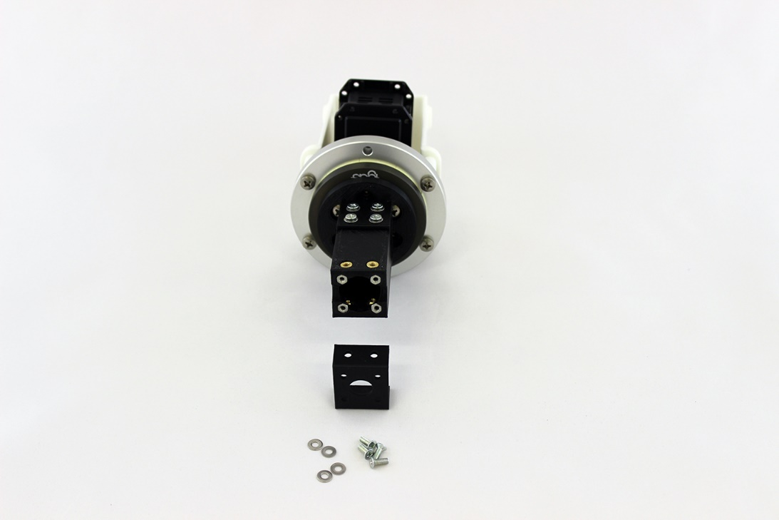 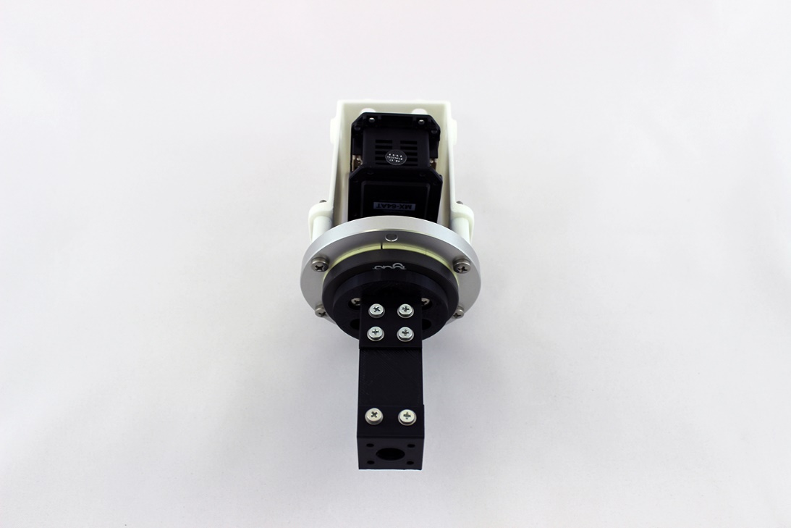

1. Attach MX-106 bottom FR05-S1 bracket to 1in_square_tubing_bracket_B using QTY:4 M2.5x6mm hex head screws that come with the bracket. (LT) Assure the orientation of the brackets are correct. The notch in FR05-S1 should face the center line of the MX-64 shoulder rotation servo

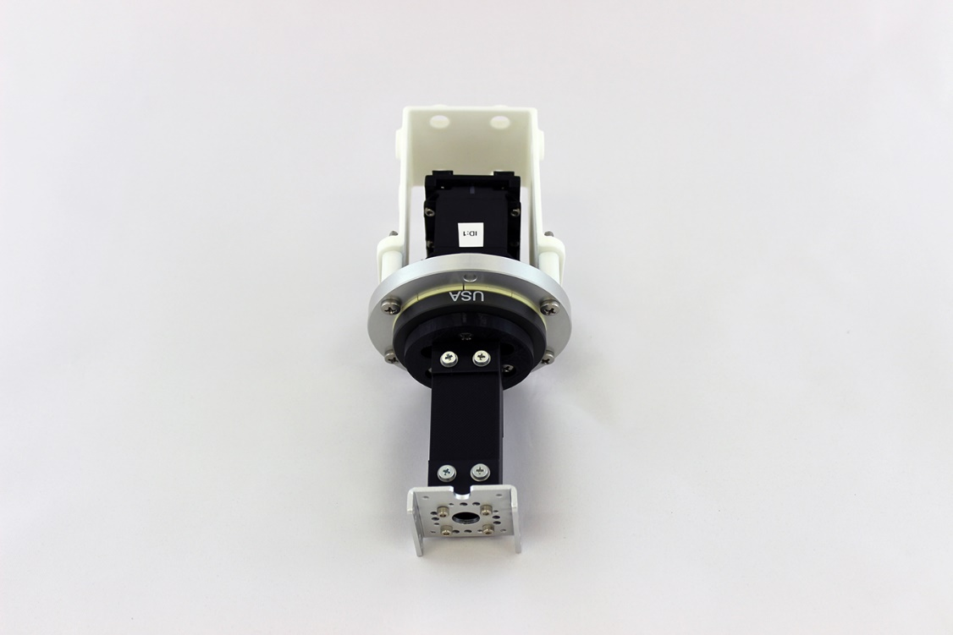

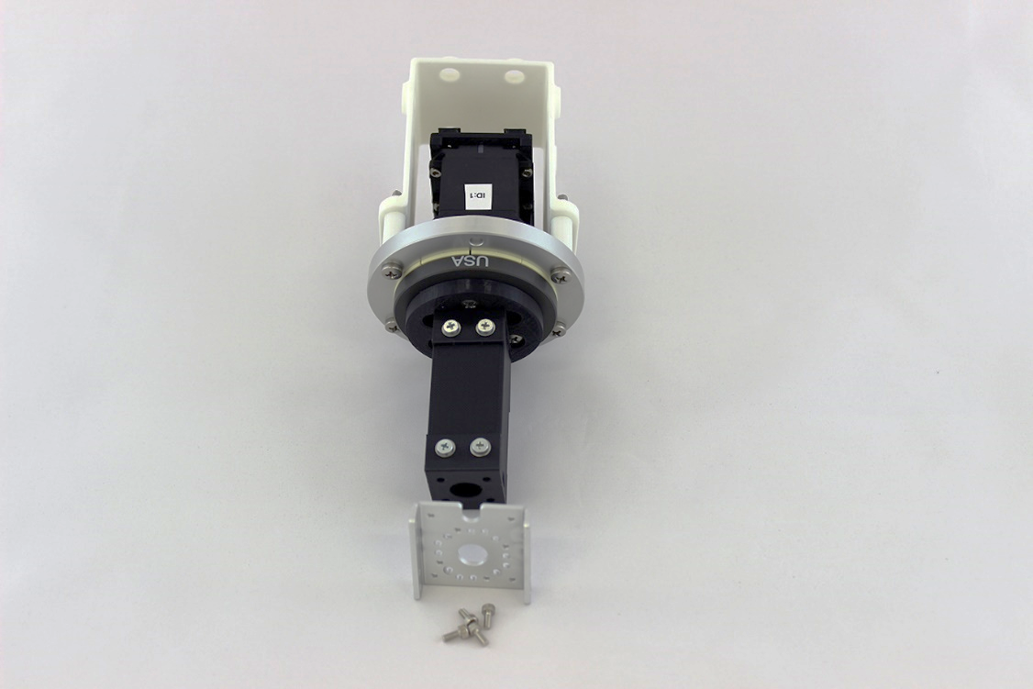

Notice the notch in the bracket

1. Attach FR08-H101 bearing assembly to MX-106. Tighten bearing assembly on until the FR08-H101 flexion bracket will fit across the MX-106 without bending.

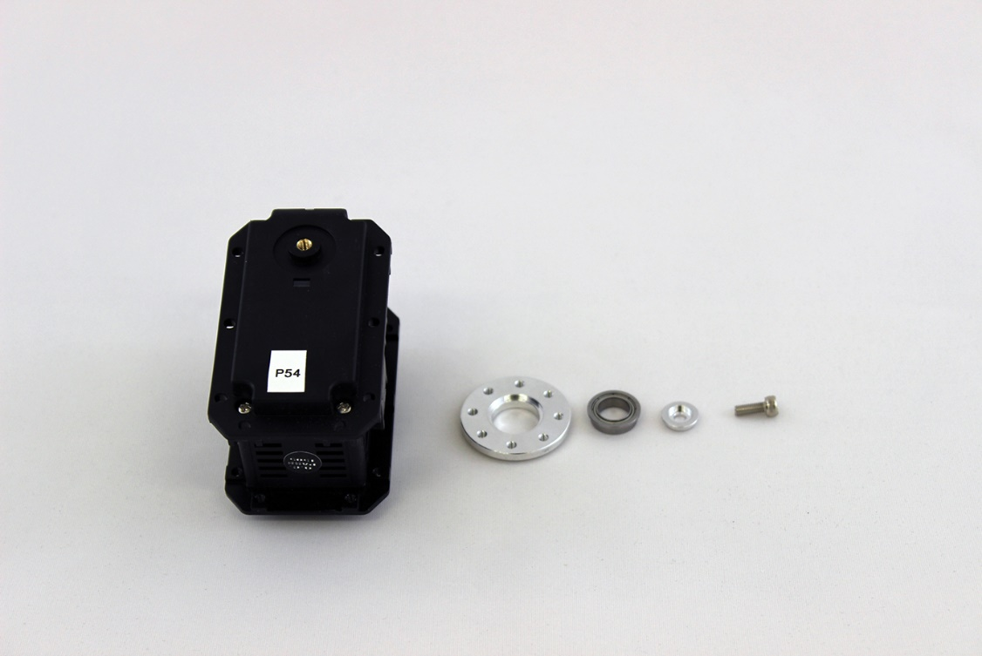

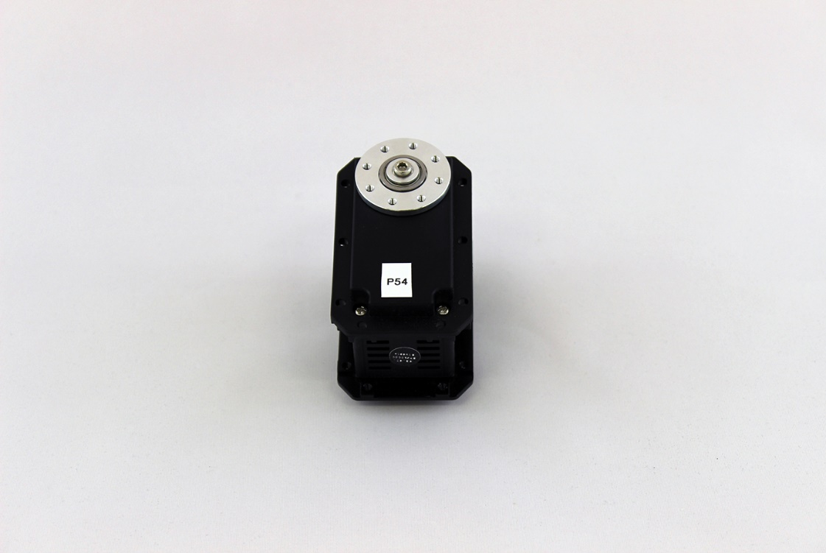

1. Use gel super glue to set QTY:2 M2.5 nut into the MX-106 servo. Use needle nose pliers to help insert the nuts by pressing against the top of the nut and the plastic servo housing. More detailed photos of how to insert the nuts can also be found in step 1 of section 1.10 for the chopsticks gripper.

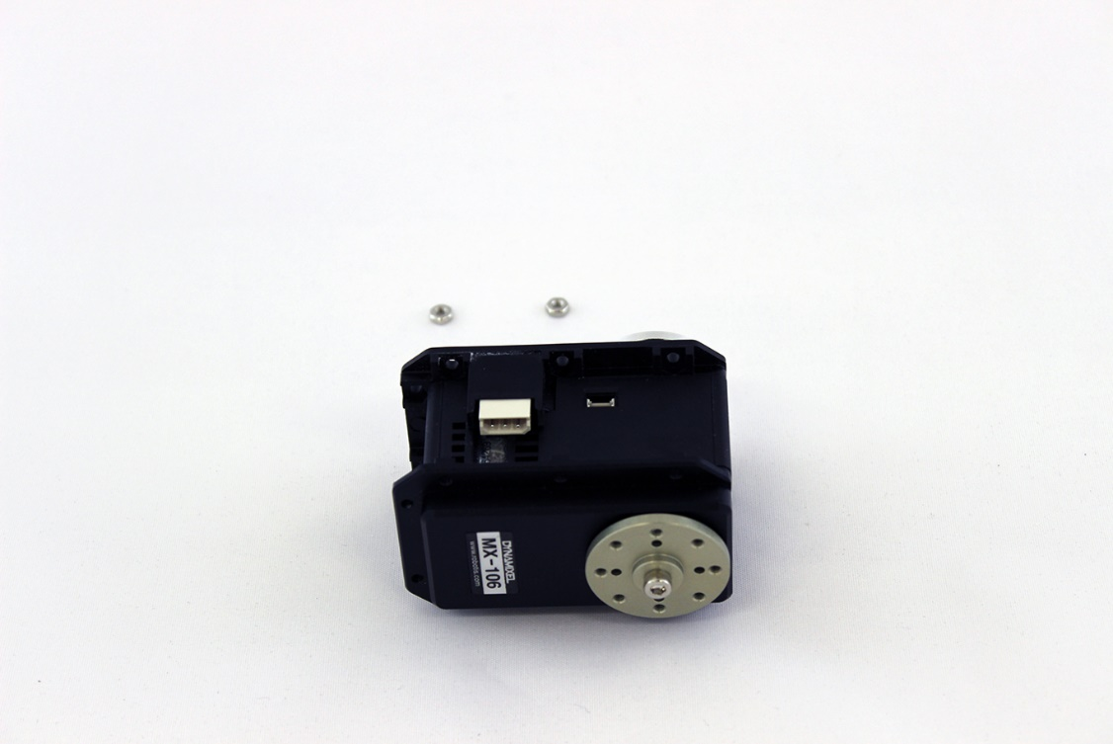

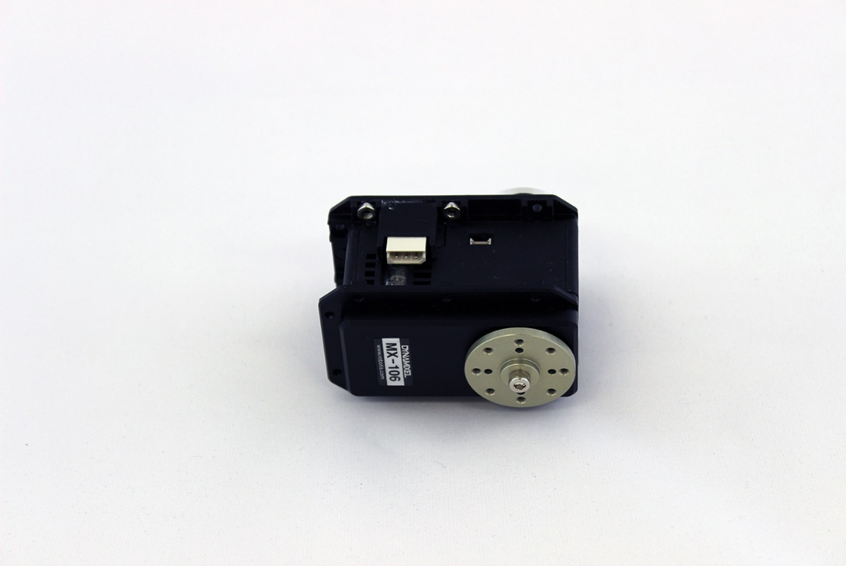

1. Make a 35cm dynamixel servo cable for connecting between the shoulder MX-64 and elbow MX-106 using flexible 20 AWG wire and molex connectors.

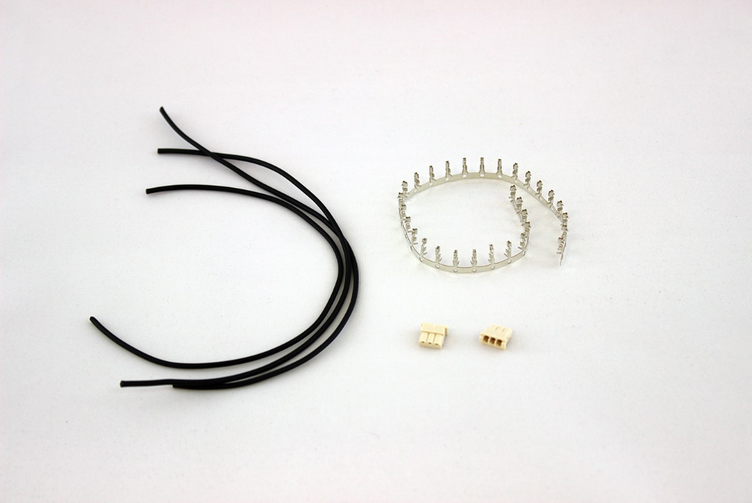

Cables

Molex connectors

Crimping pins

* 1. Measure out and cut **three** 35 cm of cable from the 20 gauge wire.

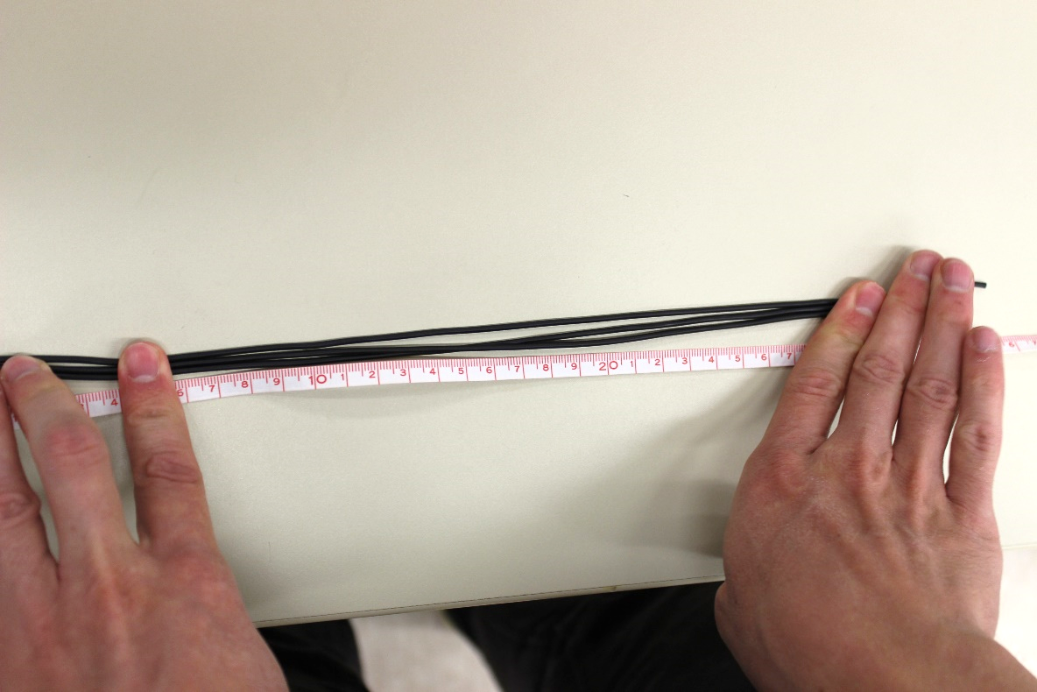

* 1. Now prepare only one side of one wire at a time. We will have to feed these wires through a small hole in the bearing before finishing the other side of the wire.
  2. Strip one wire 3.6mm from each end. This creates a clean connection in the future. Use a caliper or a ruler and mark the stripping line with a marker. Strip the wire.
  3. Twist each metal end so that the many metal fibers are now coiled around one another and are stronger.
  4. Now bend and break off 1 silver crimping pin for each wire. To take it off the pin from the strand just wiggle it off.

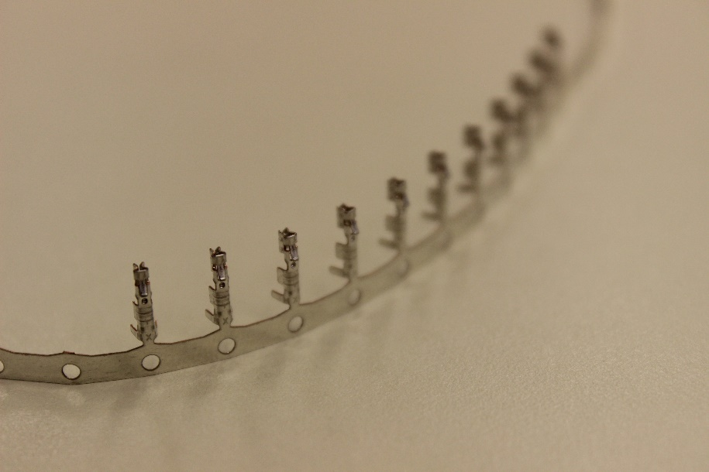

* 1. Open up the crimp tool by squeezing the crimp tool (Molex 64016-0201) handles together until the ratchet releases. Let the handles spring open fully
  2. Put terminal and holder in tool centering the terminal over the crimp position A as shown in the below photos.

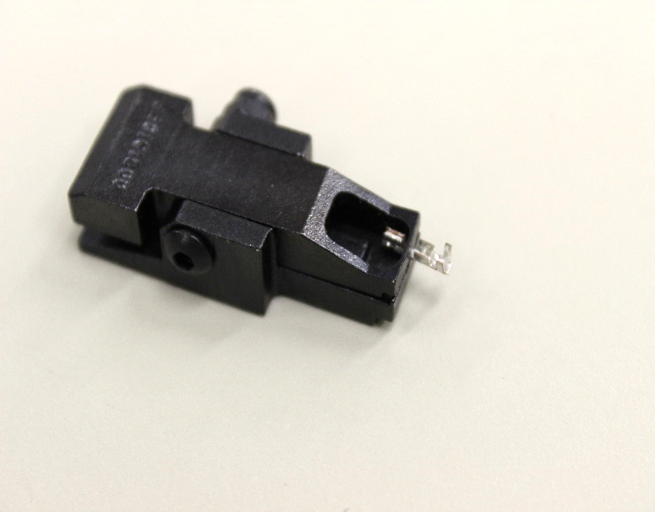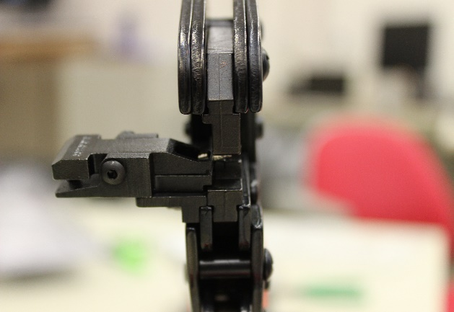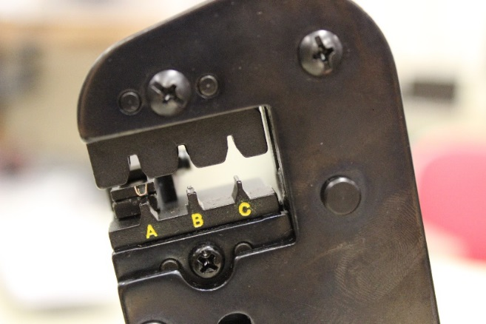

Terminal and holder

Crimping pin

* 1. Lay the wire in the terminal, being careful to keep the wire’s insulation out of the conductor crimp area of the terminal.

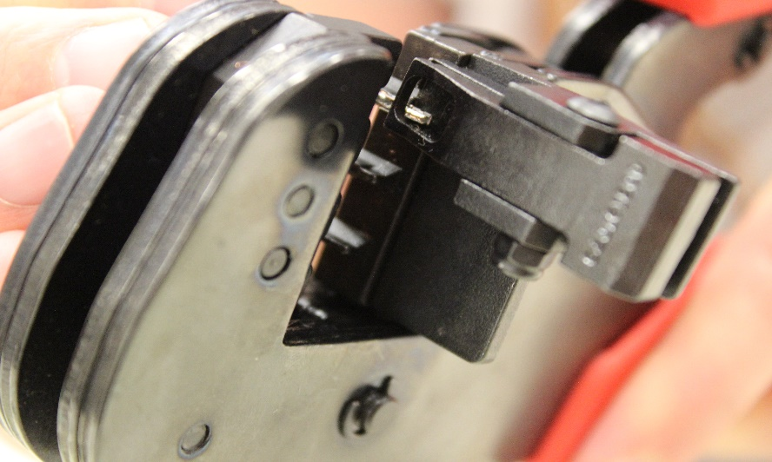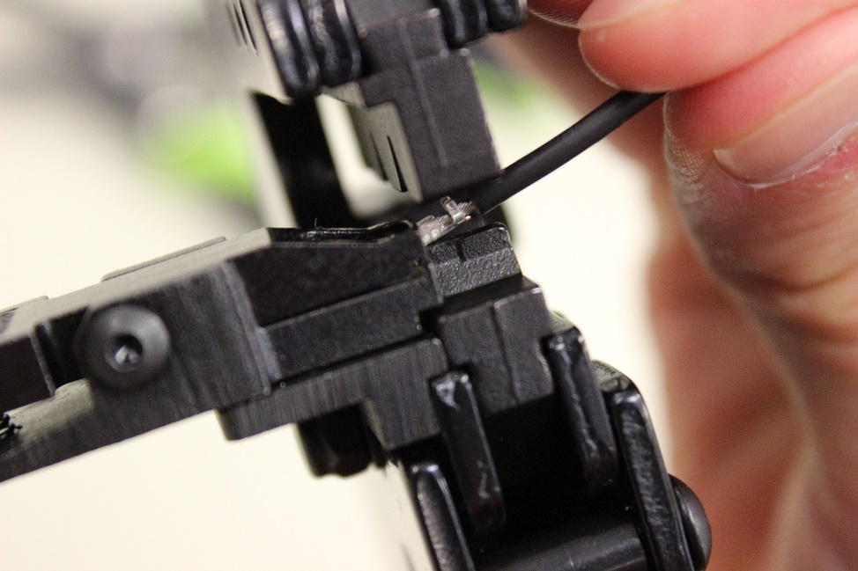

* 1. Slowly squeeze the tool handles together to crimp the terminal. If excessive handle resistance is felt, STOP and release the ratchet. Ratchet release located at inside of the pivot handle. Push up towards crimp head to release.
  2. Release the tool handles to open the tool. Remove the terminal holder with crimped terminal
  3. Open the terminal holder and remove the crimped terminal. This is what it should look like the following:

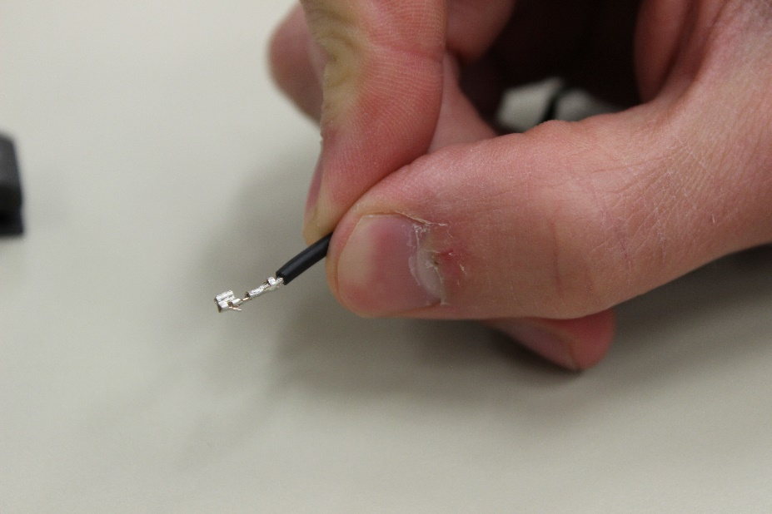

* 1. **Repeat** above procedure on only one side each wire end of QTY:3 wires
  2. Insert the crimped terminals into the molex connector on one end of the wire making a note of which pins are signal (green), power (red), and ground (black)

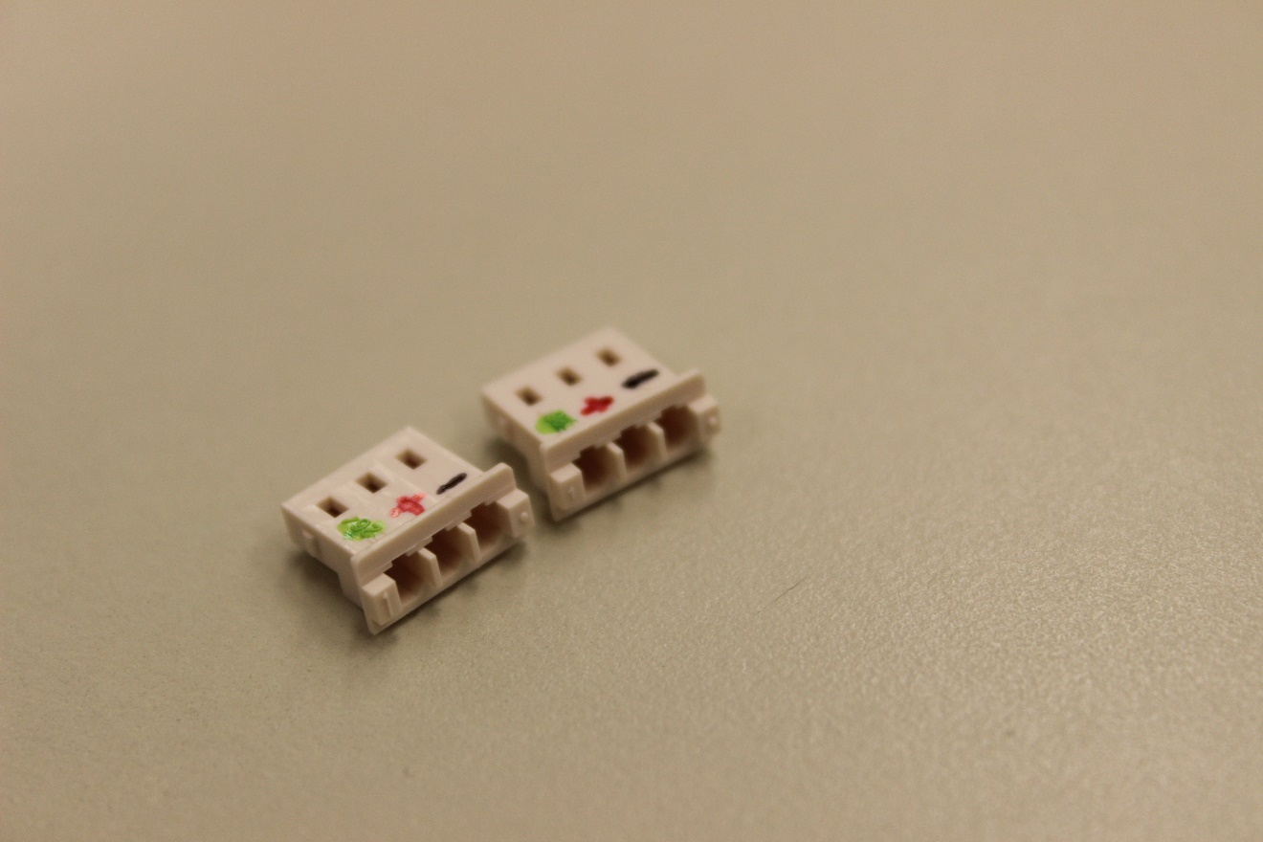

* 1. After crimping on the first connector with a crimping tool slide the wires through the back hole of the bearing on the same side as the tick marks and then crimp on the second connector (ignore this step when making other cables for the arm)

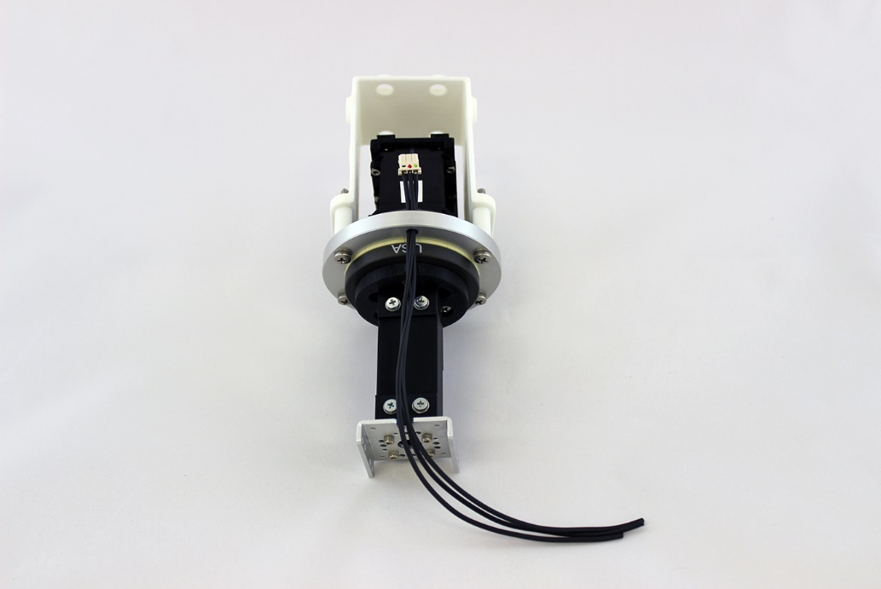

* 1. Insert the crimped terminals into the molex connector on the other end of the cable double checking to make sure the pins on each connector line up with signal (green), power (red), and ground (black)
  2. Double check cables with connectivity check on multimeters to ensure that the pins are wired correctly and that there is no intermittent connections

1. Connect the 35 cm cable to MX-64 and MX-106

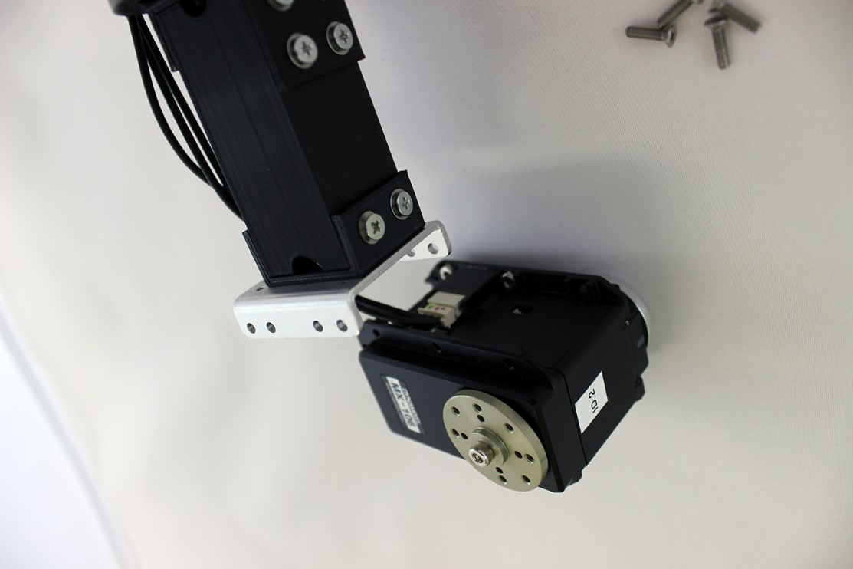

1. Attach FR05-S1 to mx-106 with QTY:3 M2.5x10mm flat head screws and QTY:1 M2.5x4mm hex head screw in the screw hole that is nearest to the 35 cm cable (LT). The reason for using the shorter screw in this position is so that the wires don’t rub against it

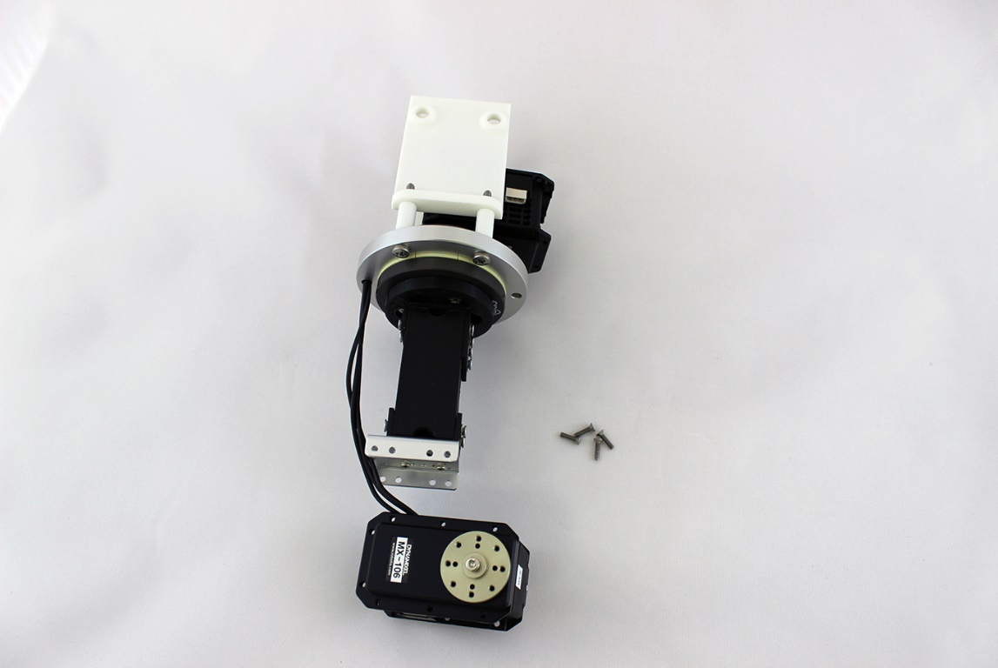

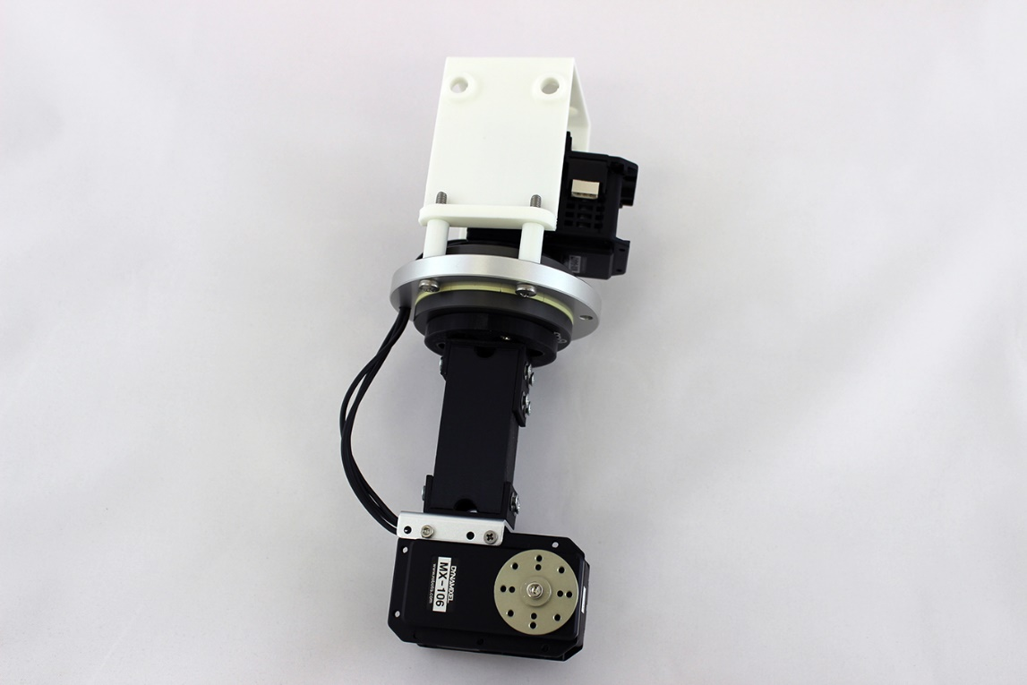

One hex screw

1. Make a 30cm dynamixel servo cable for connecting between the elbow MX-106 and wrist rotation MX-28 using flexible 20 AWG wire and molex connectors. Follow the previous instructions seen in previous steps for wire creation.
2. Slide 30cm dynamixel servo cable through 1in_square_tubing_forearm

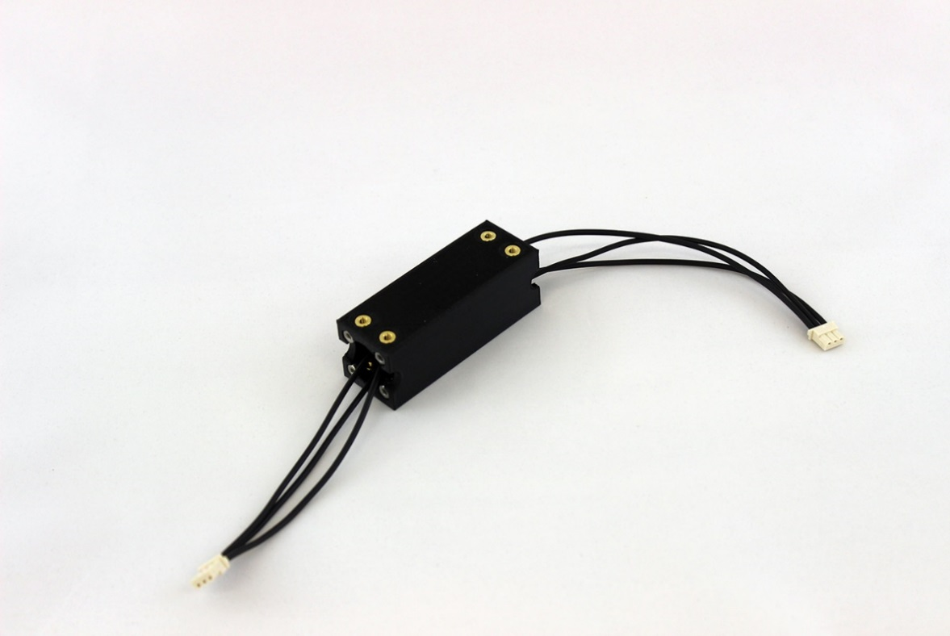

1. Attach 1in_square_tubing_bracket_B to 1in_square_tubing_forearm using QTY:4 M3x8mm flat head screws and washers. Tighten until screw is snug against the washer. Do not overtighten or the washer will bend and the snap lock arm shells will not fit on properly.

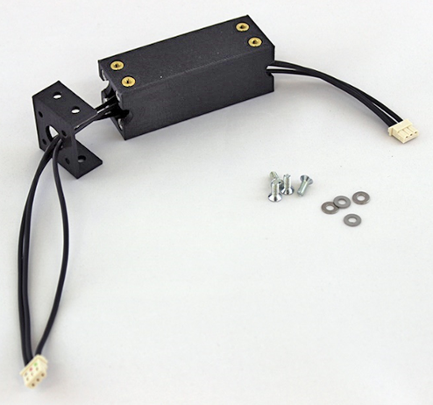

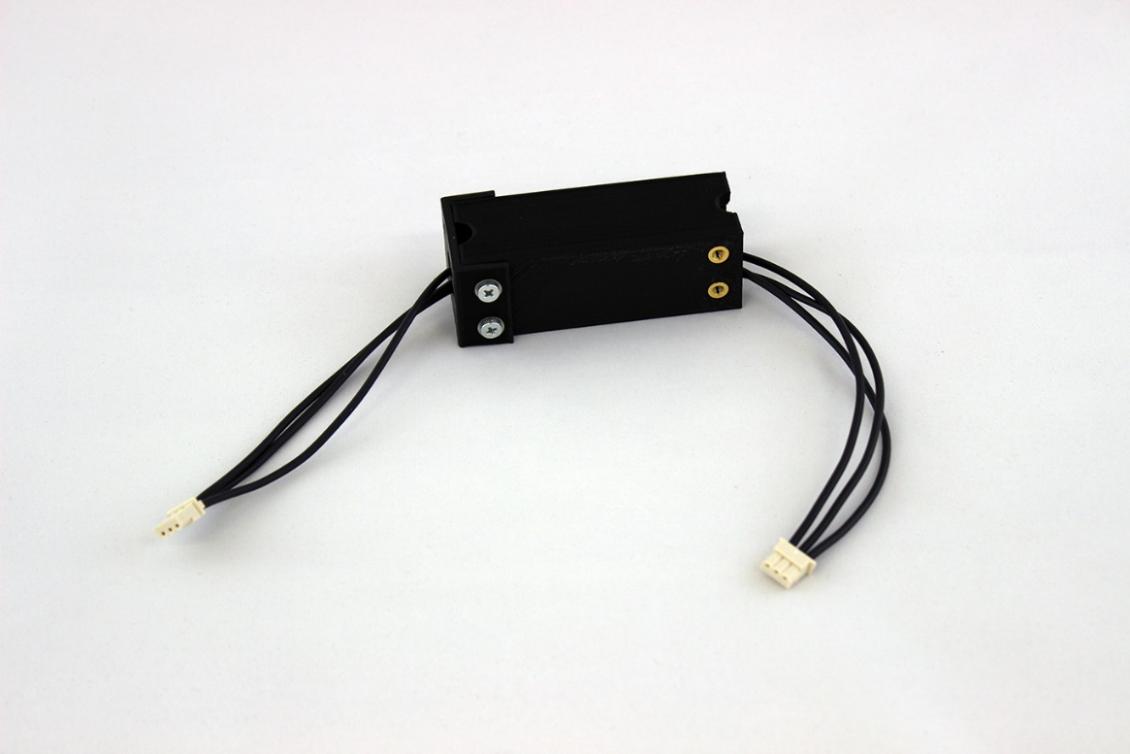

1. Slide 30cm dynamixel cable through middle hole of FR08-H101 elbow flexion bracket and attach FR08-H101 elbow flexion bracket to 1in_square_tubing_bracket_B on forearm using QTY:4 M2.5x6mm hex head screws that come with the bracket (LT).

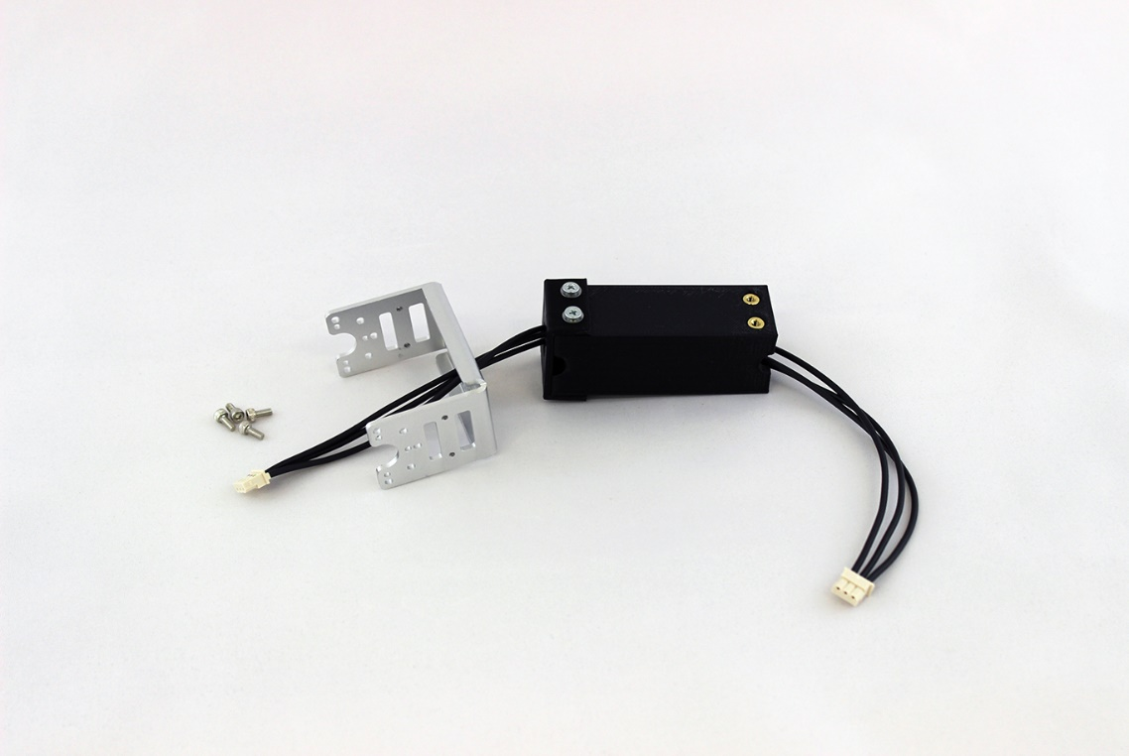

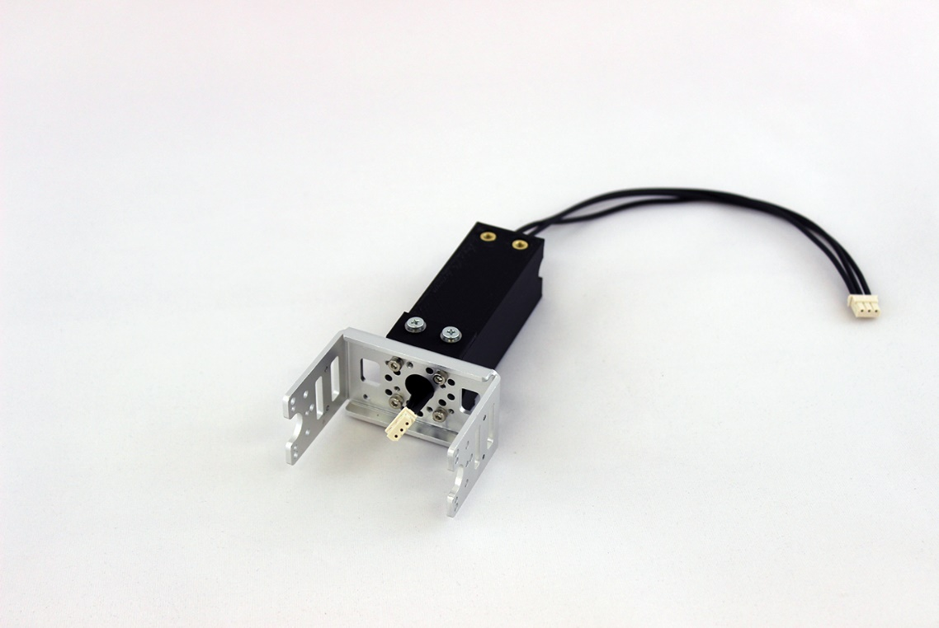

1. Attach 1in_square_tubing_bracket_C to FR07-B101 wrist rotation bracket using QTY:8 M2x4mm flat head screw

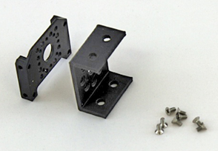 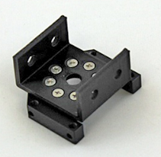

1. Attach FR07-B101 wrist rotation bracket to MX-28 ID=3 wrist rotation servo using QTY:4 M2.5x6mm hex head screws that were included with the bracket (LT)

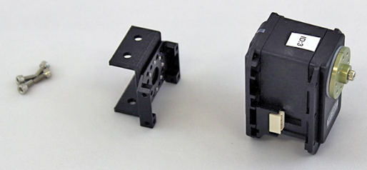

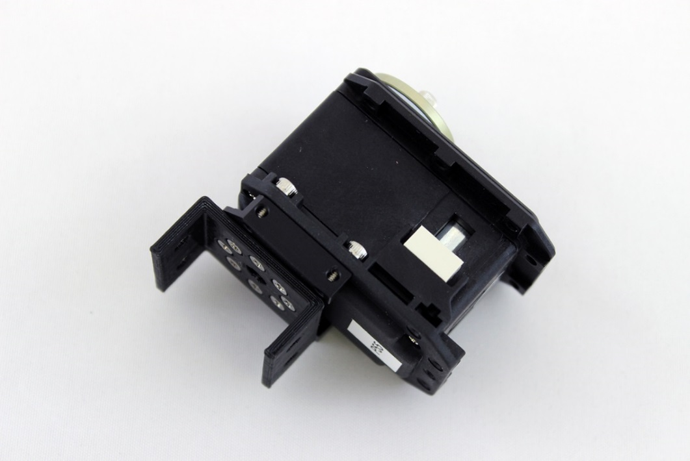

1. Attach 1in_square_tubing_bracket_C to 1in_square_tubing_forearm using QTY:4 M3x8mm flat head screws and washers. Tuck 30 cm servo cable into the right notch of the bracket being careful not to pinch it. Tighten until screw is snug against the washer. Do not overtighten or the washer will bend and the snap lock arm shells will not fit on properly.

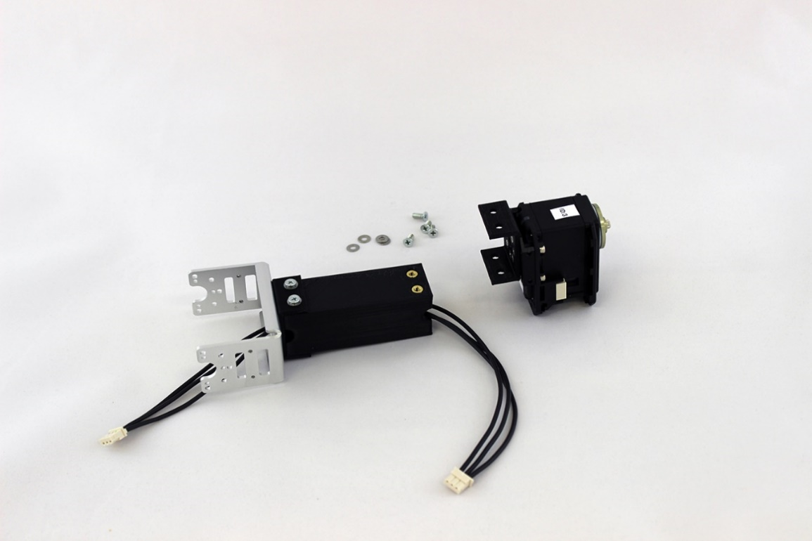

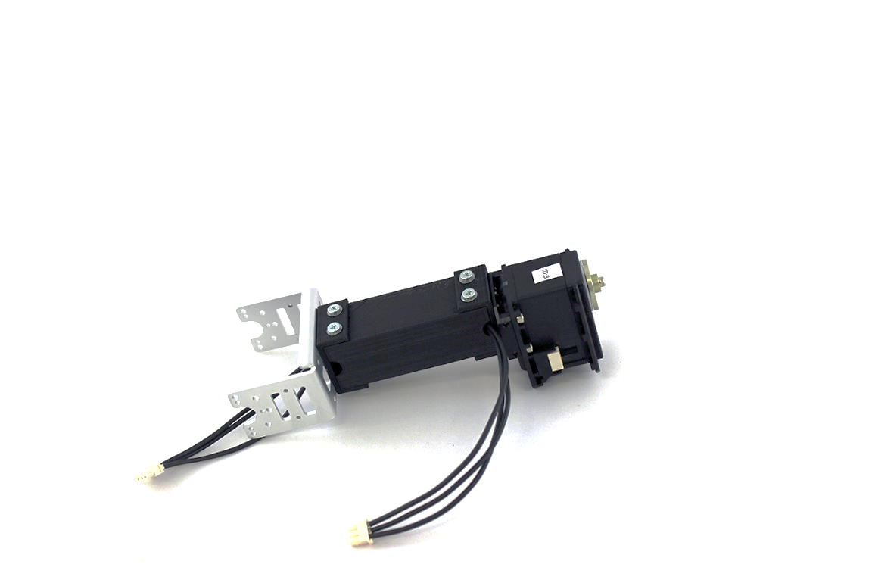

Notice the notch which the wires come through

1. Connect 30cm cable from MX-106 ID=2 into wrist rotation servo MX-28 ID=3 on the right side of the servo as viewed from the top

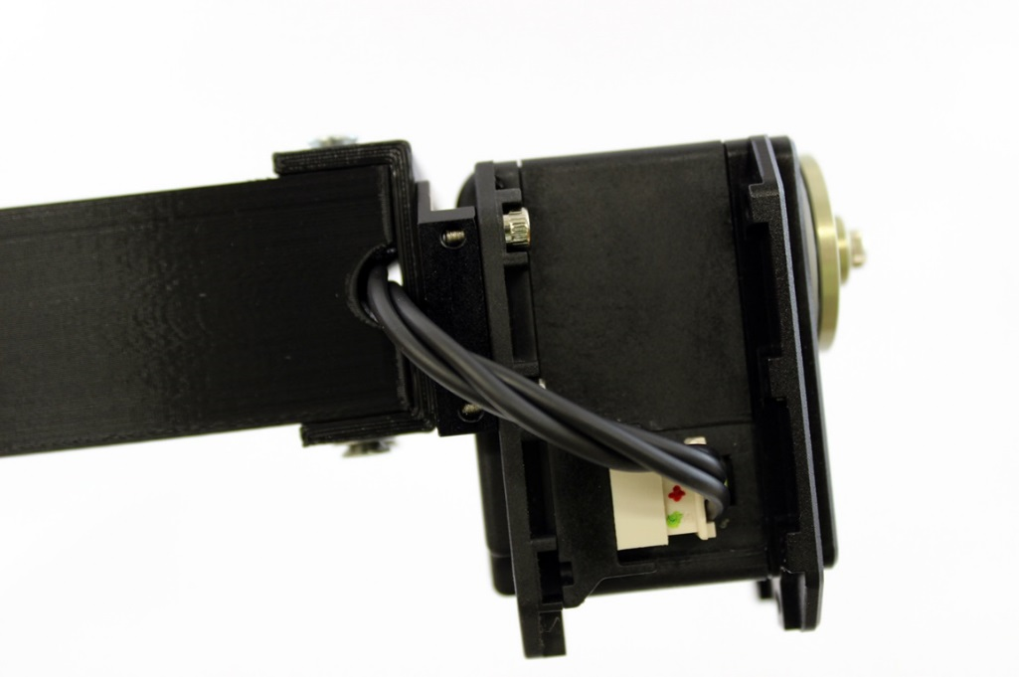

1. Attach FR07-S101K bracket to servo horn of MX-28 ID=3 wrist rotation servo using QTY:8 M2x3mm hex head screw (LT). Since the servo horn screw is fairly inaccessible if you expect the arm will undergo significant vibration it may also be advisable to Loctite it at this time (LT).

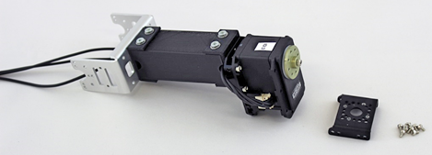



1. Use gel super glue to set QTY:2 M2.5 nut into the MX-28 servo ID=4. Use needle nose pliers to help insert the nuts by pressing against the top of the nut and the plastic servo housing.

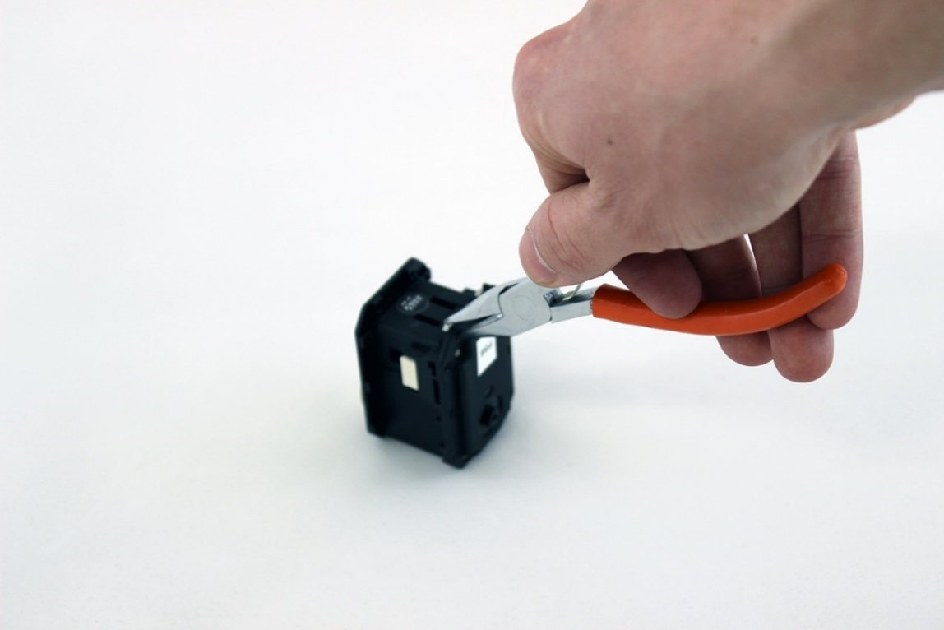 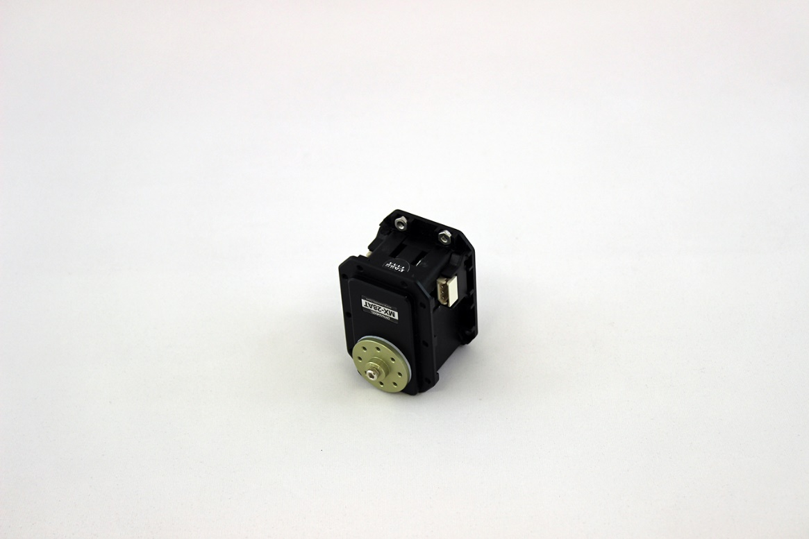

1. Attach MX-28 servo ID=4 to FR07-S101K bracket with QTY:4 M2.5x6mm screw as provided in FR07-S101K (LT). NOTE: If you are planning on attaching the arm shells later you should avoid putting Loctite on in this step. Ensure the center tick mark is lined up along the axis of the forearm before attaching the bracket.

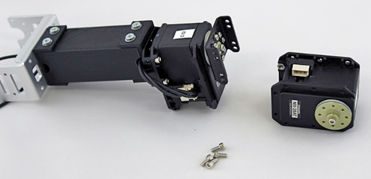

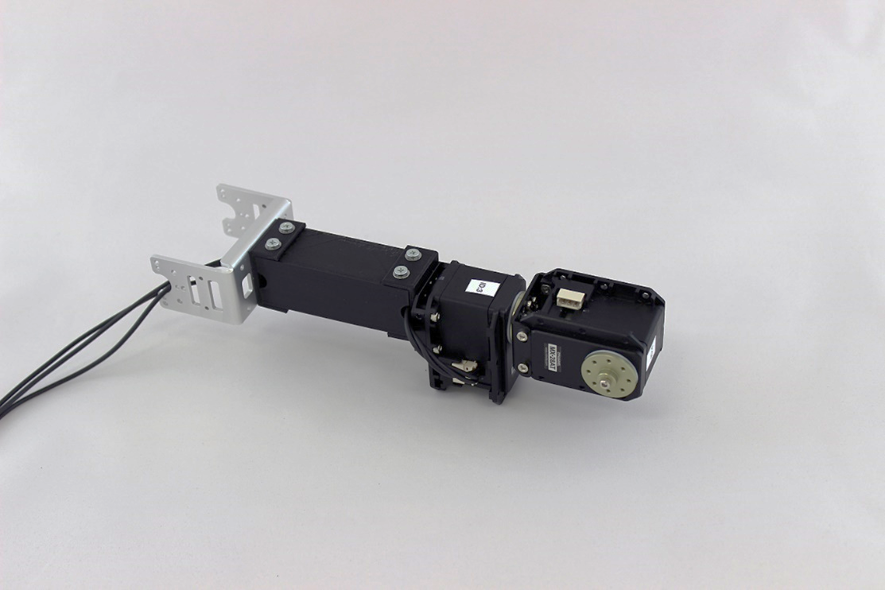

1. Connect 20cm cable that is provided with the servos from MX-28 ID=3 to MX-28 ID=4

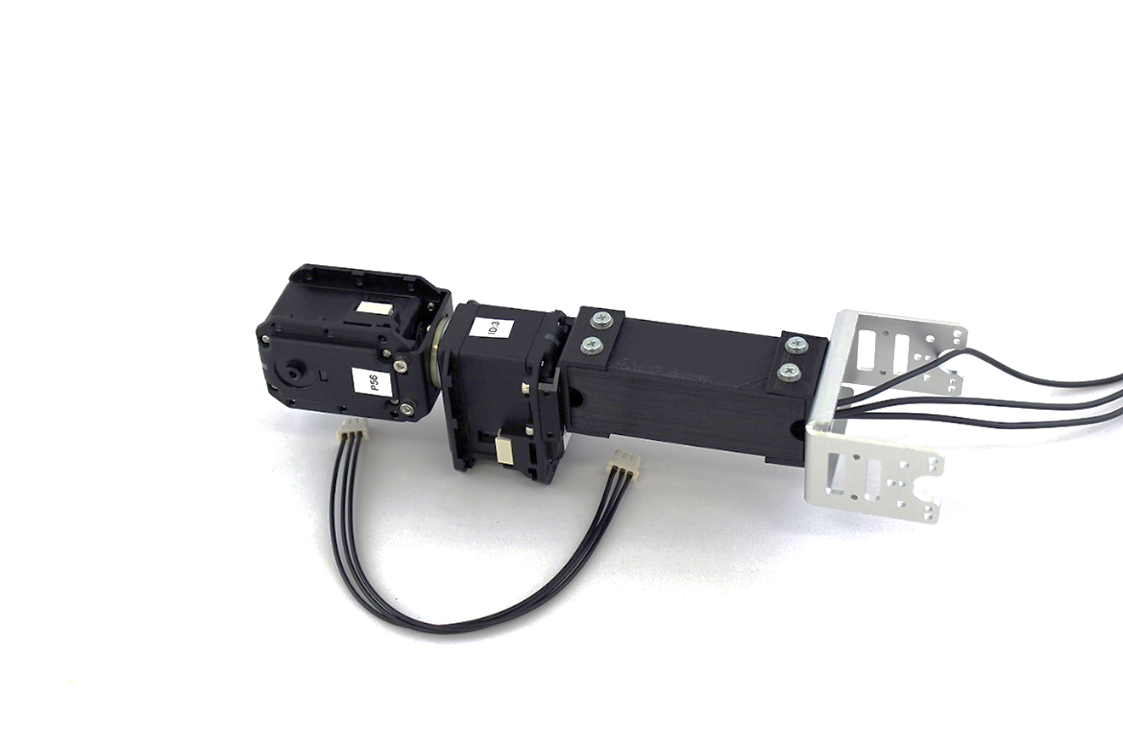

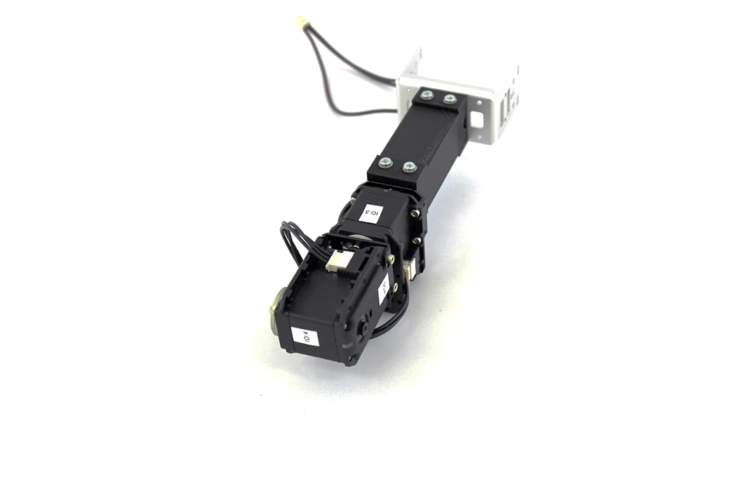

Connection Points

1. Attach FR07-H101K bearing assembly to MX-28 ID=4 with QTY:1 M2.5x7.5mm hex head screw that comes with bracket. Tighten bearing assembly on until the FR07-H101K flexion bracket will fit across the MX-28 without bending.

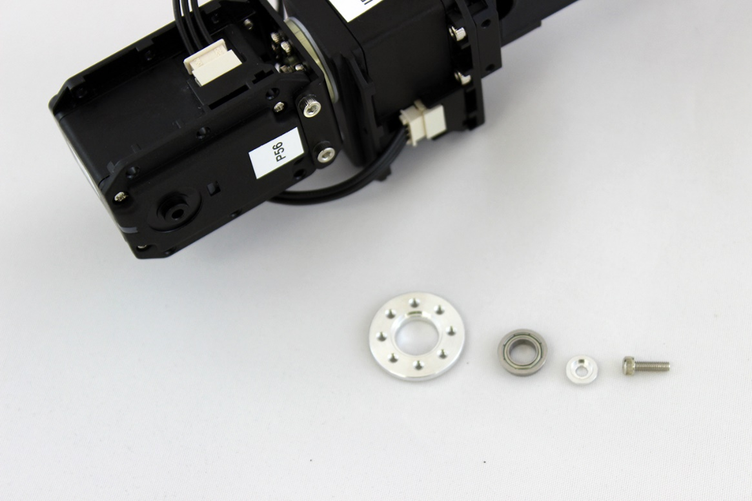

1. Attach FR07-H101K bracket to wrist hand adapter with QTY:4 M2.5x6mm flat head screws (LT)

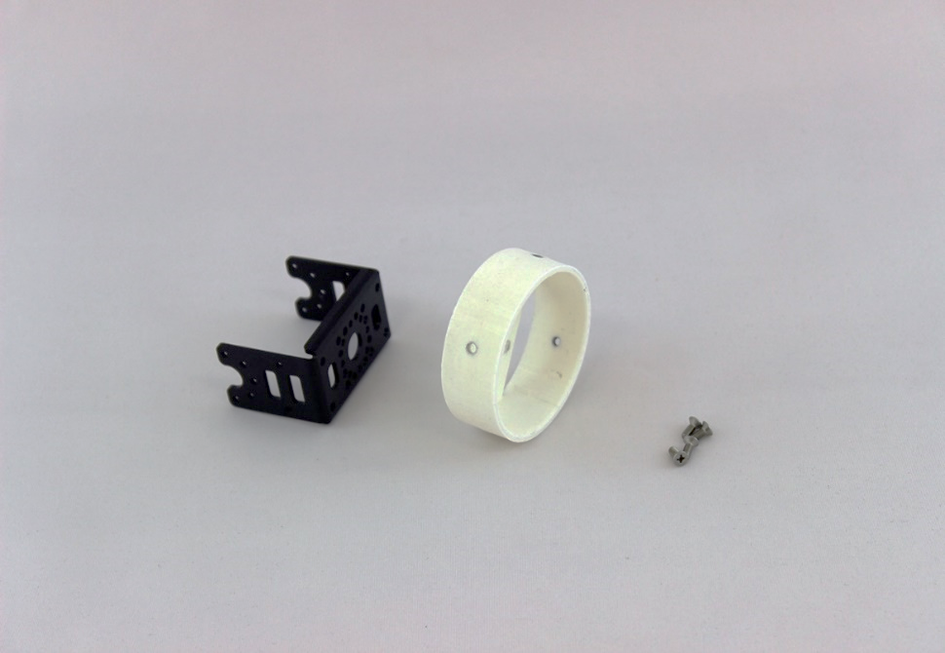

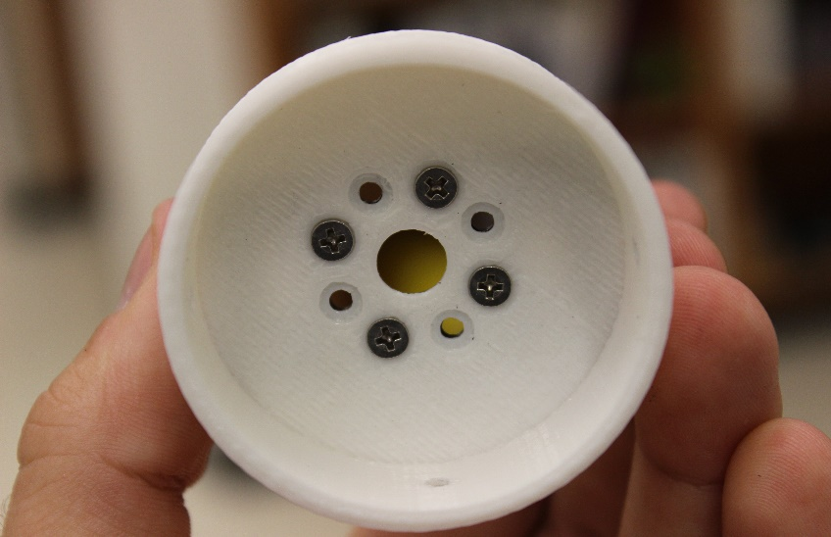

Notice that the screws are slightly askew and not centered. This is normal.

TOP

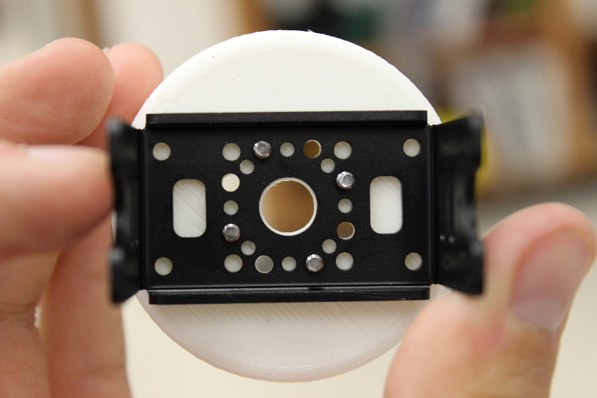

1. Attach FR07-H101K bracket to MX-28 servo ID=4 using QTY:10 M2x3mm hex head screws that came with the bracket (LT). Ensure the center tick mark is lined up along the axis of the forearm before attaching the bracket.

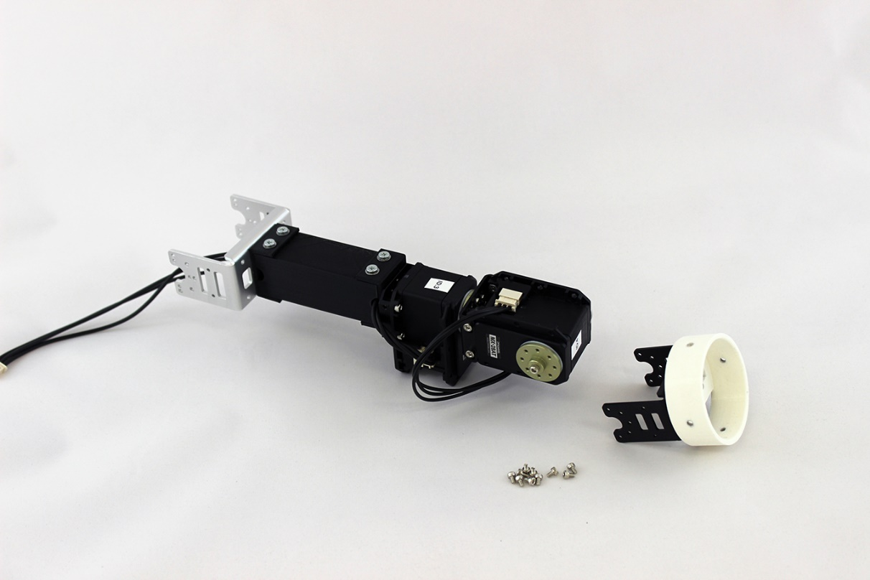

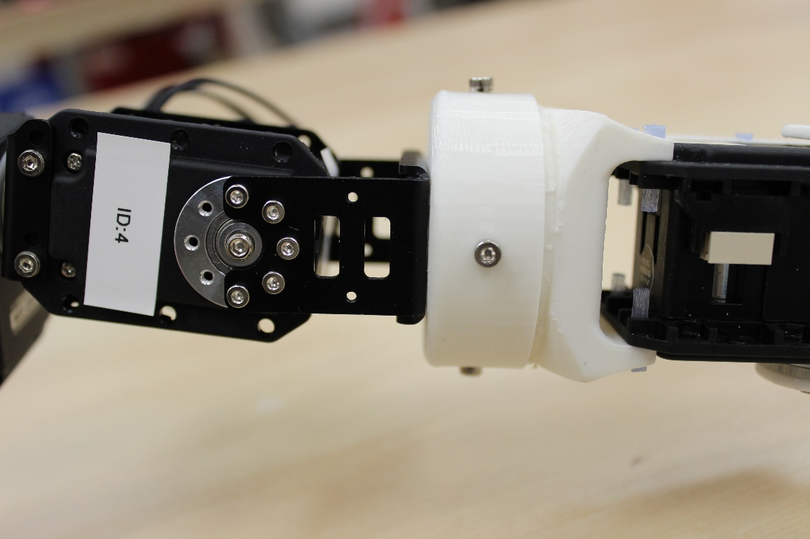

The tick mark on the motor is behind the bracket right here.

Make sure the tick mark line up!

1. Slide shoulder bracket onto top of 8020 beam stand making sure to also catch the MX-64 8020 beam adapter into the bottom channel. Double check that the center tick mark is facing towards the stand away from the front of the arm. Slide both parts until the edge of the shoulder bracket lines up with the edge of the gusset bracket on the 8020 beam stand

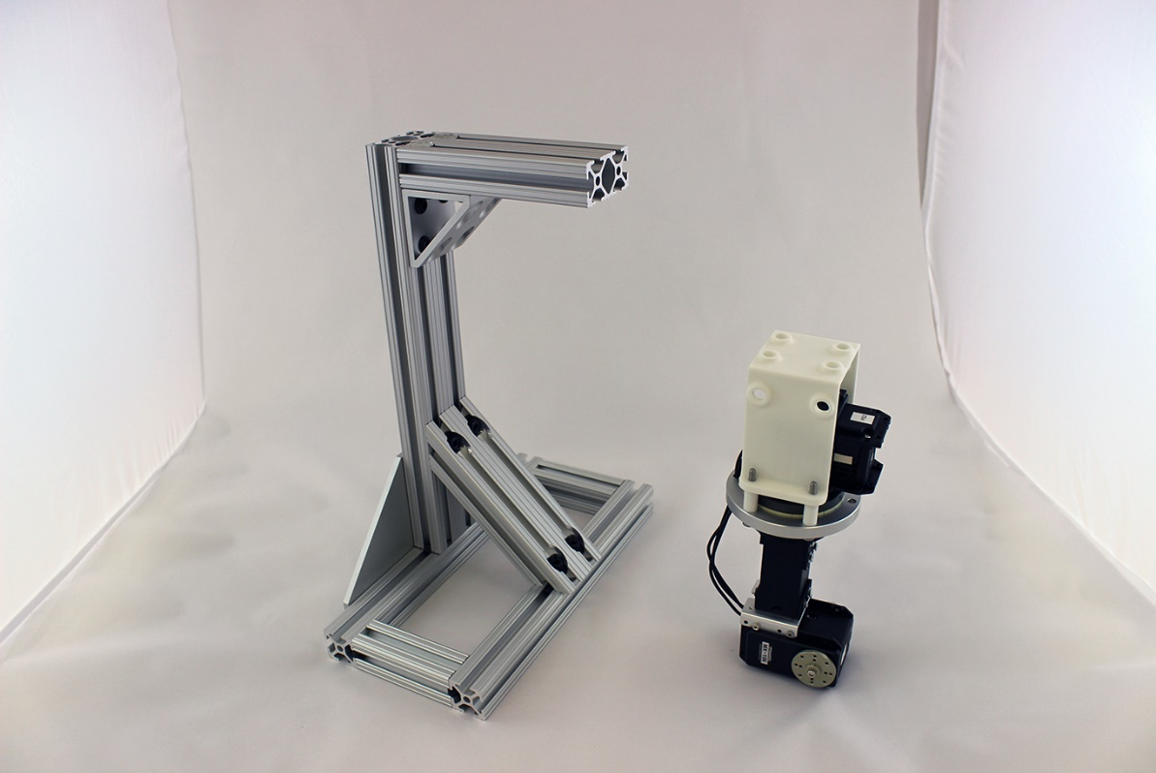 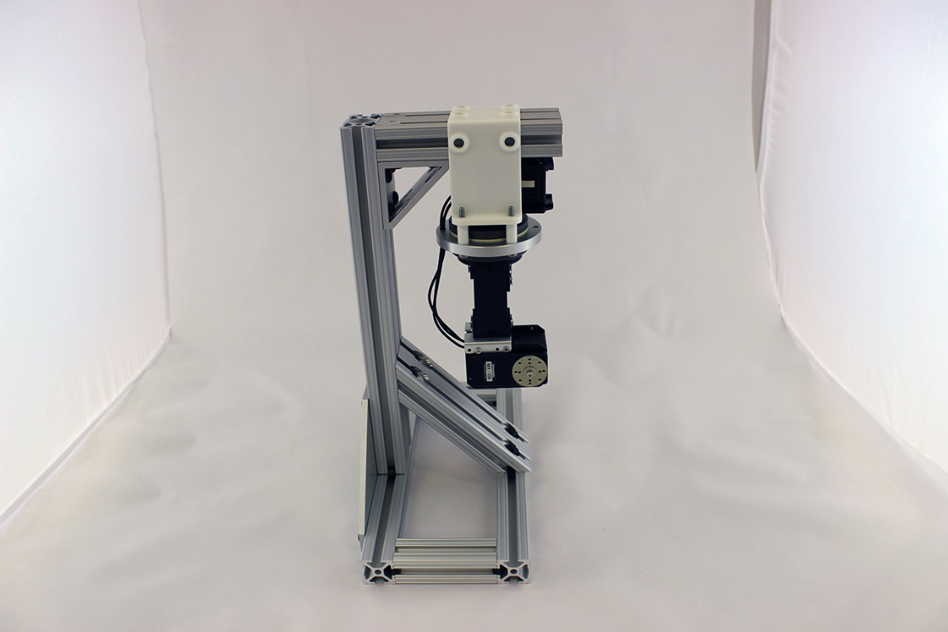

1. Secure shoulder bracket by sliding in QTY:4 economy T nuts into the top channels of the stand and screwing in QTY:4 ¼”-20 screws

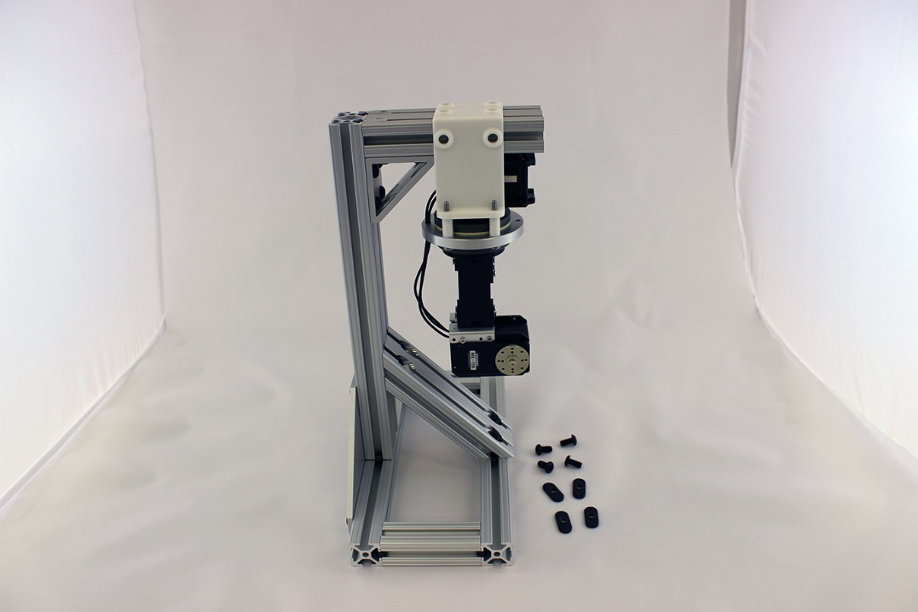 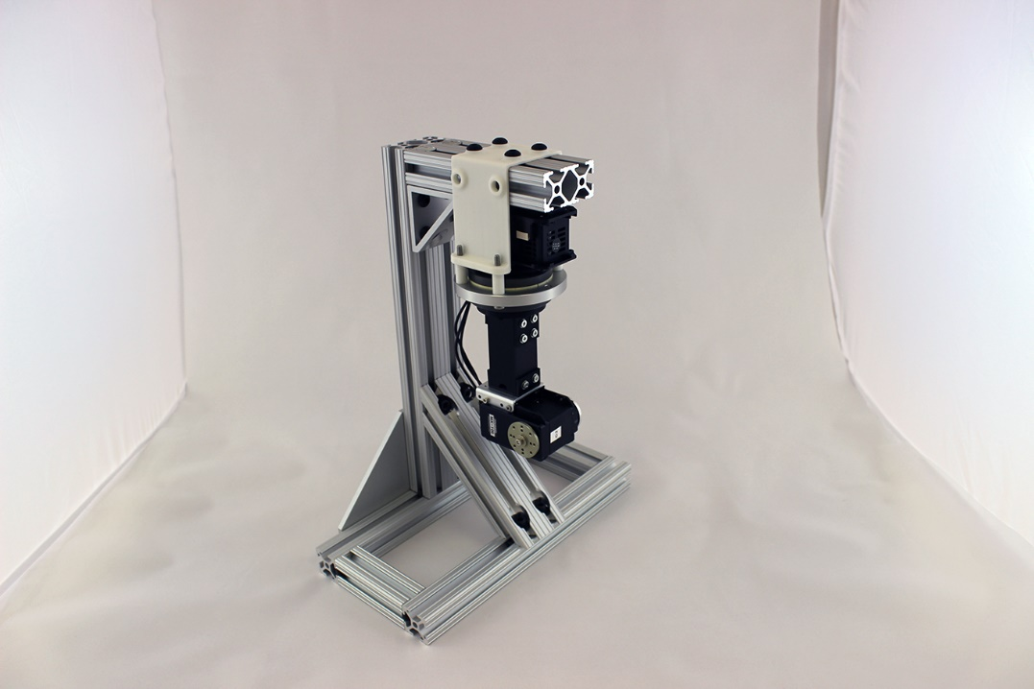

1. Connect 30cm cable from MX-28 servo ID=3 to MX-106 ID=2

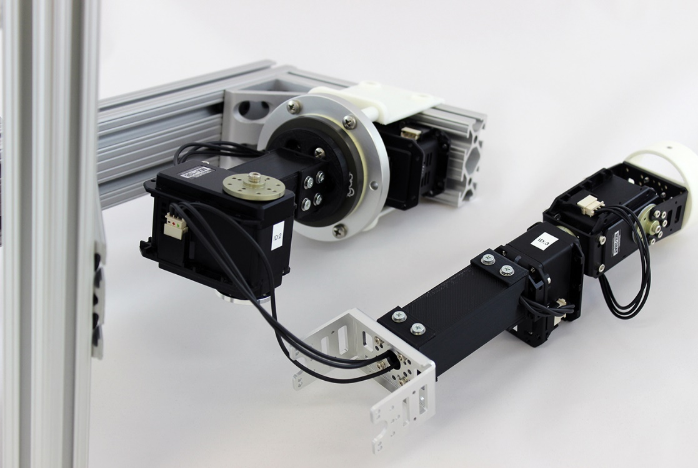

1. Attach FR08-H101 bracket to MX-106 servo ID=2 using QTY:10 M2.5x4mm hex head screws that came with the bracket (LT)**. Ensure the center tick mark is lined up along the axis of the forearm before attaching the bracket.**



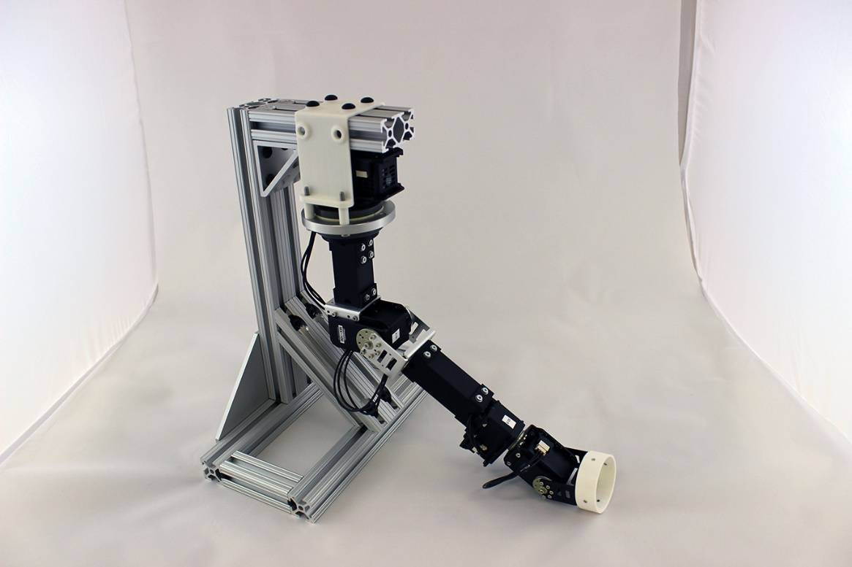

1. **The arm is now completed!** – Next step is attaching a hand which is explained in the hand guide below

## Hand/Gripper Assembly

***Required Tools:*** 1mm hex key, 2mm Hex key, #1 Drive Phillips Screwdriver, needle nose pliers

***Estimated time:*** 45 minutes

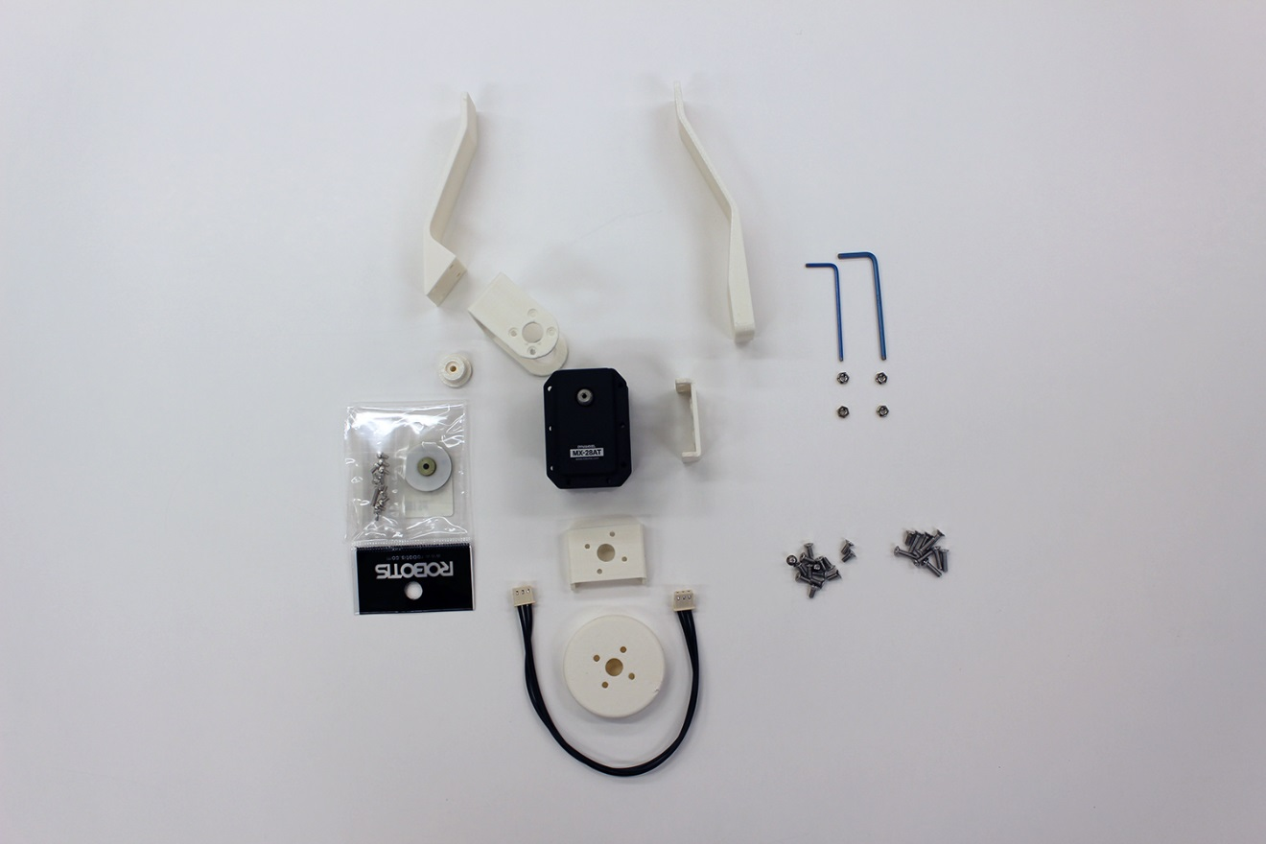

1. Use super glue to attach QTY:4 M2.5 nuts into MX-28AT nut recesses.
   1. Place the nuts into the recesses by hand or with the pliers.
   2. Once the nuts are in place you can tilt them out a bit and add a drop off super glue and then clamp back into place using the pliers
   3. Ensure that the holes in the nuts line up with the holes in the servo. Wait about 5-10 minutes for the glue to dry before trying to put in any screws.

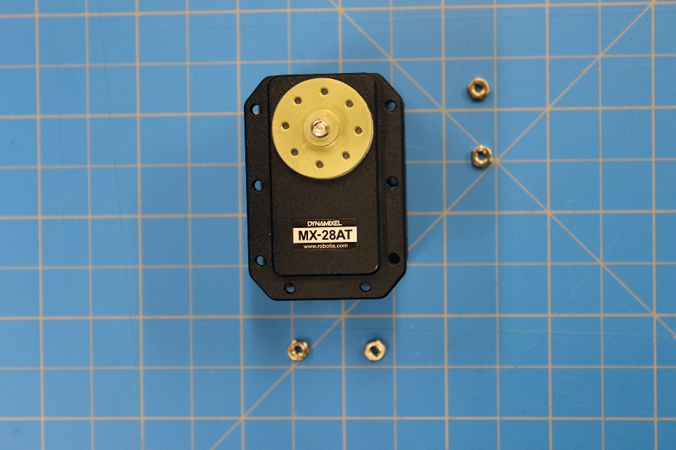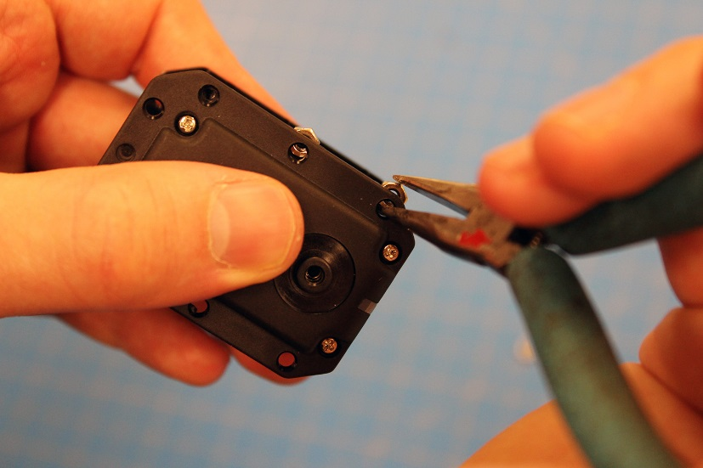

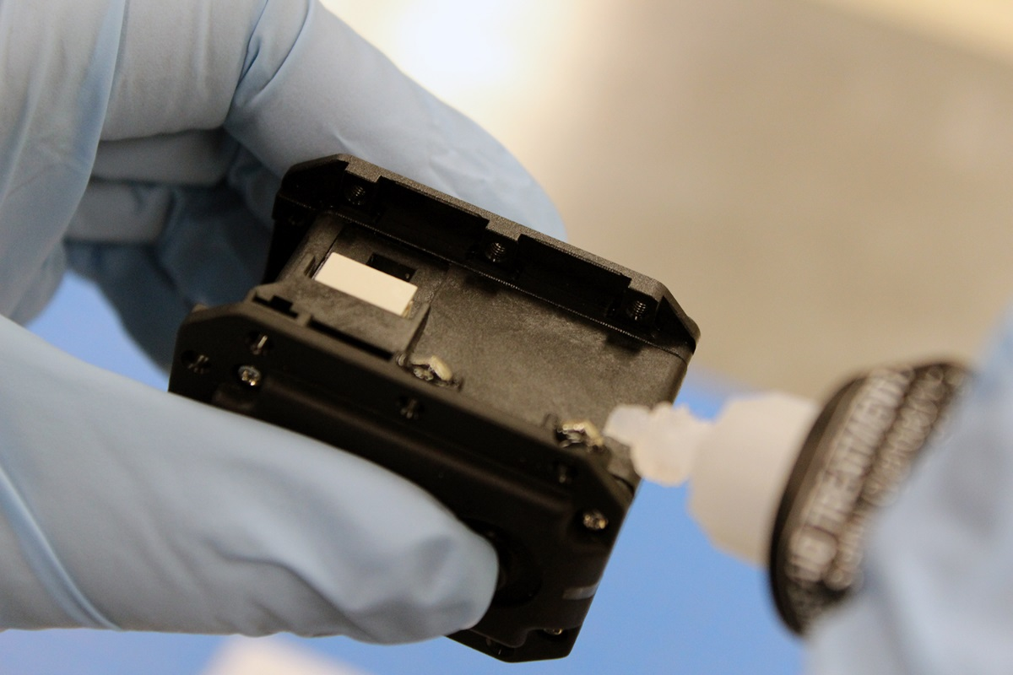

1. Attach hand_adapter to Sidebottom_bracket using QTY4 M2.5x6mm flat head screws

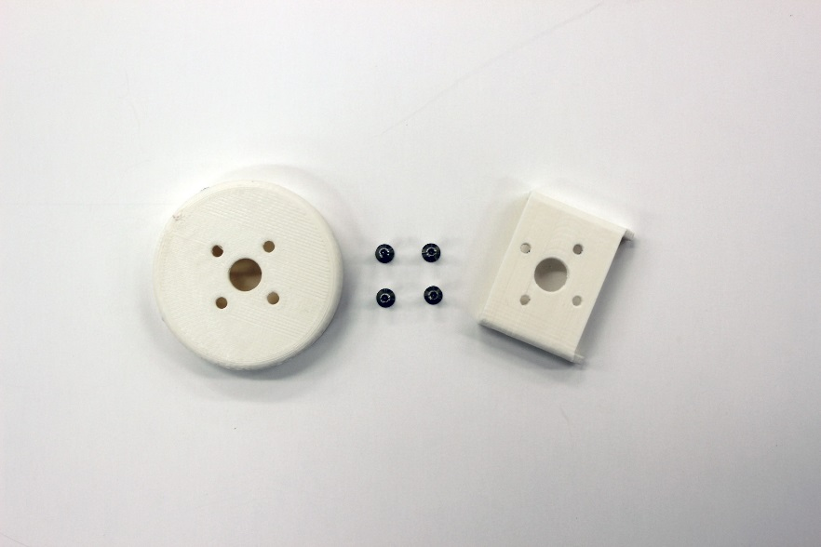

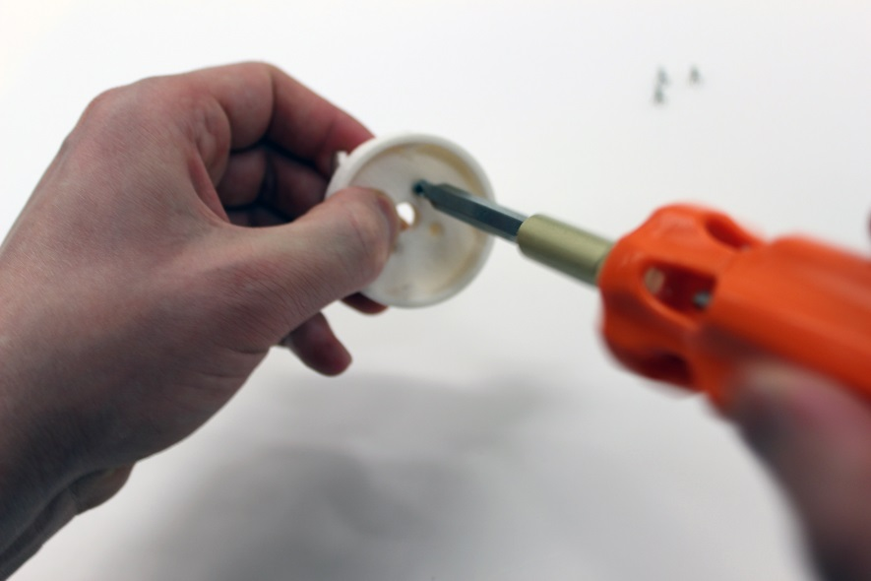

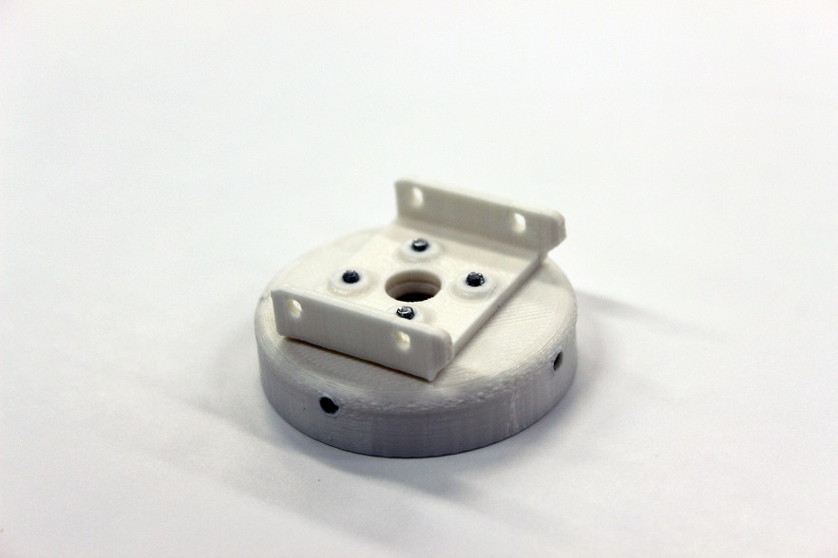

1. Attach hand adapter and Sidebottom_bracket assembly to bottom of MX-28AT servo using QTY:4 M2.5x10mm flat head screws (LT). Tighten screws until snug and be careful not to overtighten as the bracket may crack (the bracket will still work with a crack, but it does not look as good).

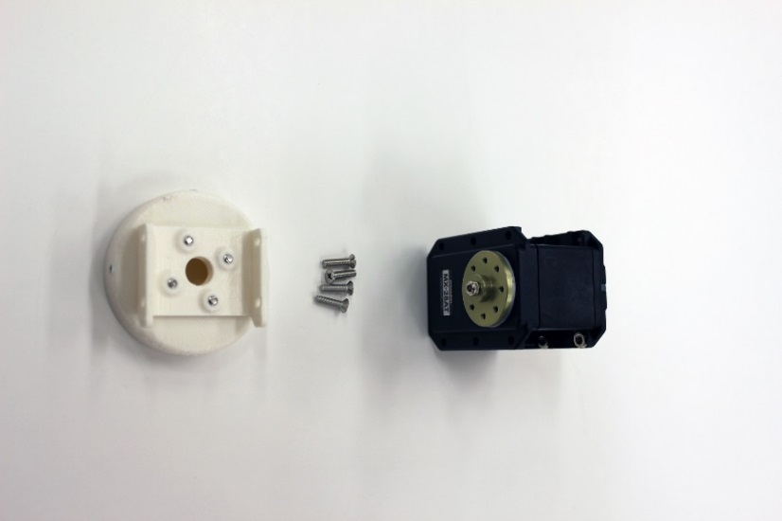

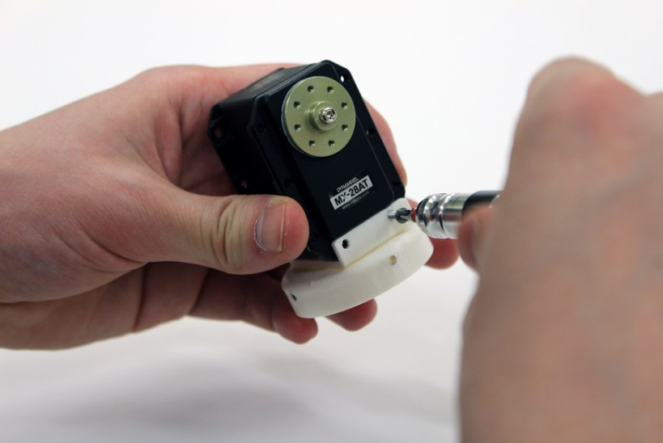

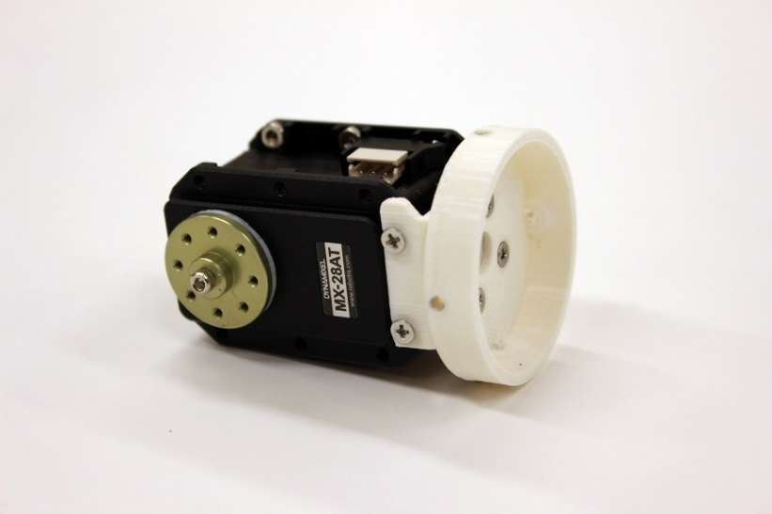

1. Attach Sidebottom_bracket to side of MX-28AT servo using QTY:4 M2.5x10mm flat head screws (LT).

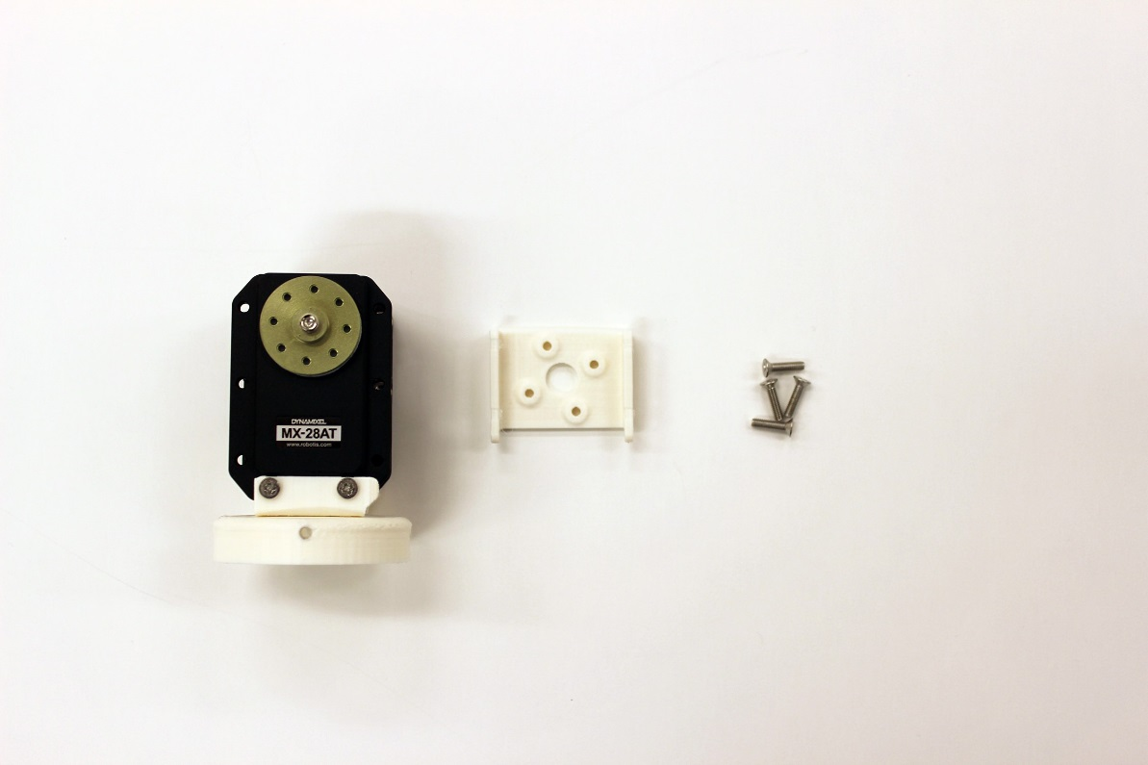

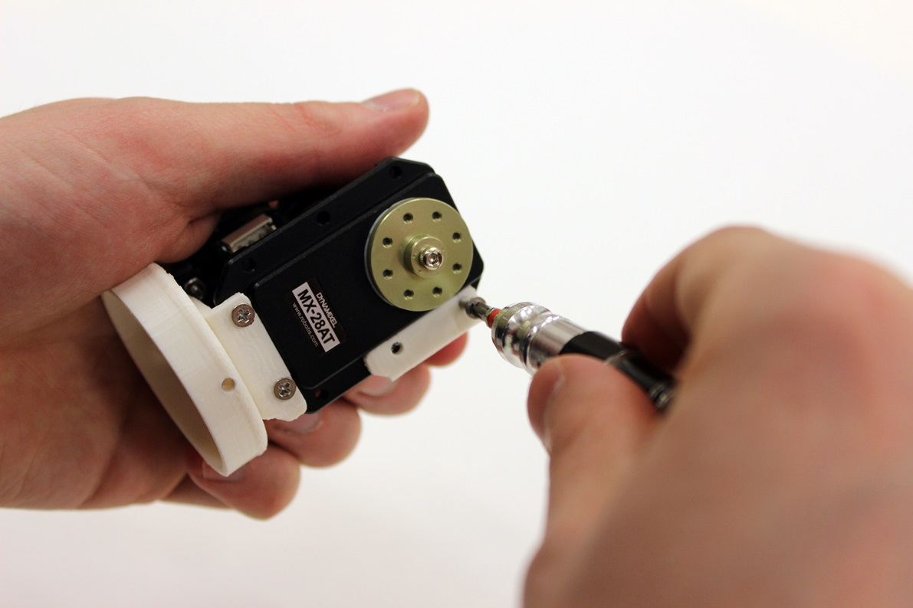

1. Attach flex_bracket to the servo horn using QTY:4 M2.5x3mm hex head screws that came with the servo horn (LT). Ensure that the small protrusions on the flex_bracket line up with the indentations on the servo horn, so that the bracket is aligned correctly.

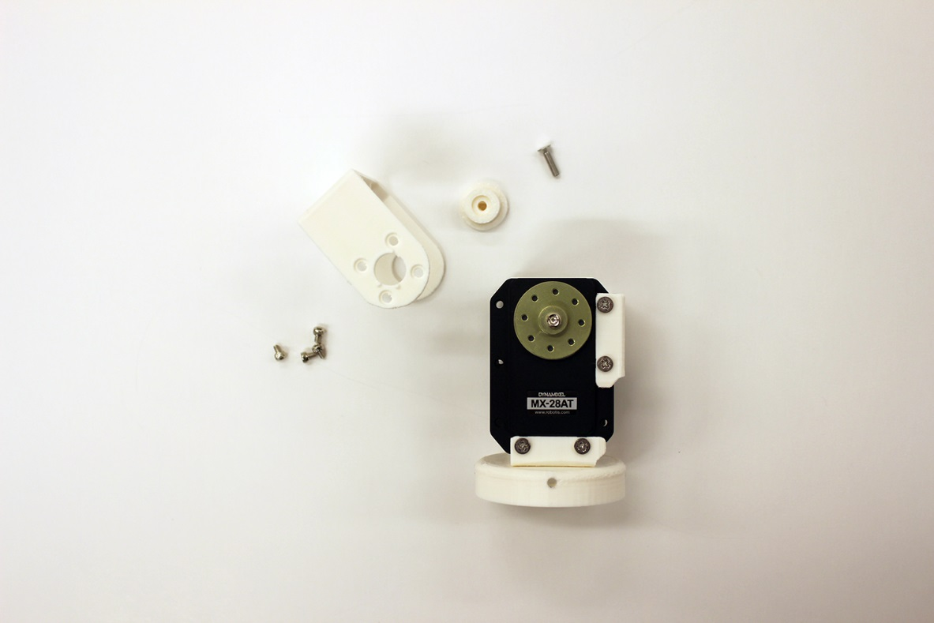

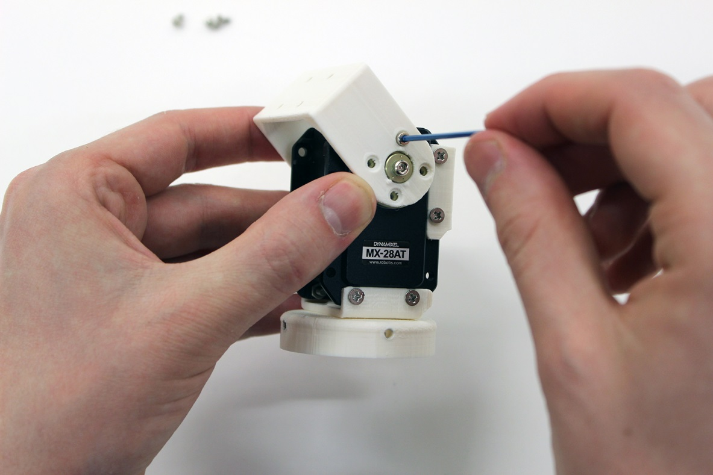

1. Slide bearing into other side of flex_bracket until it sits flush with mx-28at housing. Attach in place using a QTY:1 M2.5x10mm flat head screw

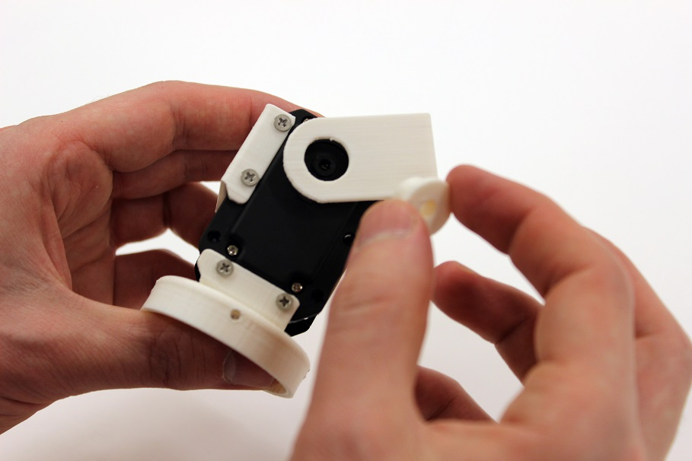

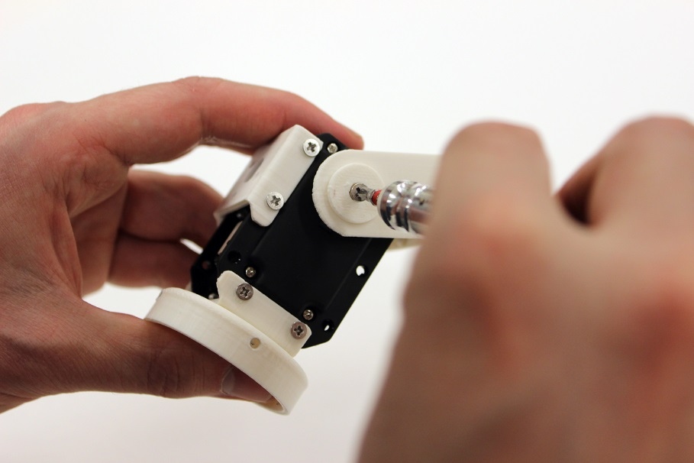

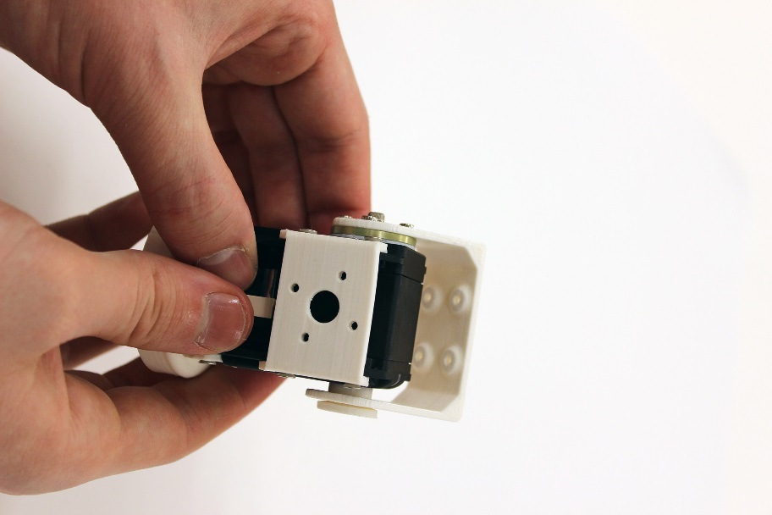

1. Attach fixed plate to Sidebottom_bracket using QTY:4 M2.5x6mm flat head screws

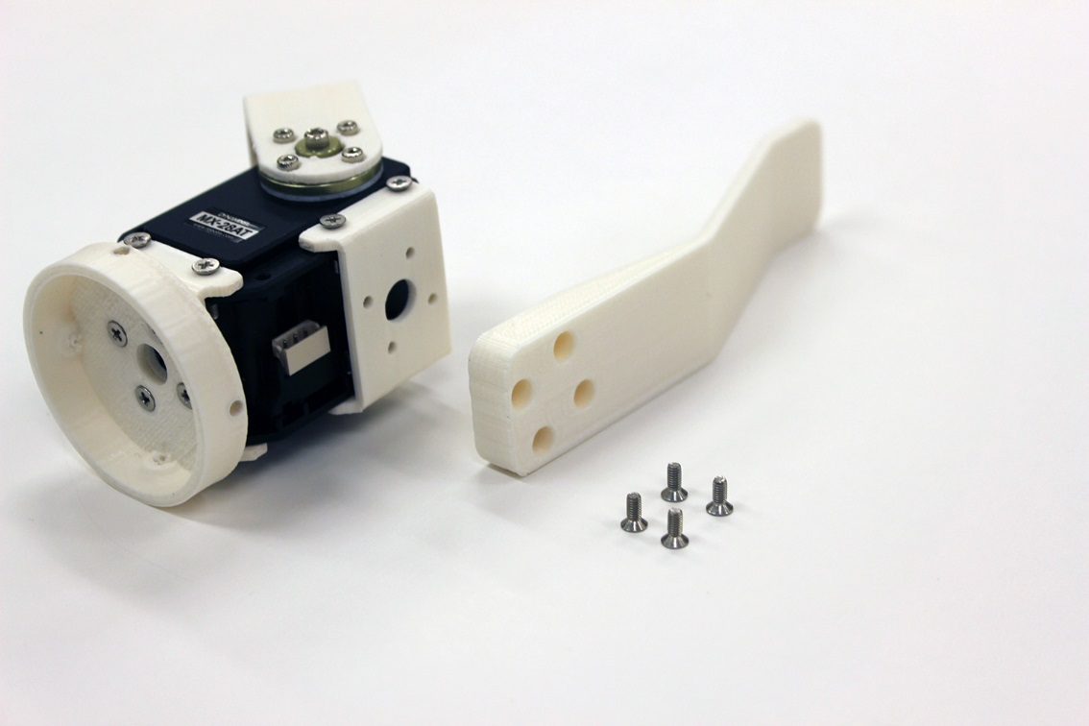

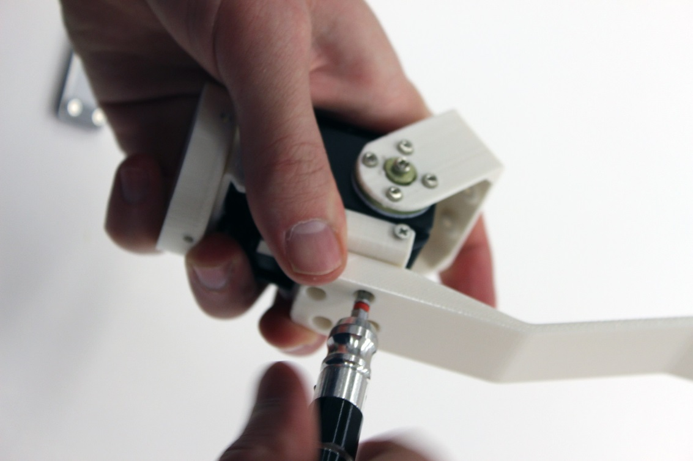

1. Attach moving plate to flex_bracket using QTY:4 M2.5x6mm flat head screws

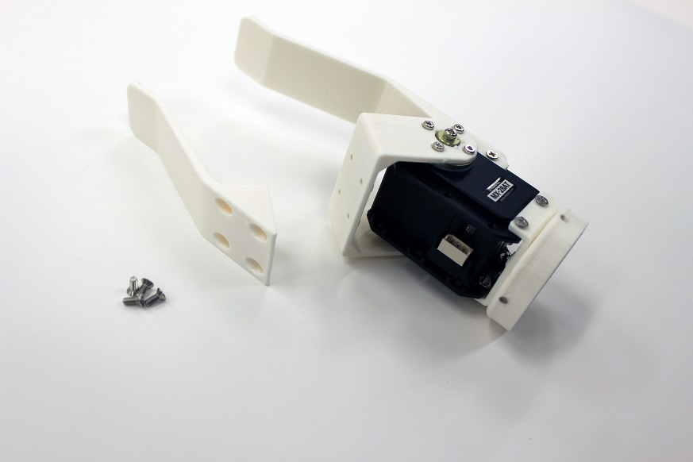

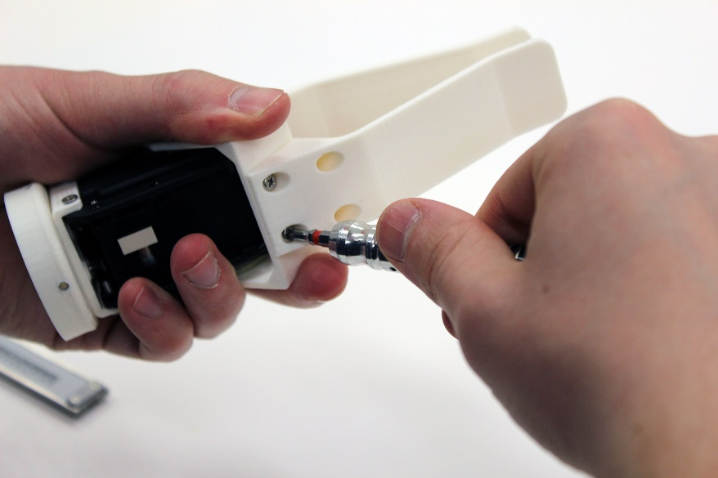

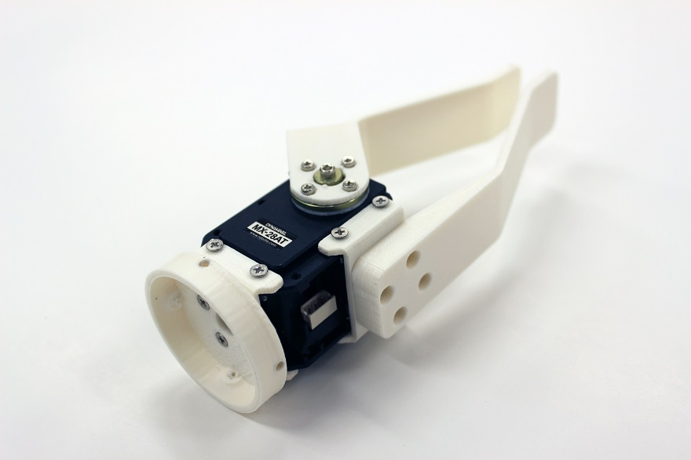

1. Remove the backing from the rubber pieces and apply to the plates. To get a stronger bond 🡪 peel back half of the rubber and apply super glue. Repeat with the other half. Push the rubber firmly into the plates. Wipe off excess super glue.

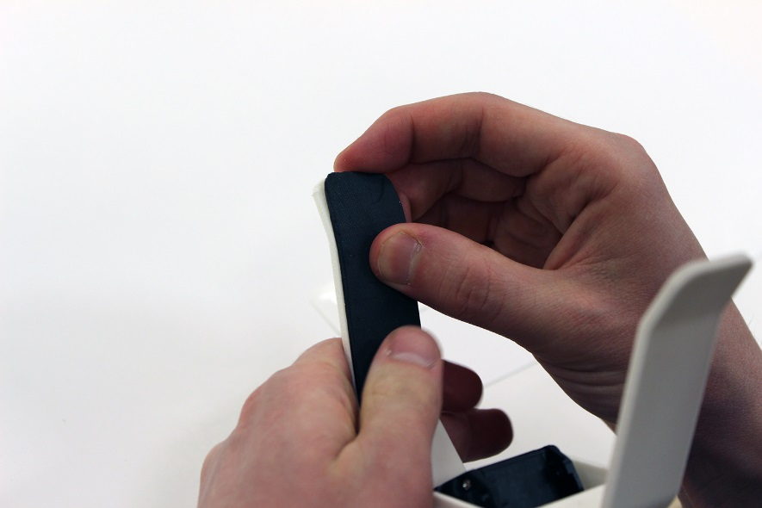

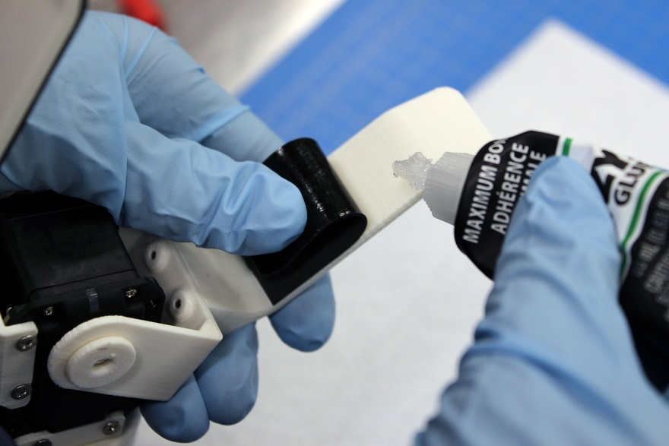

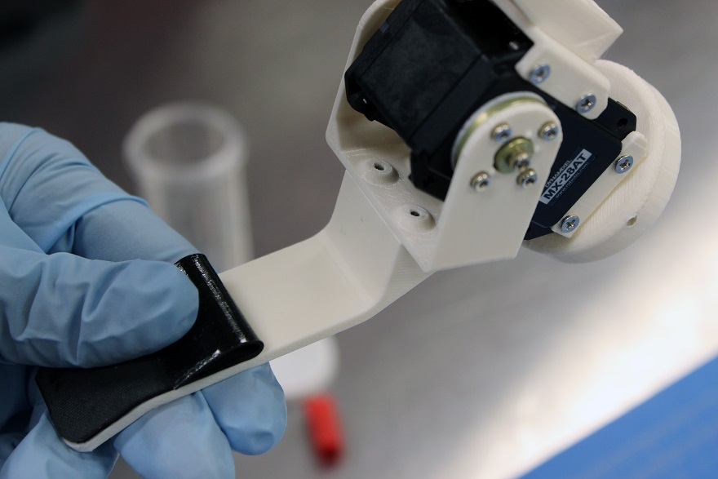

1. Plug dynamixel cable into the mx-28at connector on the same side as the fixed plate. Having the cable on the fixed plate will help reduce the chance of it getting pinched by the moving plate

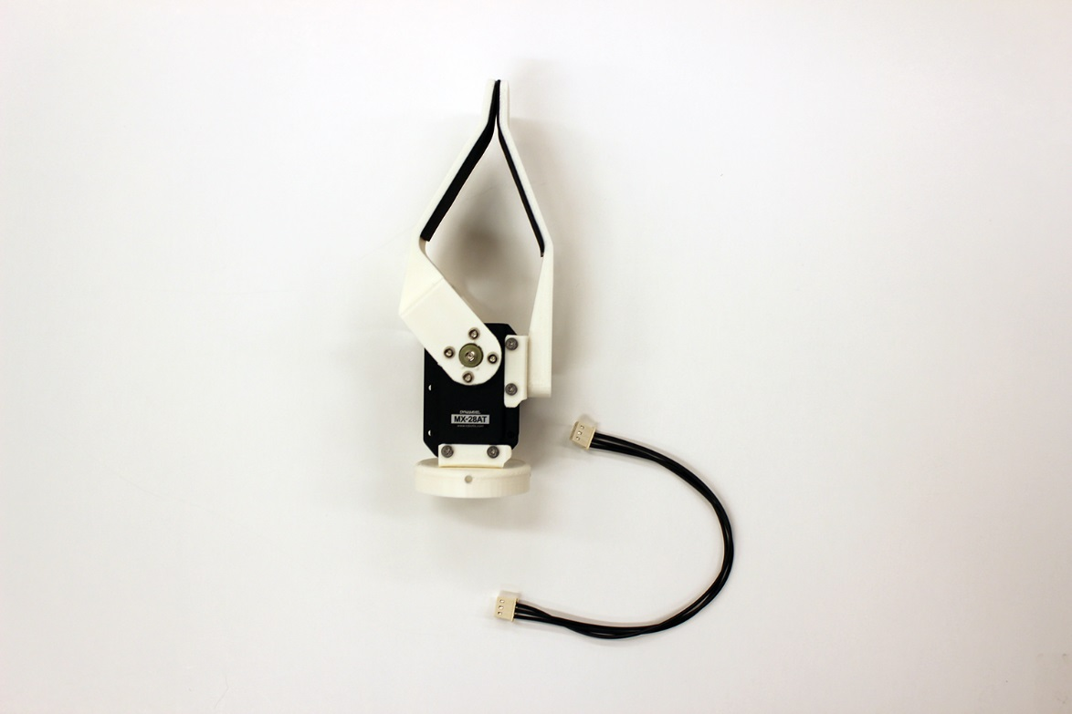

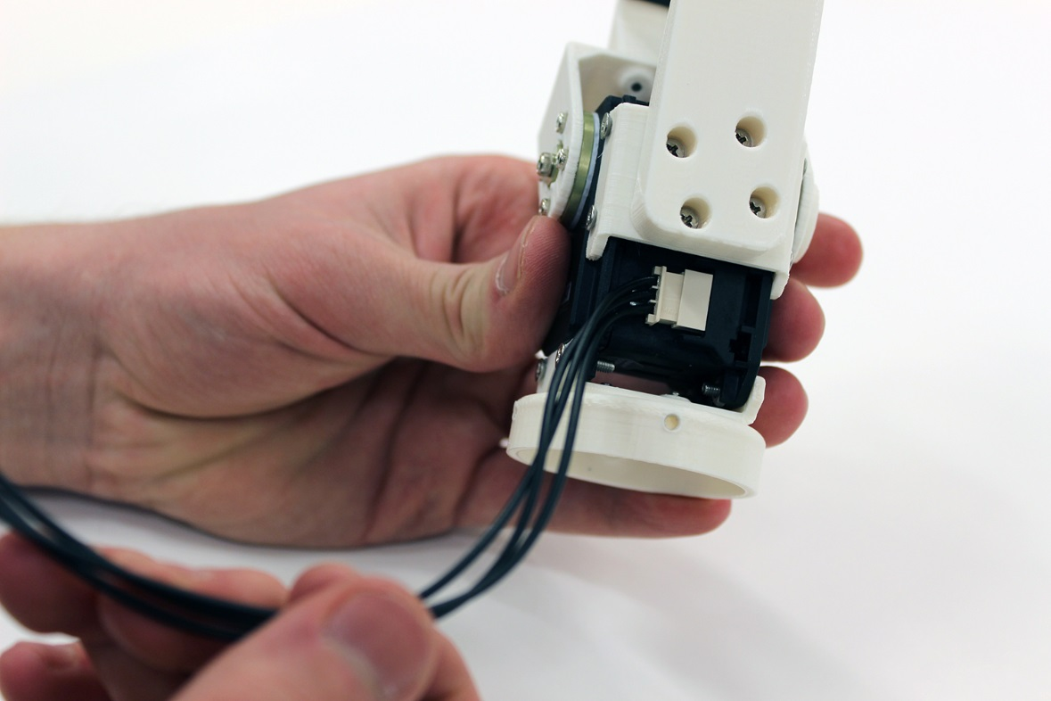

1. Slide hand_adapter into the wrist_hand adapter on the Bento Arm. Attach together with QTY:4 M3x5mm screws.

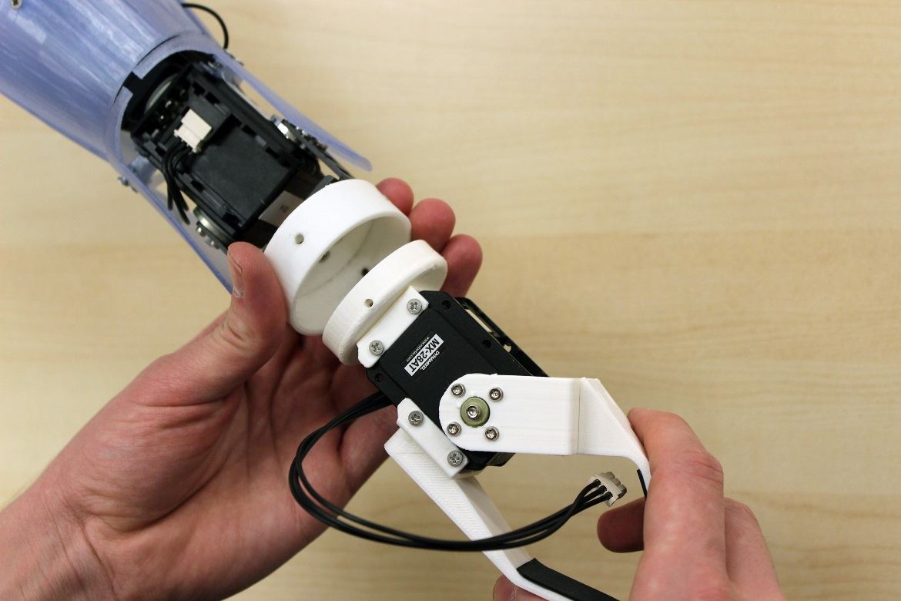

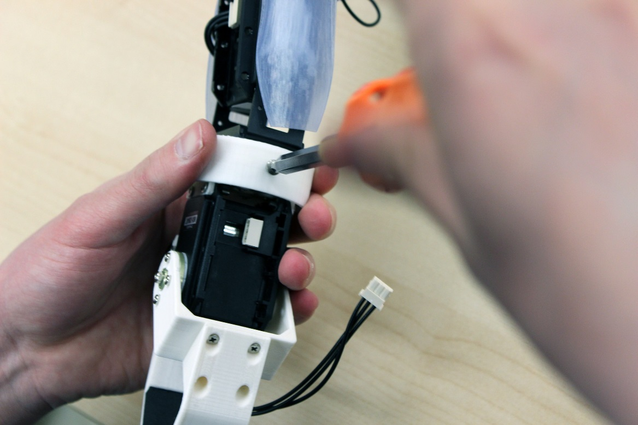

1. Plug the other end of the dynamixel cable into the wrist MX-28AT servo on the bento arm

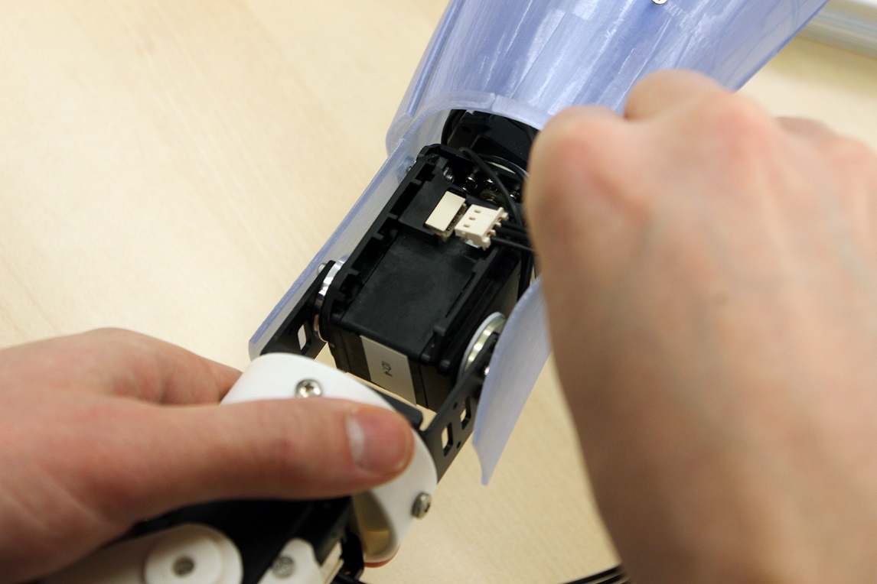

1. Your Bento Arm is now complete! ☺

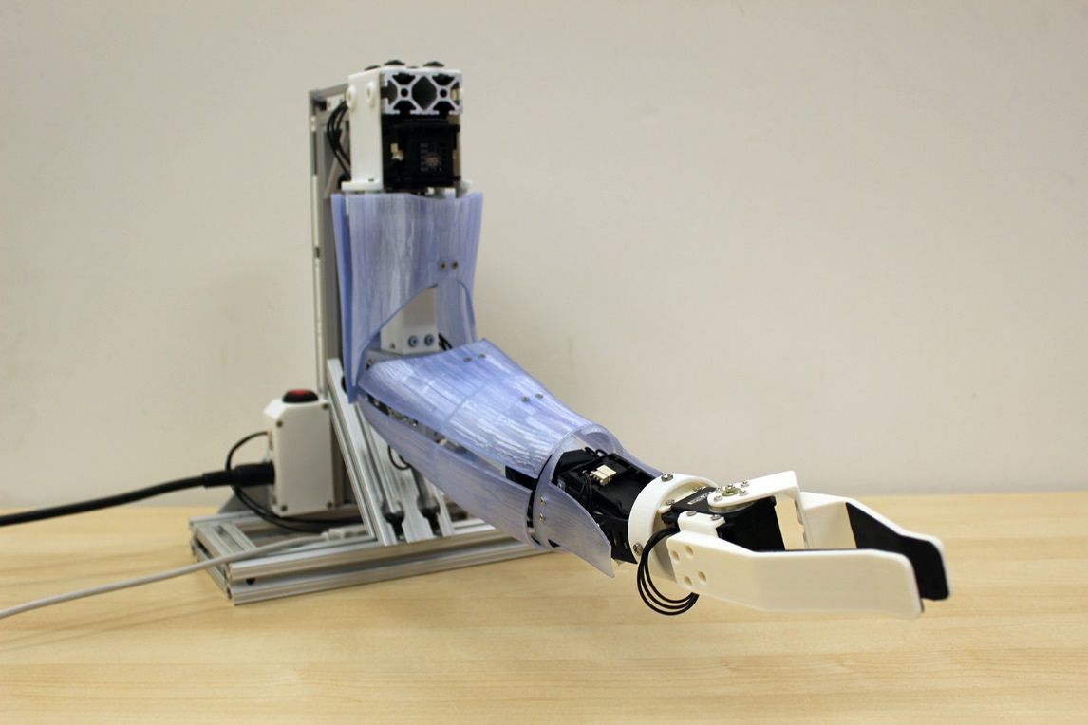

## Arm Shell Assembly

***Required Tools:*** label maker, 2mm Hex key, #1 Drive Phillips Screwdriver, #2 Drive Phillips Screwdriver, needle nose pliers, counterbore

***Required Materials:*** rare earth magnets, 3d printed parts, gel superglue

***Estimated time:*** 30 minutes

NOTE: refer to the 3D model for orientation and alignment

1. Glue forearm pieces together with gel super glue. Slide them together and then wipe off excess glue with paper towel. Let sit to dry for a few hours.

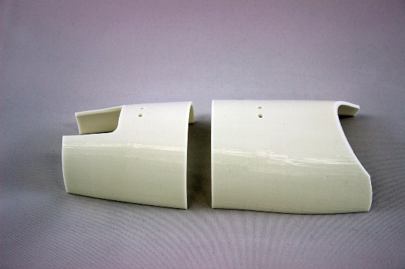 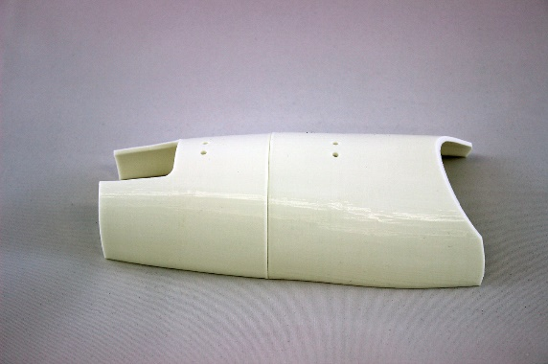

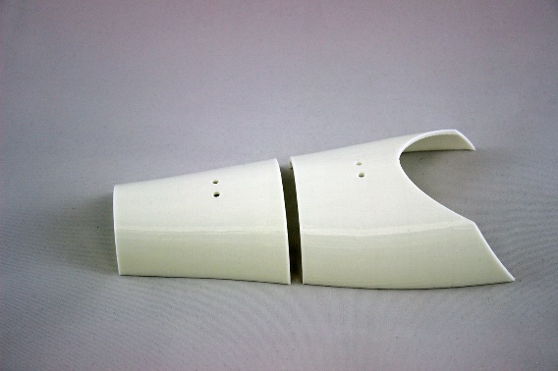 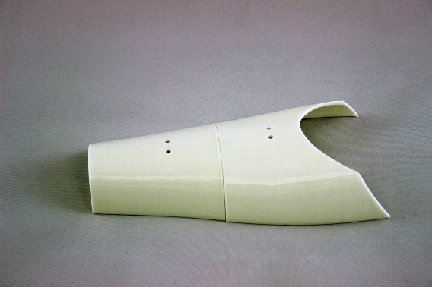

1. Glue magnets into mounting pieces. First squeeze a dollop of glue into each of the holes. Then hold a magnet (support) on the opposite side of the hole, and use this to guide another magnet (permanent) into the hole. Be careful not to get super glue onto the top of the permanent magnet, as this may reduce the holding strength of the magnet. You can adjust the alignment of the permanent magnet by moving the support magnet. Keep the back magnet in place while drying. Let sit to dry for a few hours.

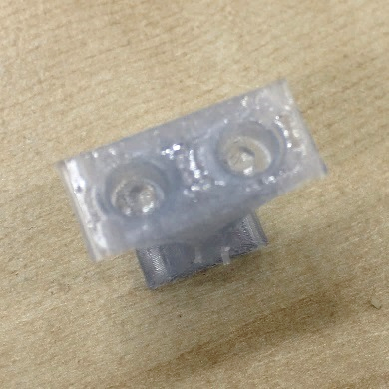 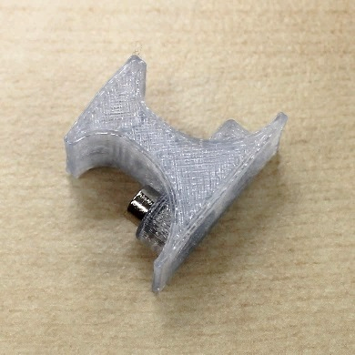 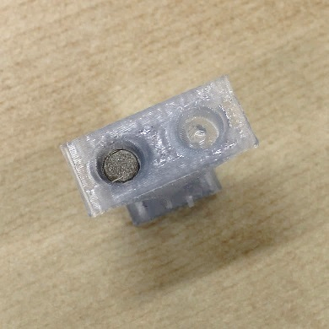

1. Attach the wrist mounts to the arm. First, unscrew the two of the M2.5x6mm screws (from the FR07-S101K kit) on the threaded side of MX-28 servo ID=4. Screw in wrist mount A with the arrow pointing upwards when arm is in neutral position using QTY: 2 M2.5x10mm screws (LT). Next, unscrew the other two M2.5x6mm screws (from the FR07-S101K kit) on the nut side of the MX-28 servo ID=4. Be careful not to dislodge the nut from the motor. Screw in wrist mount B with the arrow pointing upwards using QTY: 2 M2.5x10mm screws (LT).

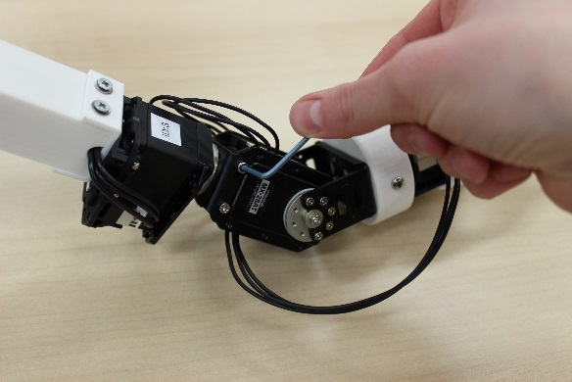

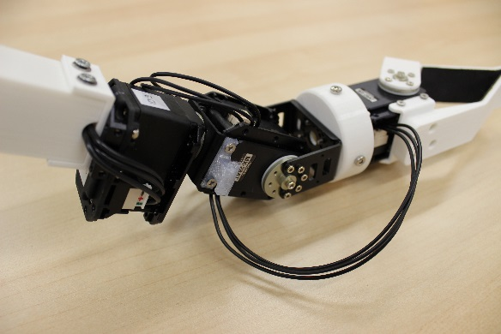 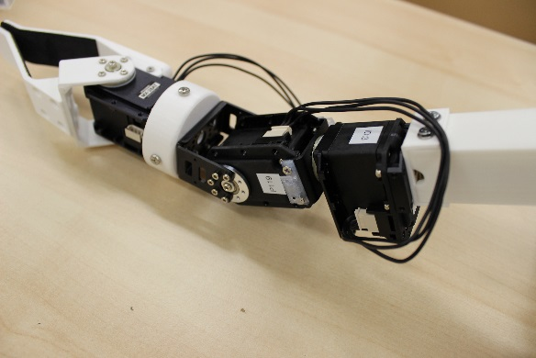

1. Attach the wrist shells to the mounts using QTY: 2 M2.5x6mm each, as shown in the image below.

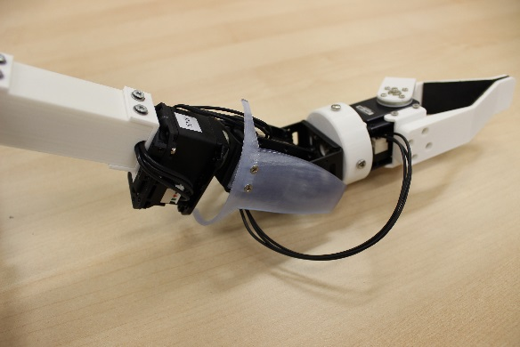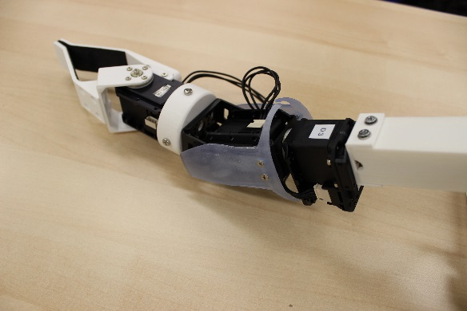

1. Use the counter bore to create a countersink on each hole to allow screws to insert properly and sit flush with the shell surfaces

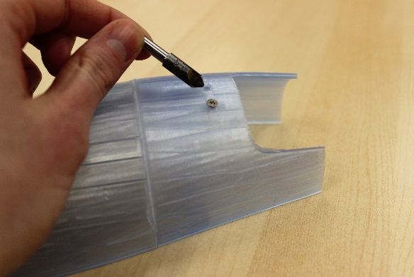

1. Tap all holes in mounts with M2.5 tap or screw/screw drive, using the procedure shown in section 1.8 Part Modifications
2. Loosely attach arm shell supports to the upper arm shells and forearm shells using M2.5 screws
3. The arm shells should now clip on with the magnets. You may have to adjust the height of the M3 screws in the linkages slightly to get a good fit. The nominal height that the top of the m3 screw head should sit above the bracket is 1.8mm. Once you have a good fit, tighten the M2.5 screws.
4. The arm shells are now ready to go and should be easily put on or removed ☺

## Electronics Enclosure Assembly

***Required Tools:*** Soldering iron, wire strippers, needle nose pliers, Philips screwdriver, heat gun, crimping tool

***Required Materials:*** 20 AWG Wire (461-1116-ND), DIN 8 power supply connector (CP-1280-ND), solder, shrink tubing, molex connectors (QTY:2 WM18887-ND, QTY:2 WM18874-ND), On/Off switch (CW155-ND), TVS diode (SA5.0ARLGOSCT-ND), QTY:12 M2.5 x 6 mm screws

***Estimated time:*** 2 hours

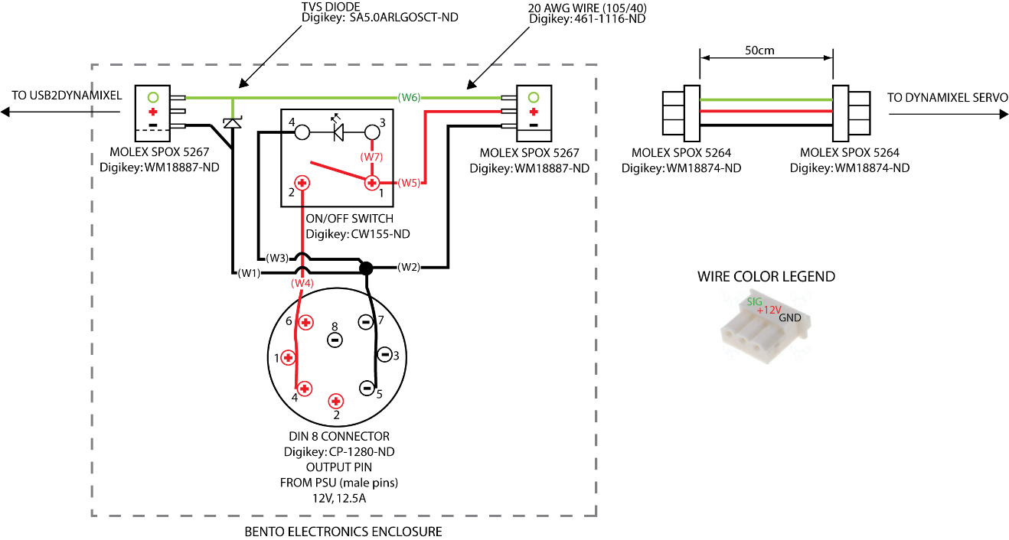

Figure 2 - Cabling Diagram

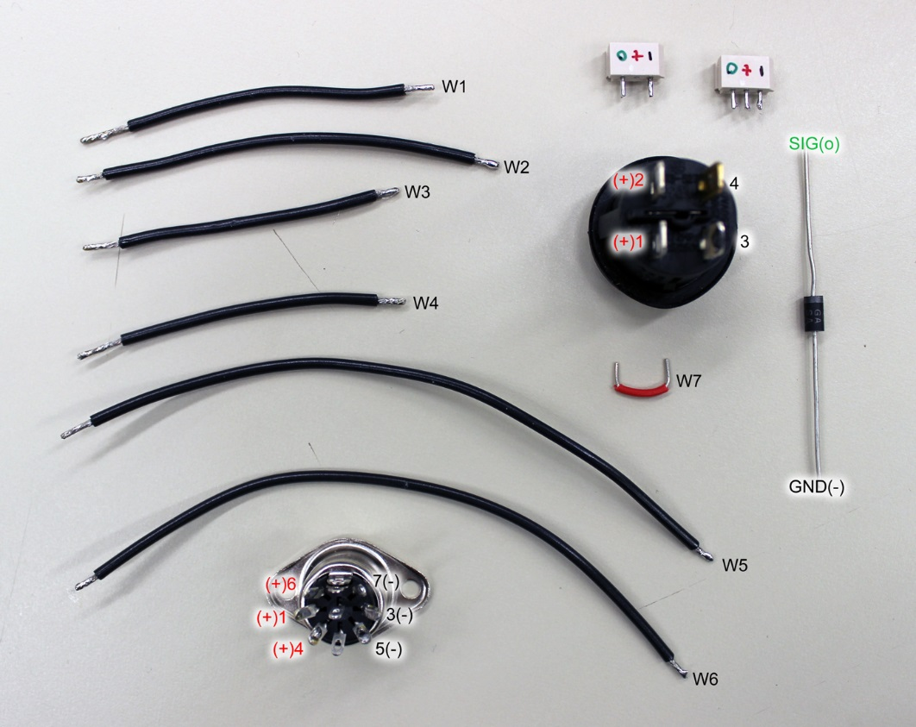

Figure 3 - Cabling Reference Photo

1. Cut wires W1 through W7 to length using 20 AWG wire and wire cutters as specified in the following table:

|  |  |
| --- | --- |
| Wire | Length (cm) |
| W1 | 6.2 |
| W2 | 7.2 |
| W3 | 5.8 |
| W4 | 5.8 |
| W5 | 12.2 |
| W6 | 11.7 |
| W7 | 2 |

1. Strip the ends of each wire by an appropriate amount for each connection. For example the ends attaching to the pins on the molex connectors can be shorter (~3mm) while the ends going into the DIN 8 connector will need to be longer in order (~10mm) in order to contact all 3 pins on the DIN 8 connector. A reference photo of each wire is shown at the beginning of this section.
2. Pre-tin the ends of each wire as well as the contacts on all the connectors with solder in order to make the soldering process easier.
3. Optional: Mark the molex connectors with colored sharpie as shown in the reference photo in order to help ensure you solder to the correct pins.
4. Solder the wires to the appropriate connectors by closely following the cabling diagram at the beginning of this section.
   1. Solder the two connecting wires W1 and W6 to the molex connector (P/N digikey WM18887-ND). Use heat shrink tubing or electrical tape to insulate the connections.
   2. Solder the TVS diode to the same molex connector as previous step, being careful to ensure the proper orientation. Refer to the figure below, and the wiring diagram above. Note that the grey line on the diode should align with the signal (green) side of the connector. After soldering, trim the ends of the diode and snip off the middle pin of the connector. Use heat shrink tubing or electrical wire to help insulate the connections.

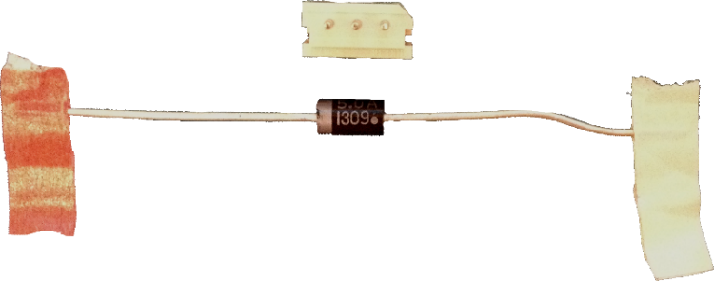

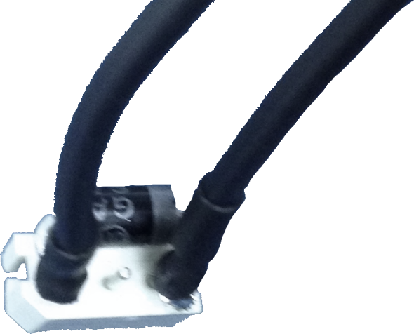

* 1. Solder the bridging wire W7 between pins 1 and 3 of the on/off switch as seen in the following figure (shown with 22 AWG red wire, but you can also use the 20 AWG wire if that is all you have):

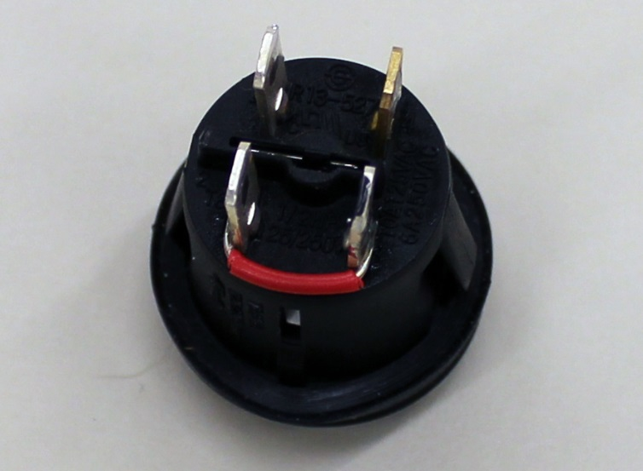

* 1. Solder the three connecting wires W3, W4, and W5 to the on/off switch. Use coloured heat shrink tubing or electrical tape to insulate the connections and to help indicate power and ground cables.
  2. Solder the connecting wires W1,W2,W3, and W4 to the DIN 8 connector. Be careful to insulate between power (+) and ground (-) connections; use heat shrink tubing and/or electrical tape where necessary. NOTE: The longer stripped ends of W2 and W4 should snake through all 3 pins of the appropriate polarity as indicated in the cabling diagram in order to achieve a higher current carrying capacity of the connector.
  3. Solder the remaining wires W2, W5, and W6 to the molex connector that will be used for the connection to the shoulder dynamixel. Insulate the connections using heat shrink tubing.
  4. The final cable assembly should look similar to the image below. Additional insulation should be added to the DIN 8 connector using heat shrink tubing or electrical tape

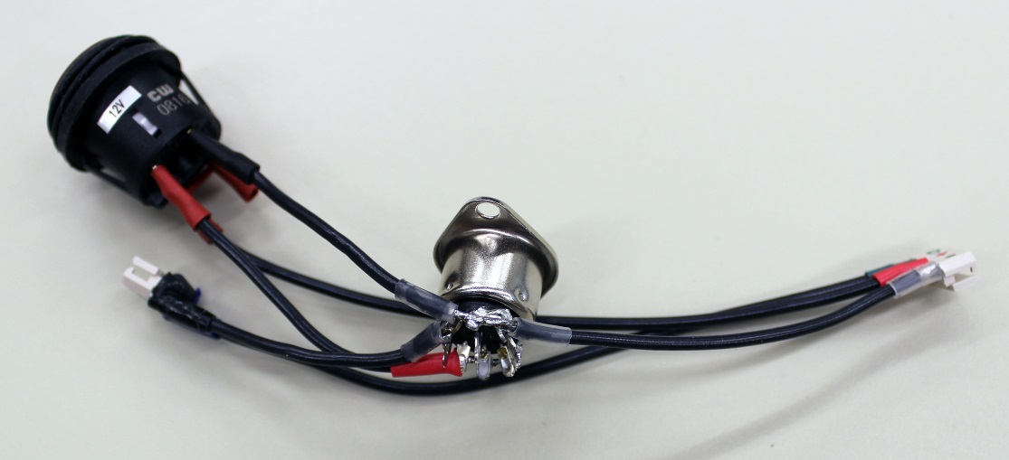

1. Thread the wires and connections into the 3D printed enclosure, and screw the DIN 8 connector into place using QTY:2 M2.5 screws and QTY:2 M2.5 nuts as spacers. Superglue the 3D printed brackets to the sides of the molex connector, and screw to the power enclosure using QTY:2 M2.5 screws. Note that this connection is somewhat fragile, so should not be unplugged and plugged in too often.

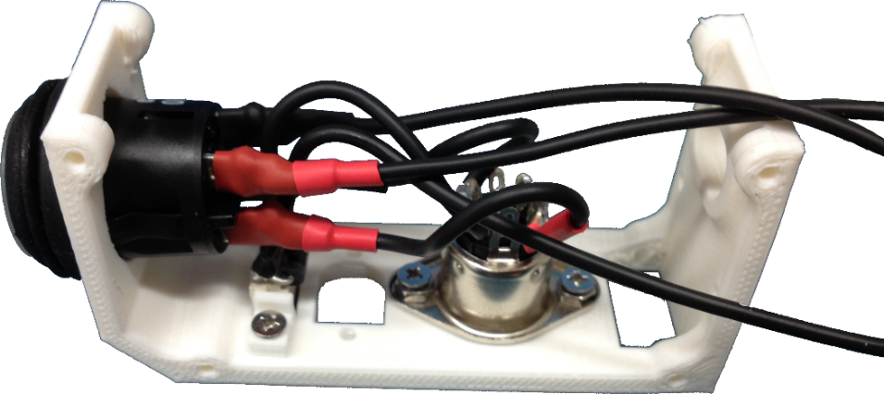

1. The back plate can now be screwed on to the power enclosure using QTY:4 M2.5 screws. This is the plate that faces away from the arm.

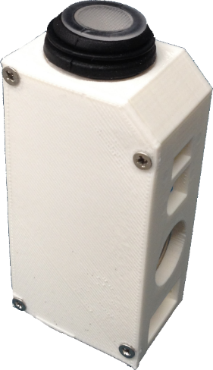

1. The power enclosure can be mounted to the frame of the Bento Arm using a ¼” 8020 beam screw and a T-nut

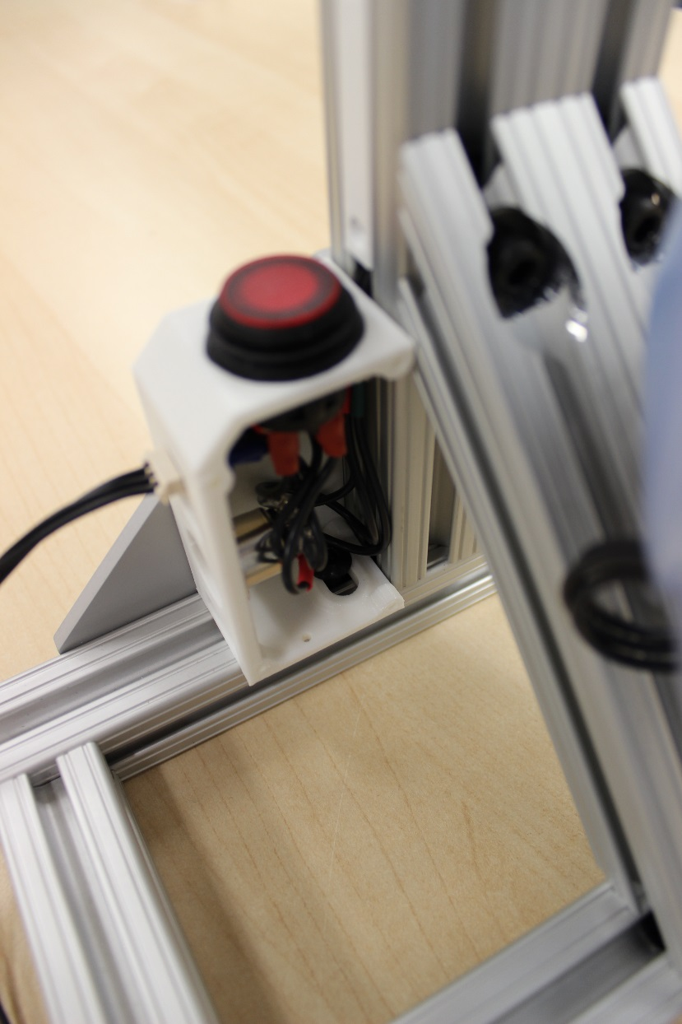

1. Following similar instructions to 1.9 Arm assembly step 13 – make a 50cm dynamixel cable to connect the power enclosure to the shoulder servo (MX-64). The wiring can be tucked into the 8020 beam and held in place with the cable relief inserts.
2. Install the front cover plate (the plate that faces the arm) using QTY:4 M2.5 screws.
3. This completes the power enclosure assembly. **NOTE**: to avoid damaging power surges on the USB2Dynamixel, always power on the switch before plugging in the USB2Dynamixel, and power off the switch after the USB2Dynamixel has been unplugged.